Organization Name

Software Design

Document

Project Name  
*Revision 1.0*

*Date: (mm/dd/yyyy)*

# Revision History

|  |  |  |  |
| --- | --- | --- | --- |
| **Version** | **Name** | **Reason For Changes** | **Date** |
| *1.0* | *Sue Dillehay*  *David Kurth*  *Jon Fletcher* | *Initial Revision* | *8/19/2022* |
|  |  |  |  |

# 

# Approved By

Approvals should be obtained for project manager, and all developers working on the project.

|  |  |  |  |
| --- | --- | --- | --- |
| **Name** | **Signature** | **Department** | **Date** |
| Bill Currie |  | BP-IT-Development |  |
|  |  |  |  |

Contents

Revision History 2

Approved By 2

**1.** **Introduction** 7

**1.1** Overview 7

**1.2** Purpose 7

**1.3** Project Scope 7

**1.4** References 7

**1.5** Target Audience 7

**1.6** List of Abbreviation 7

**2.** **Overall Description** 8

**2.1** **Problem Statement** 8

**2.2** **Proposed Solution** 8

**2.2.1** Project Idea 8

**2.2.2** Stakeholders 8

**2.2.3** Actors 8

**2.3** **Product Overview** 8

**2.3.1** Functional requirement 8

**2.3.2** Nonfunctional Requirement (Quality Attributes) 8

2.3.2.1 Reliability 8

2.3.2.2 Availability 8

2.3.2.3 Security 8

2.3.2.4 Maintainability 8

2.3.2.5 Portability 8

**2.4** **Areas of Risk** 9

**3.** **System Analysis** 9

**3.1** **Use case Diagrams (per functionality)** 9

**3.2** **Activity Diagram** 9

**3.3** **Component Diagram** 9

**3.4** **Class Diagram** 9

**3.5** **ERD** 9

**4.** **Overall Design** 10

**4.1** **Sitemap** 10

**4.2** **Wireframes** 10

**4.3** **Mockups** 10

**5.** **Overall Development** 10

**5.1** **Development Overview** 10

**5.2** **The preferable Development Tool, Technique, and Software Development Methodology** 10

**5.3** **Solution Evaluation** 10

**5.3.1** Development Tools Comparison 10

**5.3.2** Development Techniques Comparison 11

**5.3.3** Software Development Methodology Comparison 11

**6.** **Development Plan Discussion** 11

**6.1** **Development Review** 11

**6.1.1** Peer review feedback 11

**6.1.2** Interpret the peer review feedback 11

**6.1.3** Identify and evaluate new opportunities 11

**6.2** **Application Development** 11

**6.2.1** Database 11

**6.2.2** Screenshots of your application 11

**7.** **Testing** 12

**7.1** **Testing plan** 12

**7.2** **Performance review** 12

**7.3** **Critical review for all application development phases** 12

**7.4** **Application evaluation and future development** 13

**8.** **Implementation and support** 13

Table of Tables

Table 1 Advantages and Disadvantages of types of each design tool 10

Table 2 Advantages and Disadvantages of types of each development tool 11

Table 3 Test cases plan table 13

Table of Figures

[Figure 1 A use case to supply chain members relations 9](https://hatuniversity-my.sharepoint.com/personal/lina_hammad_htu_edu_jo/Documents/Courses/HTU%20courses/Application%20Development/2022%20Spring/Slides/SDD%20-%20my%20vesrion%20.docx#_Toc104153686)

[Figure 2 a use case to enterprise architect user guide 9](https://hatuniversity-my.sharepoint.com/personal/lina_hammad_htu_edu_jo/Documents/Courses/HTU%20courses/Application%20Development/2022%20Spring/Slides/SDD%20-%20my%20vesrion%20.docx#_Toc104153687)

# **Introduction**

## Overview

The SDD or software design document delineates the design and architecture of the employee salary calculator system along with the planned implementation. This tells how the system is organized, major components involved, and how each part of the application was developed. The paper follows a systematic development of the system and its functionalities which were followed by requirement, design model, development and testing.

The SDD has many sections that describe the overall functioning of the system, the roles of users, the steps in processes, the look of screens, development tools to be used and the technical architecture. It has diagrams, wireframes, mockups, and development plans to make sure all stakeholders (developers, testers, project managers, reviewers, etc.) know how the system will work. The purpose of this document is to serve as a comprehensive reference for all stages of the development process – making sure that all guidelines are consistent, accurate, and in line with the purposes of the project.

## Purpose

The aim of this Software Design Document (SDD) is to specify the architecture, design decisions, components, and technical structure of Employee Salary Calculator System. The software design specification explains how the system will be. Constructed. It describes the various modules, workflows, models, interfaces and.

approach needed to create an application that functions as required.

This is a project document for software developers, project manager, tester, system administrator and technical reviewer and all other stakeholders. This confirms that every team member presently understands the system design. This facilitates correct subsequent implementation during system development, and provides an easy reference for future maintenance and development.

## Project Scope

This project aims to design and develop an **Employee Salary Calculator System** that automates payroll operations for the HR department.  
The system will replace manual salary processing with a computerized approach that calculates salaries, generates pays lips, manages allowances and deductions, and produces financial reports.

### In Scope

* **Employee Management**
  + Add, edit, and view employee information such as name, department, position, and bank details.
  + Maintain employee records in a centralized database.
* **Payroll Calculation**
  + Automatically calculate monthly salaries based on basic pay, allowances, bonuses, and deductions.
  + Generate accurate net salaries for each employee.
* **Pay slip Generation**
  + Create salary slip for each employee.
  + Include clear breakdowns of all earnings and deductions.
* **Reports and Analytics**
  + Generate monthly payroll summaries and department-based reports.
* **User Roles and Authentication**
  + Role-based access control for Admin, HR, and Employee accounts.
  + Secure login and logout features for system users.
* **Advance Salary Request System (Student Feature)**
  + Employees can request a portion of their salary in advance.
  + HR reviews and approves or rejects requests with repayment terms.

### Out of scope

* Integration with external accounting, tax filing, or HR systems.
* Automatic synchronization with government tax databases or APIs.

### Assumptions

* HR staff will provide accurate employee and salary details to the system.
* Tax and deduction rates will be updated manually by authorized staff when needed.
* The system will be used internally by HR.

### Constraints

* The system must ensure data security and comply with organizational privacy policies.
* The project must be completed within 3 -5 months.

## References

This section is optional

List any other documents or Web addresses to which this SDD refers. These may include user interface style guides, contracts, standards, system requirements specifications, use case documents, or a vision and scope document. Provide enough information so that the reader can access a copy of each reference, including title, author, version number, date, and source or location.

## Target Audience

This section is optional

Describe the different types of reader that the document is intended for, such as developers, project managers, marketing staff, users, testers, and documentation writers. Describe what the rest of this SRS contains and how it is organized. Suggest a sequence for reading the document, beginning with the overview sections and proceeding through the sections that are most pertinent to each reader type.

## List of Abbreviation

|  |  |
| --- | --- |
| Abbreviation | Definition |
| SDD | Software Design Document |
| SDLC | Software Development Life Cycle |
| RAD | Rapid Application Development |
| UI | User Interface |
| UX | User Experience |
| API | Application Programming Interface |
| CRUD | Create, Read, Update, Delete |
| HR | Human Resources |
| DB | Database |
| SQL | Structured Query Language |
| MySQL | A relational database management system used for storing payroll and employee data |
| JSON | JavaScript Object Notation |
| ID | Identifier |
| UI/UX | User Interface / User Experience |
| REACT | Frontend JavaScript library used to build component-based UI |
| Node.js | JavaScript runtime environment used for backend development |
| ERD | Entity Relationship Diagram |
| PK | Primary Key |
| FK | Foreign Key |
| HRMS | Human Resource Management System |
| CRUD | Create, Read, Update, Delete |
| CSS | Cascading Style Sheets |

# **Overall Description**

## **Problem Statement**

**Problem**: The problem is that the current process of dealing with the employee payments is done manually or with disorganized sheets, which is prone to inaccuracies, time-consuming, and the process of creating reports is complex. Automation of calculating salaries and creating slips is the solution.

**Gap: At present, salary calculations are done manually or using multiple spreadsheets. The process takes time, can be susceptible to human error, and makes supervision of payroll history, reporting, or data standardization between accounting departments harder.**

**Impact**: By creating a simple system to handle salary calculations automatically, most of these problems can be avoided. The system would do all the math instantly, apply deductions correctly, and generate pay slips without extra work. It would also store everything in one place, so HR can find employees or payroll information easily. This would save time, reduce errors, and make the overall process more organized and reliable for the organization.

## **Proposed Solution**

## Project Idea

Overview

Develop an application that will be able to automate employee salary processing.

The system will aid the human resources department in calculating employee salaries, creating pay slips, processing allowances and deductions, and granting employees safe access to their payment transactions.

It seeks to reduce human involvement, remove the possibility of mathematical errors, or improve the efficiency of the process.

Key features

* **Employee Management**: Store and manage employee details including name, department, position, and bank information.
* **Automatic salary calculation**: Automatically calculate monthly salaries based on basic pay, allowances, bonuses, and deductions
* **Pay slip generation**: Generate clear pay slips that show all earnings and deductions for each employee.
* **Reports and analytics**: Create monthly payroll summaries and departmental expense reports for management review.
* **Secure User Roles**: Role-based login access for Admin, HR, and Employees to ensure data privacy and controlled access.
* **Advance Salary Request System**: Employees can request a portion of their salary in advance, HR can approve or reject requests, and the system automatically deducts repayments in future payroll cycles.

## Stakeholders

* Employees
  + Can view their salary slips.
  + Can submit advance salary requests and check repayment status.
* HR
  + Responsible for entering and updating employee information.
  + Manage payroll calculations, generate pay slips, and approve advance requests.
* Executives
  + Oversees the hole flow of the development and ensure the application does not break any privacy regulations.
* IT department
  + Preform regular data backup.
  + Provide support for HR staff using the system.

## Actors

**Employees**

* Log in to view their salary slips.
* Submit advance salary requests.
* Check approval status and repayment history.

**HR staff**

* Add and update employee information.
* Manage payroll calculations and generate pay slips.
* Review and process advance salary requests.
* Generate monthly payroll reports and department summaries.

**Administrator**

* Manage user accounts, roles, and access levels.
* Ensure data privacy and system security policies are followed.
* Perform system configuration, backups, and maintenance.

## **Product Overview**

## Functional requirement

**Benefit (B):** How much value or improvement it brings (1 = low, 9 = very high)

**Penalty (P):** Impact if it fails or is missing (1 = low, 9 = severe)

**Cost (C):** Relative effort or resources to implement (1 = low, 9 = very high)

**Risk (R):** Likelihood of errors or issues (1 = low, 9 = very high)

1. **Employee management  
   Priority: High  
   B = 9 | P = 8 | C = 5 | R = 4**
   1. The system should allow HR staff to add, edit, and delete employee records.
   2. It should store details such as name, department, position, salary, and bank information.
   3. HR should be able to search and view employee profiles easily.
2. **Payroll calculation  
   Priority: High  
   B = 9 | P = 9 | C = 7 | R = 5**
   1. The system shall automatically calculate the employee’s net salary based on
      1. Basic pay
      2. Allowances like housing and transport
      3. Bonuses
      4. Deductions like tax and insurance
   2. The payroll formula should be applied consistently for all employees.
   3. HR should be able to modify pay structures and immediately update calculations.
3. **Pays lip generation  
   Priority: High  
   B = 8 | P = 8 | C = 4 | R = 3**
   1. The system should generate a pays lip for each employee every month.
   2. The pays lip must display breakdown of basic pay, allowances, deductions, and total net salary.
   3. Employees and HR should be able to view pay slips securely.
4. **Reports and Analytics  
   Priority: Medium  
   B = 7 | P = 6 | C = 5 | R = 3**
   1. The system should generate monthly reports.
   2. Reports must include salary totals, deductions, allowances, and bonuses.
5. **User Roles and Authentication  
   Priority: High  
   B = 9 | P = 9 | C = 5 | R = 6**
   1. The system shall support role-based access control for Admin, HR, and Employees.
   2. Each user must log in using valid credentials (username and password).
   3. Admins should have full access, while other users have limited, role-appropriate permissions.
6. **Advance Salary Request System  
   Priority: Medium  
   B = 8 | P = 7 | C = 6 | R = 5**
   1. Employees should be able to request a portion of their salary in advance by entering the amount and reason.
   2. HR can approve or reject requests and set repayment terms.
   3. Once approved, the system automatically schedules deductions in future payrolls until the amount is fully repaid.
7. **System Administration  
   Priority: Medium  
   B = 7 | P = 6 | C = 4 | R = 3**
   1. The Admin should be able to add or remove users and assign appropriate roles.
8. User must be able to login with proper roles.
9. NOTE: all systems should have a notifications.

## Nonfunctional Requirement (Quality Attributes)

### Reliability

* 1. The system must remain stable during payroll periods and heavy usage.

### Availability

* The system should be accessible during standard working hours with minimal downtime.
* Scheduled maintenance should occur outside payroll processing periods.

### Security

* The system must protect sensitive employee and payroll data through secure login and role-based access.
* Passwords should be encrypted, and data transmission must be secured.
* Only authorized users can access or modify salary details.
* Regular backups must be performed to prevent data loss.

### Maintainability

* The system codebase should be well-documented for future updates or debugging.

### Portability

* The system should be able to run on multiple computers within the organization without requiring complex installation steps.
* It should be compatible with different operating systems.
* The application should allow easy migration to other devices if the organization upgrades its hardware.

## **Areas of Risk**

### Low risks

1. Hardware Compatibility Issues

* **Description**: The system might not perform properly on older computers or unsupported operating systems.
* **Impact** **Level**: Low
* **Mitigation**: Ensure minimum system requirements are defined clearly and test the software on multiple setups before installation.
* **Phase:** Testing.

### Medium risks

1. Resistance to Change

* **Description:** HR staff might be hesitant to switch from manual payroll methods to a computerized system.
* **Impact Level:** Medium
* **Mitigation:** Demonstrate system benefits and provide initial support during transition.
* **Phase:** Deployment.

1. **User Errors or Insufficient Training**

* **Description:** Users may make mistakes while using the system if not properly trained.
* **Impact Level:** Medium
* **Mitigation:** Provide simple training sessions and a user manual or help guide.
* **Phase**: testing and deployment.

### High risks

1. Data Breach or Unauthorized Access

* **Description:** Sensitive employee and salary data could be accessed by unauthorized users if proper security is not enforced.
* **Impact Level:** High
* **Mitigation:** Use user authentication, role-based access, and encryption for stored data. Limit system access to authorized personnel only.
* **Phase**: Design and testing.

1. System Crash During Payroll Processing

* **Description:** The system may crash or malfunction during salary processing due to software bugs or hardware issues.
* **Impact Level:** High
* **Mitigation:** Conduct thorough system testing, perform regular backups, and ensure a stable runtime environment.
* **Phase**: Testing.

## System Analysis

## **Use case Diagrams (per functionality)**

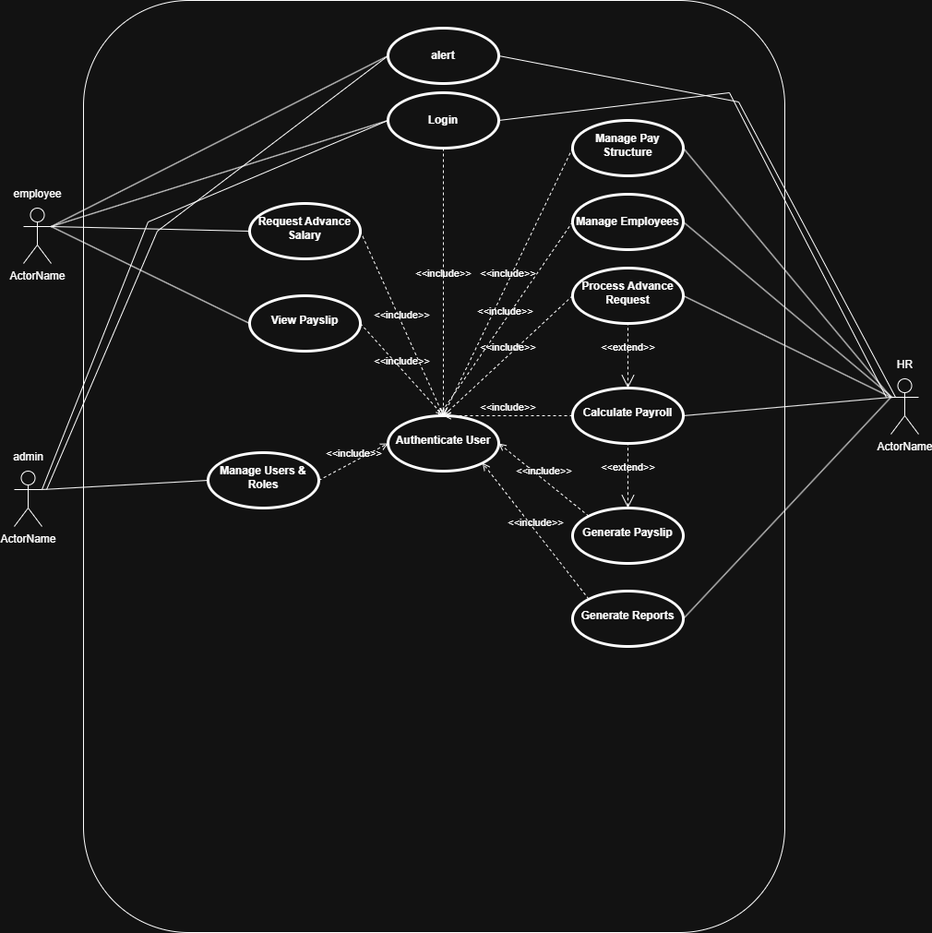Use case diagram

This Use Case Diagram shows how the different users of the Employee Salary Management System interact with the system’s main functions. All actors begin by performing the **Login** use case, which includes **Authenticate User** to ensure secure access.

**Employees** can *View Payslips* and *Request Advance Salary*.  
**HR Staff** perform the core operations such as *Manage Employees*, *Manage Pay Structure*, *Calculate Payroll*, *Process Advance Requests*, *Generate Payslips*, and *Generate Reports*.  
**Administrators** manage system access through *Manage Users & Roles*.

Include and extend relationships are used to show that certain functions depend on authentication or follow from other processes (e.g., generating payslips after payroll calculation).

## **Activity Diagram**

calculating payroll

This activity diagram shows the steps HR Staff follow to calculate payroll. The process begins when HR opens the Payroll Module, after which the system displays the payroll dashboard. HR selects the pay period and chooses the employees to include. The system checks the input and validates the selection. If the input is valid, the system loads employee and pay-grade data and calculates the salary amounts. The process ends once the calculation is completed.

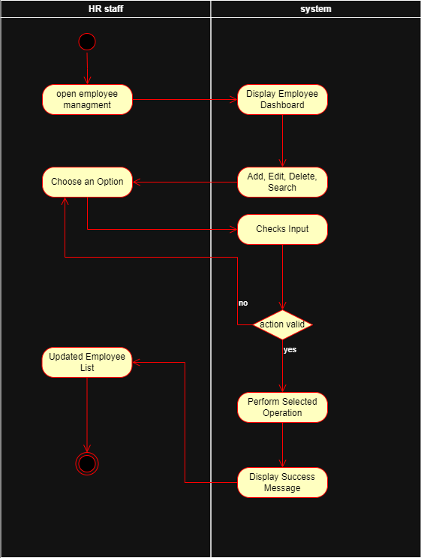

**Employee management**

This activity diagram shows how HR Staff manage employee records. The process starts when HR opens the Employee Management module, and the system displays the employee dashboard. HR chooses an action such as add, edit, delete, or search, and the system checks the input. If the action or data is invalid, the user is returned to choose another option. If the input is valid, the system performs the selected operation and then displays a success message. The updated employee list is shown, and the process ends.

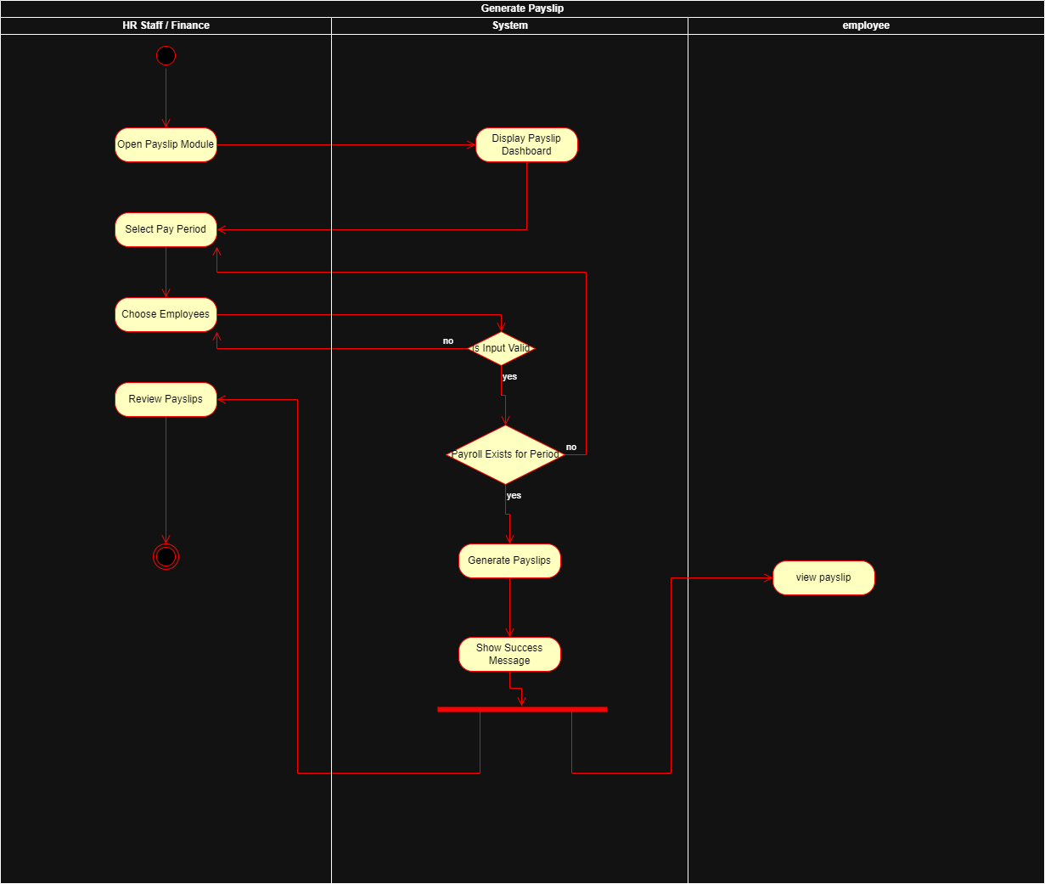

**Generate pay slip**

This activity diagram shows how HR staff generate payslips. The process begins when the user opens the Payslip Module and the system displays the payslip dashboard. The user selects the pay period and chooses the employees they want to generate payslips for. The system validates the input, and if it is incorrect, the user is returned to adjust their selections. If the input is valid, the system checks whether payroll has been calculated for that period. If payroll exists, the system generates the payslips and displays a success message. HR can then review the payslips, while employees can view their own payslip afterward. The process ends once the payslips have been successfully generated.

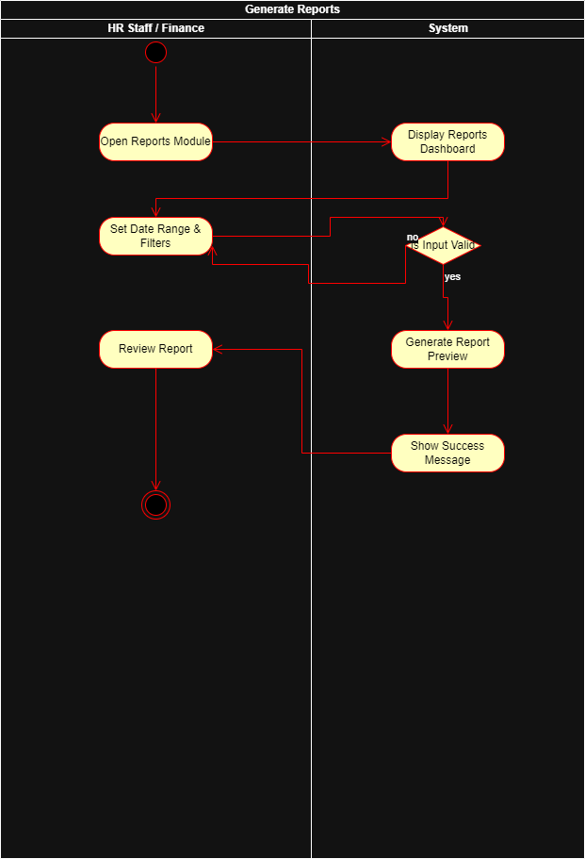

**Generate report**

This activity diagram shows how HR staff generate system reports. The process begins when the user opens the Reports Module, and the system displays the reports dashboard. The user then sets the date range and any required filters. The system validates the input, and if the input is incorrect, the user is sent back to adjust the filters. If the input is valid, the system generates a report preview and displays a success message. The user then reviews the generated report, and the process ends.

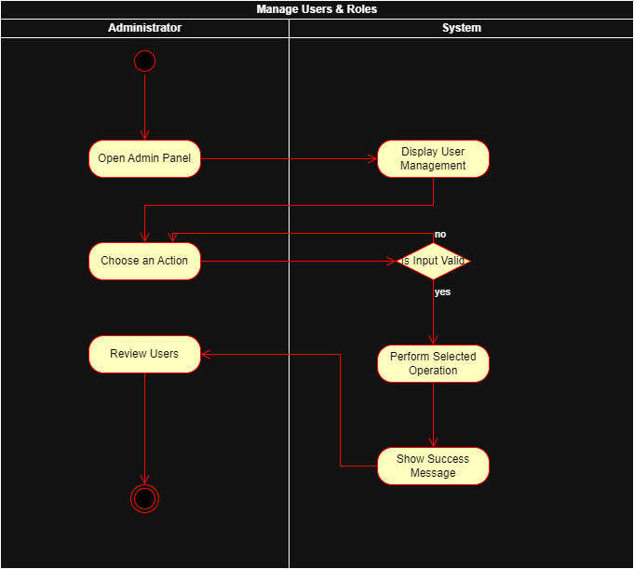**Manage roles**

This activity diagram shows how the Administrator manages system users and their roles. The process starts when the administrator opens the Admin Panel, and the system displays the user management interface. The administrator chooses an action such as adding, editing, or deleting a user. The system checks whether the input is valid. If not, the administrator is returned to select another action. If the input is valid, the system performs the selected operation and displays a success message. The administrator then reviews the updated user list, and the process ends.

**Process Advance Request**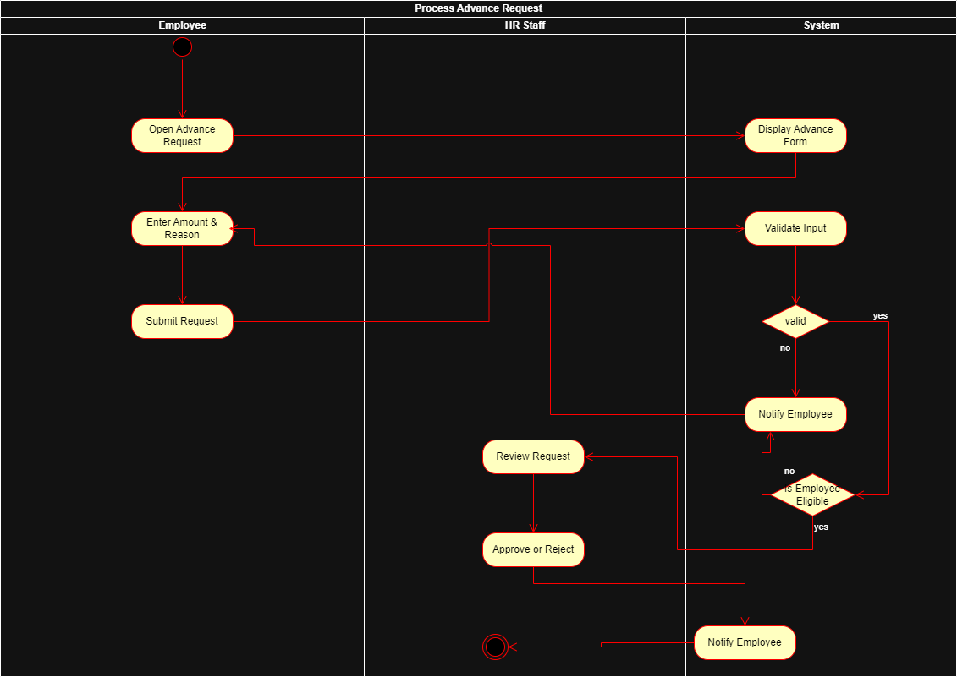

This activity diagram shows how an employee submits an advance salary request and how HR processes it. The employee starts by opening the advance request form, entering the amount and reason, and submitting the request. The system validates the input; if the information is invalid, the employee is notified and must correct it. If the request is valid, the system checks whether the employee is eligible. If not eligible, the system notifies the employee and the process ends. If the employee is eligible, HR reviews the request and decides to approve or reject it. The system then sends a final notification to the employee, completing the process.

## **Component Diagram**

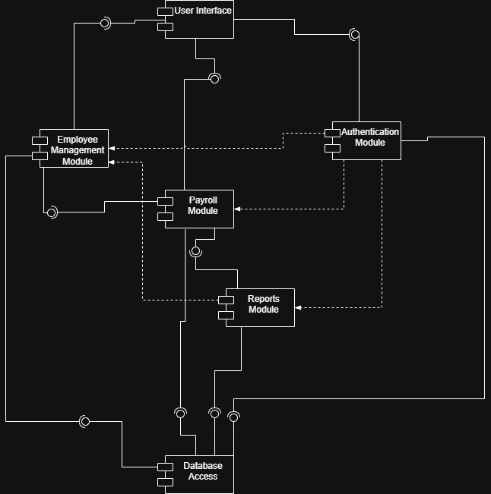

**Component diagram**

This component diagram shows the main modules of the Employee Salary Management System and how they interact. The User Interface is the entry point for all users and connects to the Authentication Module, Employee Management Module, and Payroll Module, which provide the system’s core functions.

The Payroll Module also interacts with the Reports Module to generate payroll summaries and financial reports. All functional modules depend on the Database Access component, which handles data storage and retrieval for the system.

Provided and required interfaces are represented through the lollipop and socket symbols, while dashed arrows indicate module dependencies. The diagram shows a clear separation between the UI, business logic modules, and the data access layer.

## **Class Diagram**

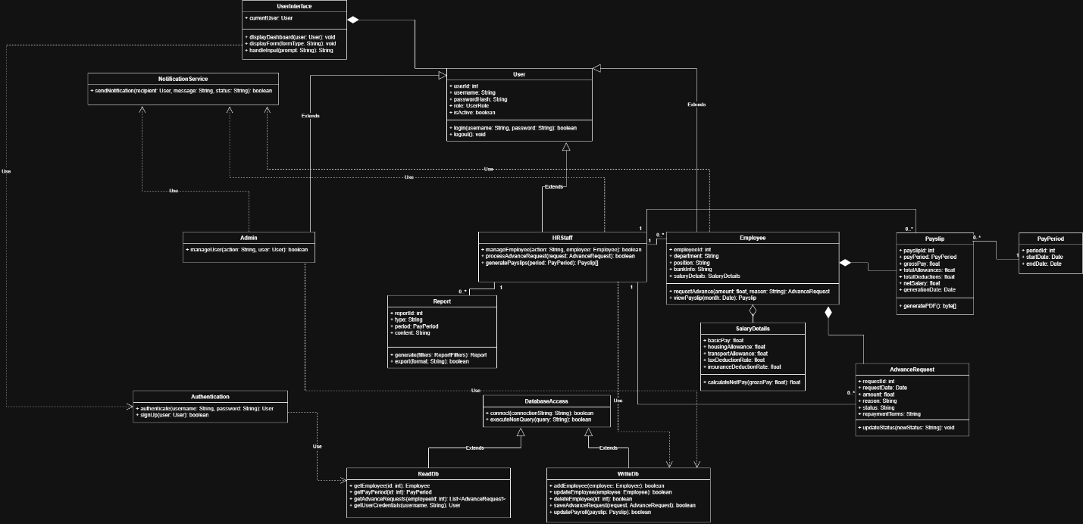

**Class diagram**

The Class Diagram above illustrates the chief entities and responsibilities of the Payroll Management System. The User class provides the overall functionalities of user management through the inheritance of **three** subclasses: **Admin, HRStaff, and Employee**. These subclasses provide the functionality of their respective roles: **Admin** manages users' accounts, **HRStaff** manages employees' information and their advance requests as well as payslips generation, and **Employee** requests advances and can also access their payslips.

The system's business entities are modeled as **SalaryDetails, PayPeriod, Payslip, AdvanceRequest, and Report**. The Employee class has a reference to the SalaryDetails class which contains the components of their salaries and the net pay method. The class also has composite mappings to AdvanceRequest and Payslip meaning the two are the objects that will be created when the employee's existence accomplishes. Payslip has a reference to PayPeriod containing information regarding gross pay, allowances, deductions, and net salary. The AdvanceRequest class provides information about the advance salary requests together with their statues. The Report class provides information regarding the management reports created concerning particular pay periods.

Support and technological functionality of the Payroll System is provided by **UserInterface, Authentication, NotificationService, and the database components**. The UserInterface class provides the functionality of the various dashboards and forms users interact with when accessing the system needing the Authentication class which verifies the users' credentials. The Authentication class utilizes the read functionality of the ReadDb class. The DatabaseAccess class provides the general access functionality of the database necessitated by ReadDb and WriteDb which provide the read functionality of the employee and pay periods information and the write functionality of the information respectively.

NotificationService functionality provides notifications concerning the completion of various tasks handled by the various users' roles and the business components enabling notifications of completion of activities. The various users' roles and business components also depend on the database components as mentioned above. The class diagram illustrates the clear interaction of the users' roles and business components.

## **ERD**

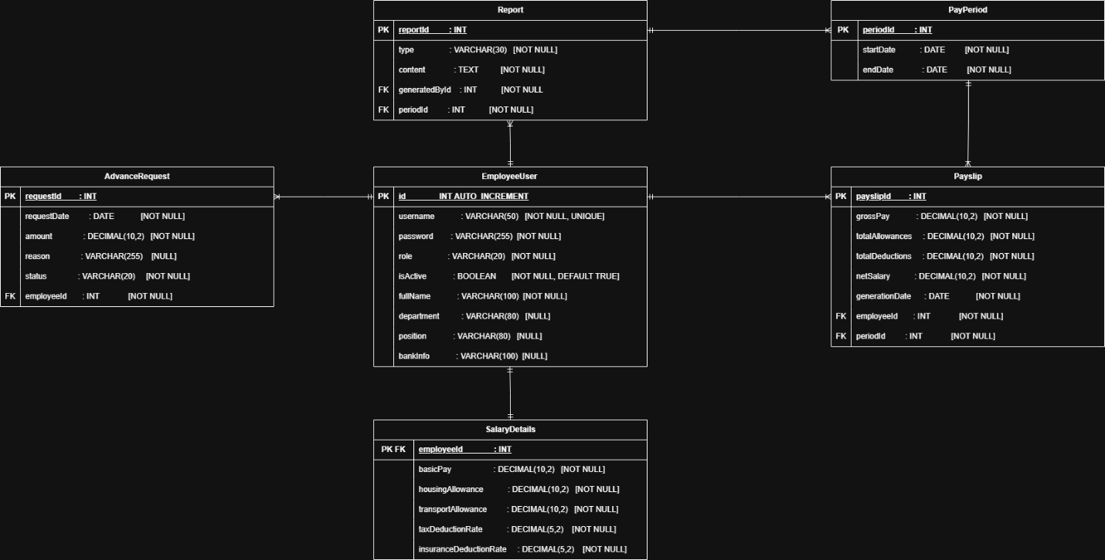

ERD diagram

The Entity Relationship Diagram (ERD) explains the physical database structure used by the Payroll Management System. At the core of the database schema stands the EmployeeUser table. It holds the login details (username, password, Role, Active) along with the HR-related fields (Full Name, Department, Position, Bank Details). The SalaryDetails table is in one-to-one correspondence with the EmployeeUser table. It holds the financial configuration for each of the system’s users. The configuration holds the values for the individual’s basic salary, allowance rates, and the rates for their deductions. Data in the Payroll System is organized in terms of the PayPeriod table. It holds the parameters for the beginning and the end of each period. Payments and the related operations in the system are represented by the Payslip table. It maintains relationships with EmployeeUser and PayPeriod tables. Additionally, it holds the values for the individual’s Gross Pay, Allowances, Total Deductions, Net Salary, along with the date for the generation of the payslip. Employee advances in the system are represented by the AdvanceRequest table. It holds relations back to EmployeeUser. Additionally, it holds the requested amount for the advance along with the requested date. Supporting the report generation in the system stands the REPORT table. It holds relations back to EmployeeUser (report authors) along with the PayPeriod. Finally, it holds the report details. Keys (PK), Foreign Keys (FK), along with their relations for all related tables are defined for each table in the ERD. EmployeeUser.id is related back by SalaryDetails, Payslip, AdvanceRequest, along with the REPORT table. This relates the whole system back to the Employee/user. PayPeriod.periodId is related back by both Payslip and REPORT tables. Each period in the PayPeriod table relates back to many Payslip and REPORT tables.

# **Overall Design**

## **Sitemap**

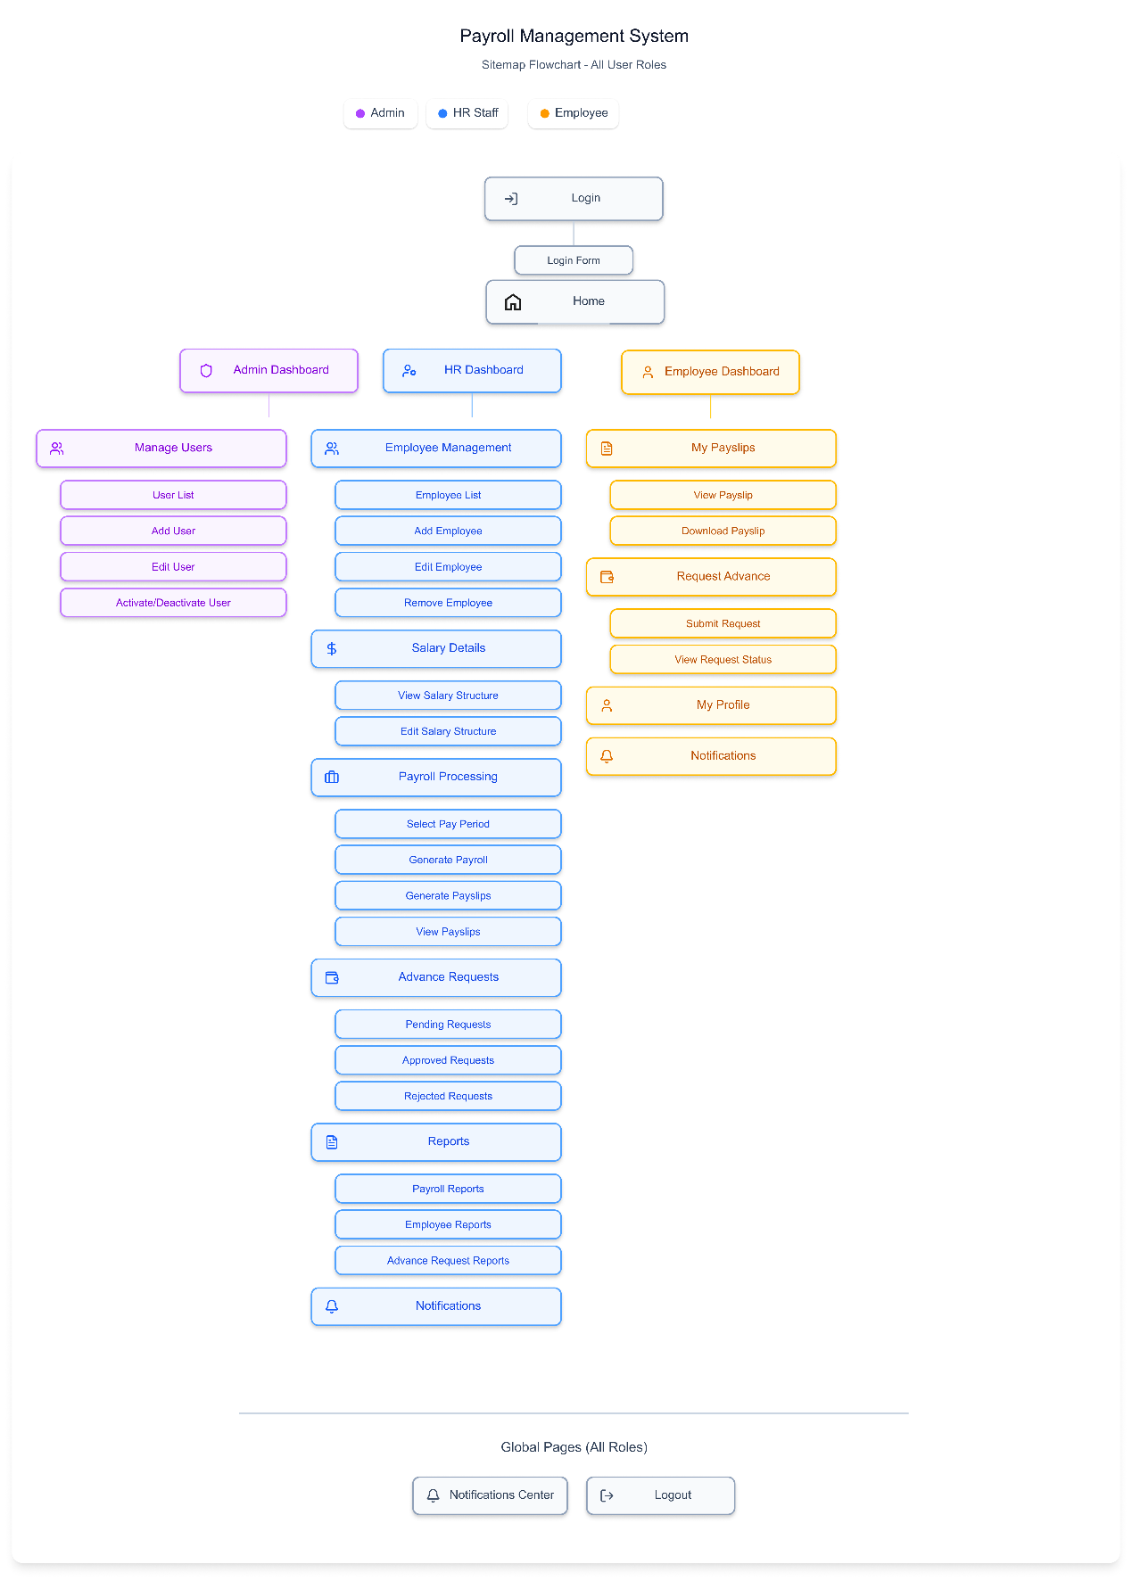

**Sitemap**

The sitemap shows all the pages and navigation of the Payroll Management System in the proper format. The tool is divided based on the user’s role which comprises **Admin, HR Staff, and Employee**, where each user can view the functions relevant only to them. The **Admin** section is focused on managing users of the system to add, edit, activate, etc. The **HR** section includes the management of employees, setting up of salaries, processing of payrolls, handling advance salary requests, and generating reports. **Employees** can check their payslips, apply for salary advances, and change their personal profiles. Anyone logged into the system can access the notifications and logout page. In summary, the sitemap shows how the features of the system are organized for easy navigation and role-based usability.

**Wireframes**

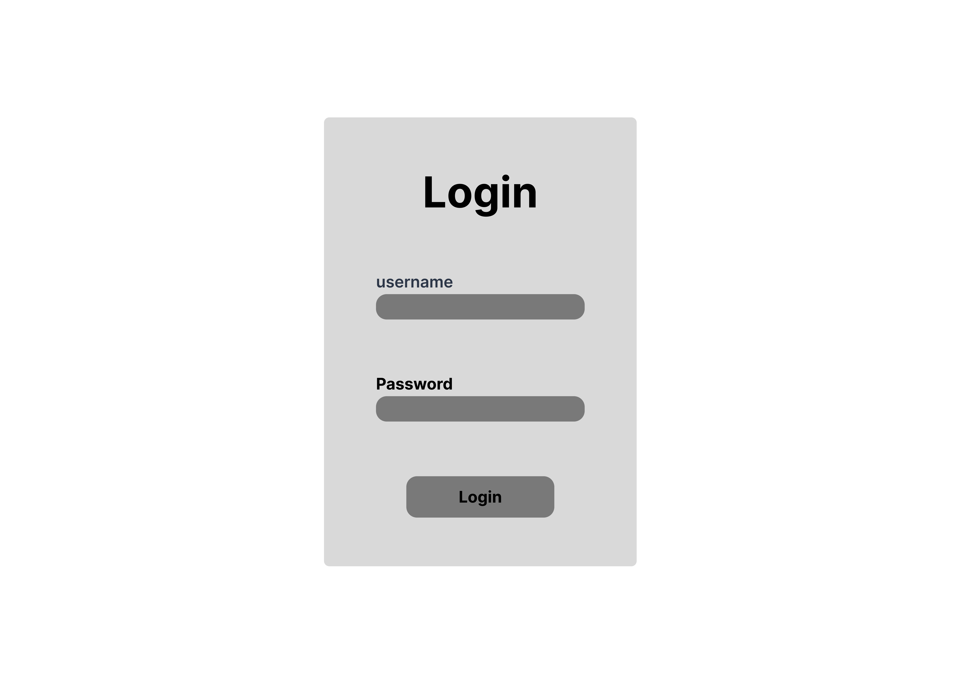

**Login Screen**

This screen provides the user with a simple and clean login form used to access the system. It contains fields for entering an username and password, along with a primary login button. Its purpose is to authenticate users before allowing them into the Employee Calculator platform. The layout is minimal to keep the focus on completing the login process quickly.

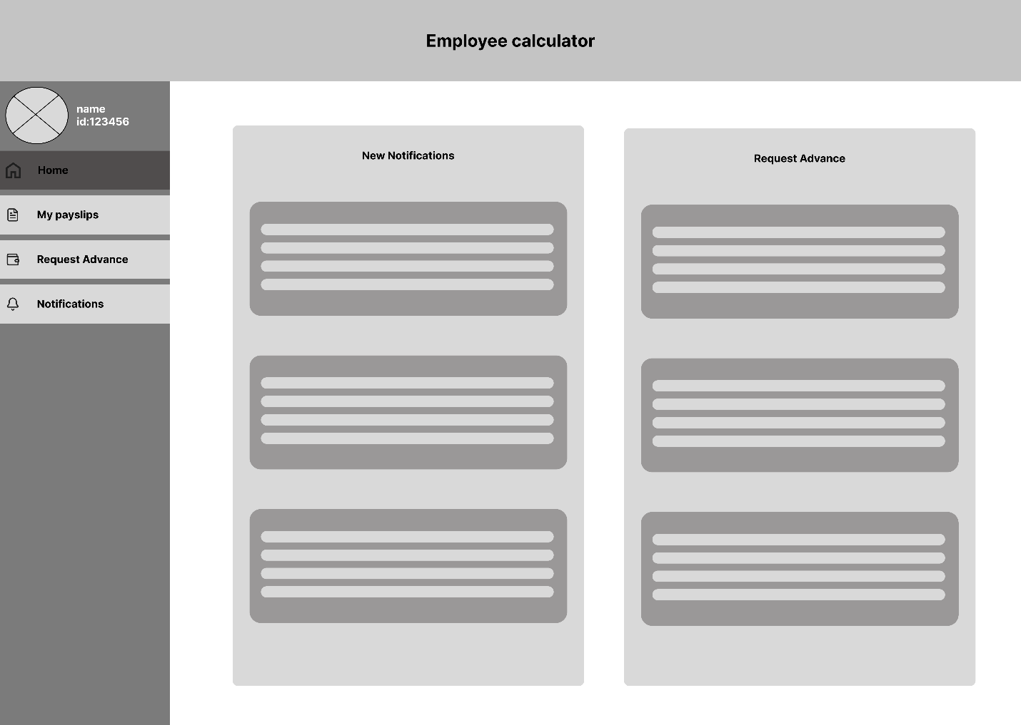

**Employee Home Dashboard**

This dashboard gives employees a quick overview of their status within the system. It displays summary cards such as total employees, pending payroll items, and current advance requests. Below that, users can see a list of recent activity, including updates related to payroll, company events, or personal actions. The layout is designed to surface important updates immediately upon login.

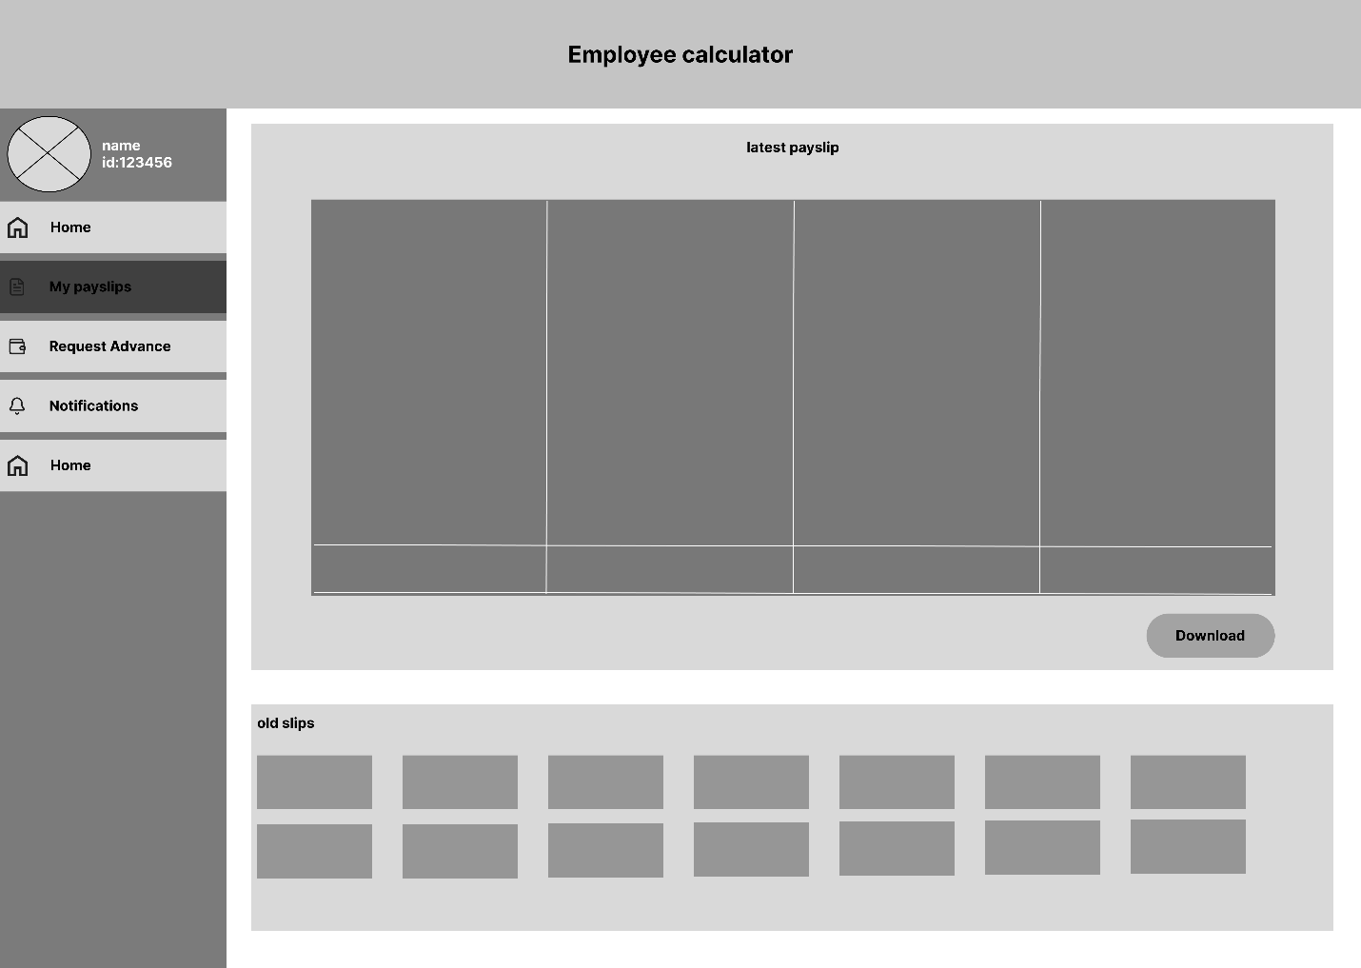

**Employee – My Payslips**

This screen shows the employee their latest payslip in a large preview area and provides the option to download it. Beneath the preview, older payslips are shown in a grid format, allowing the user to browse through their full history easily. The goal is to provide quick access to both recent and previous payslips with a simple and visual layout.

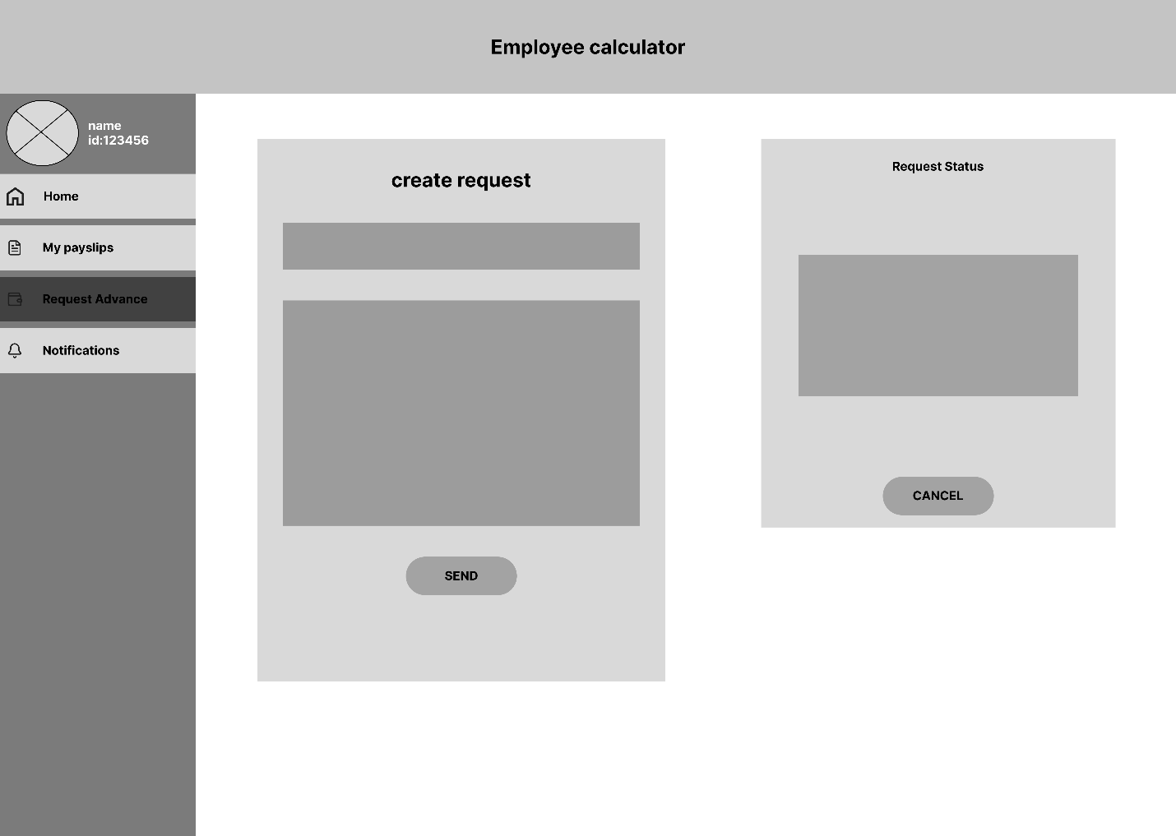

**Employee – Request Advance**

This screen allows employees to submit a salary advance request. The left side presents a form where the employee fills in the request details. On the right, a status panel displays the current state of any active or pending requests and provides the option to cancel them. This helps users manage and track their requests in one place.

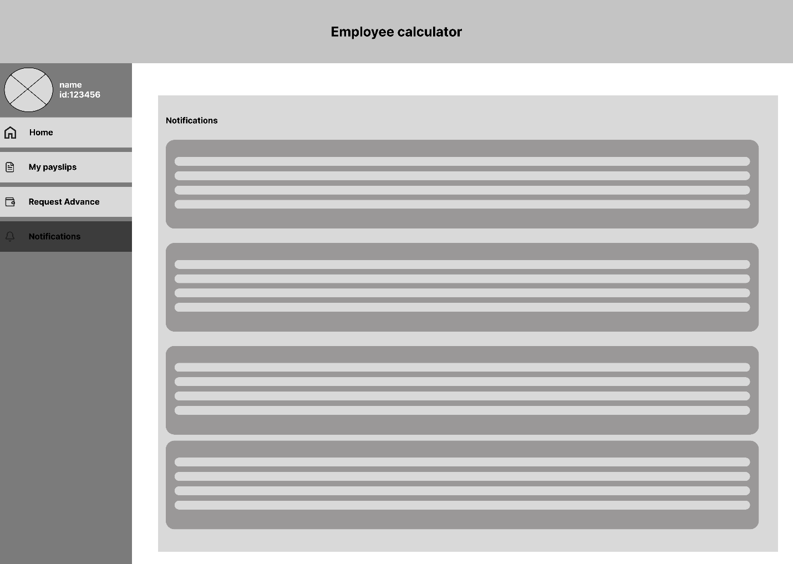

**Notifications**

This page presents a list of notifications relevant to the employee. Each notification is displayed as a card with a short description. The layout is designed to be clean and easy to scroll through, ensuring that employees can quickly review any actions or updates that require attention.

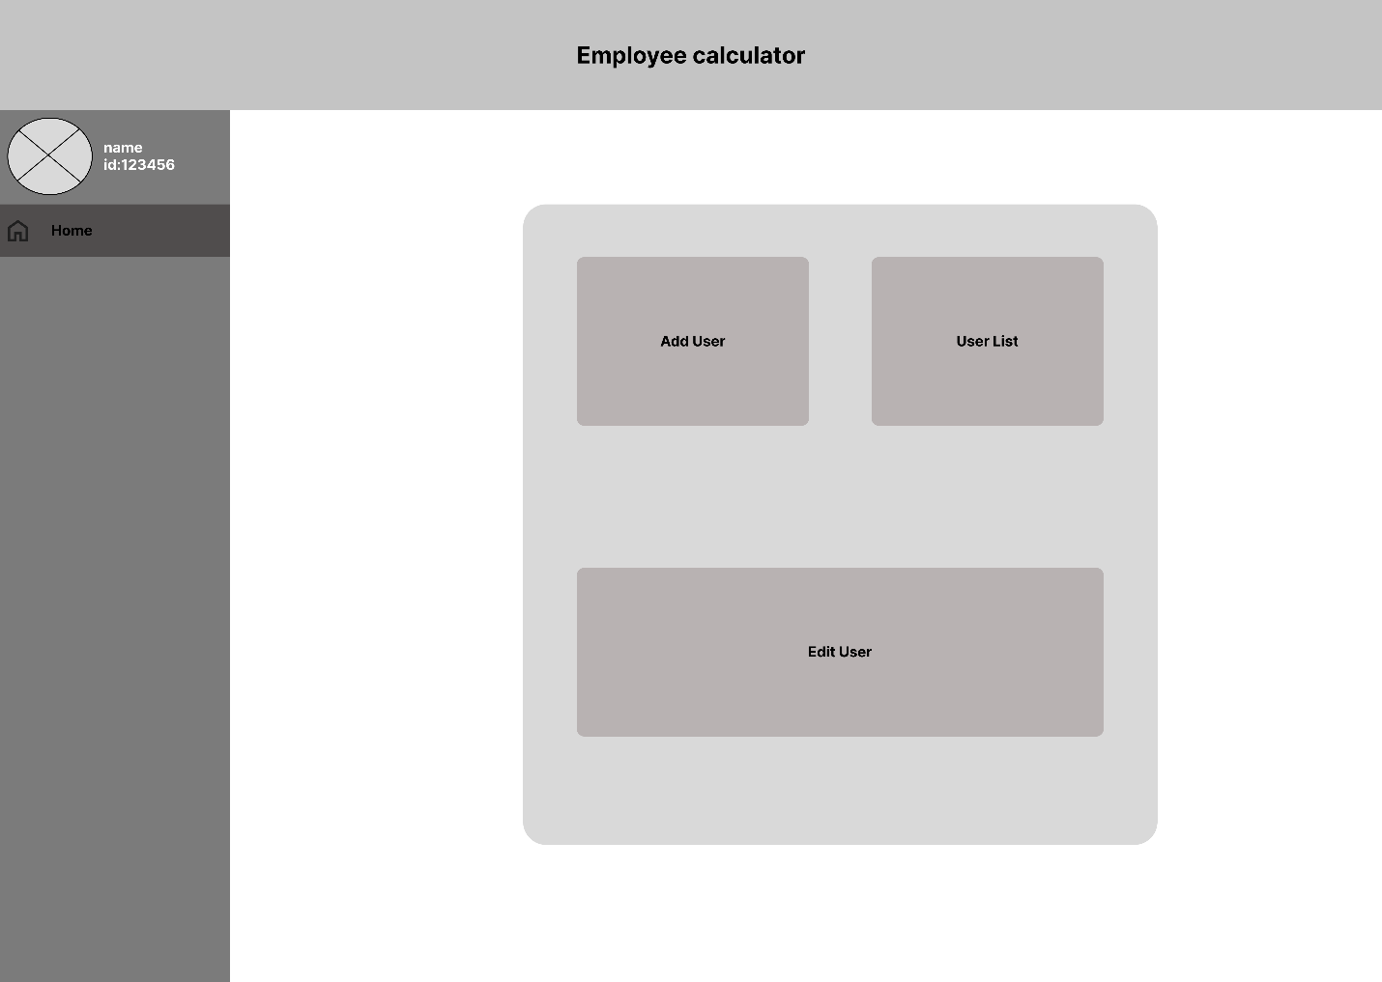

**Admin Home Page**

This screen serves as the main dashboard for system administrators. It provides three main management options: **Add User**, **User List**, and **Edit User**. Each option is presented as a large, clear selection card, making it easy for administrators to quickly navigate to the desired action. The layout is simple and clean, focusing on usability and quick access.

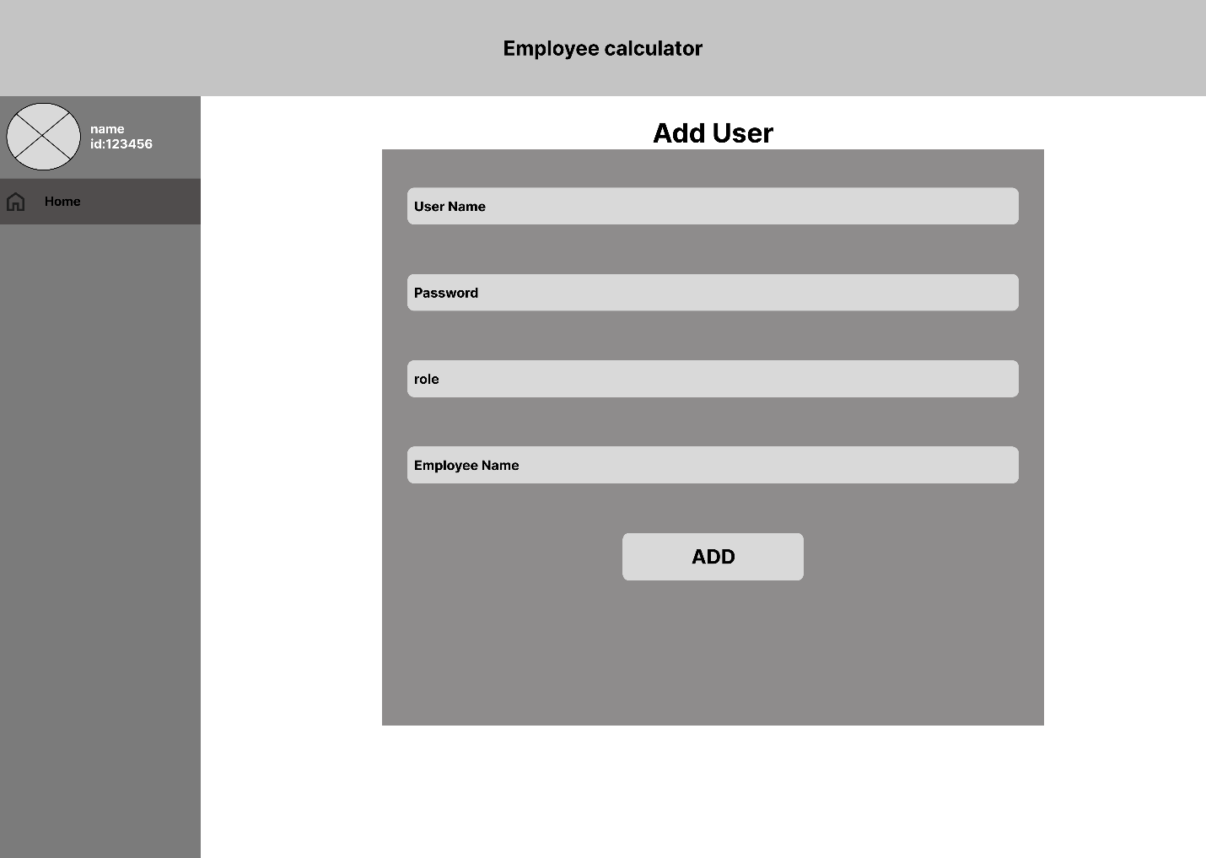

**Admin – Add User**

This page allows administrators to create a new system user. It includes form fields for entering a **username**, **password**, **role**, and the **employee name** the account is linked to. The design is straightforward, ensuring admins can easily fill in the required details and submit using the prominent **ADD** button at the bottom.

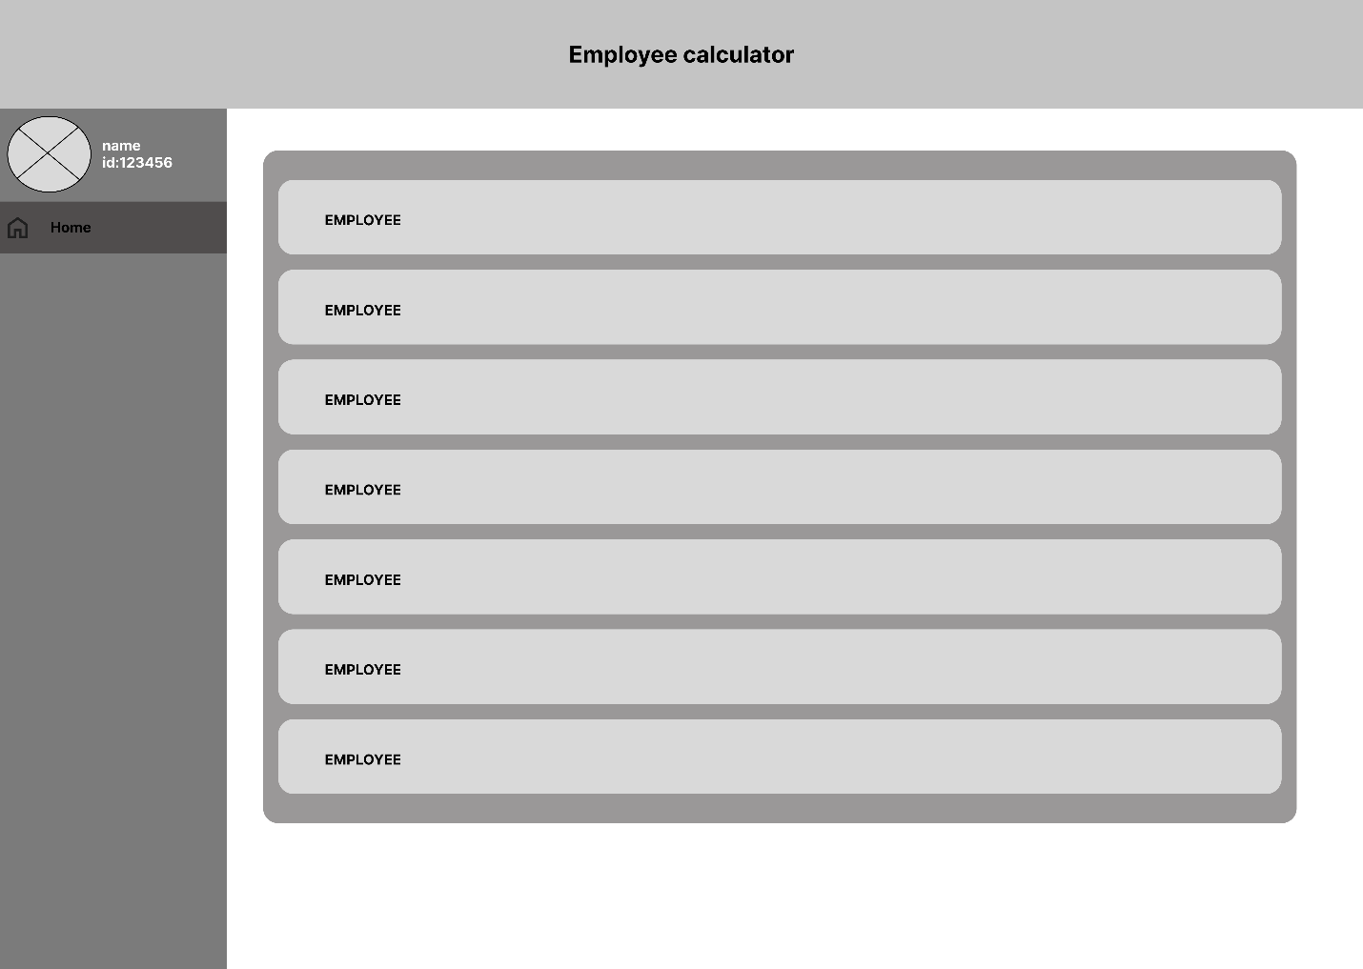

**Admin – User List**

This screen displays a scrollable list of all registered users. Each user appears as a separate row labeled **EMPLOYEE**, representing a placeholder for their actual information. The minimalist layout focuses on showing the full list in a structured and organized way, allowing admins to quickly browse through existing accounts.

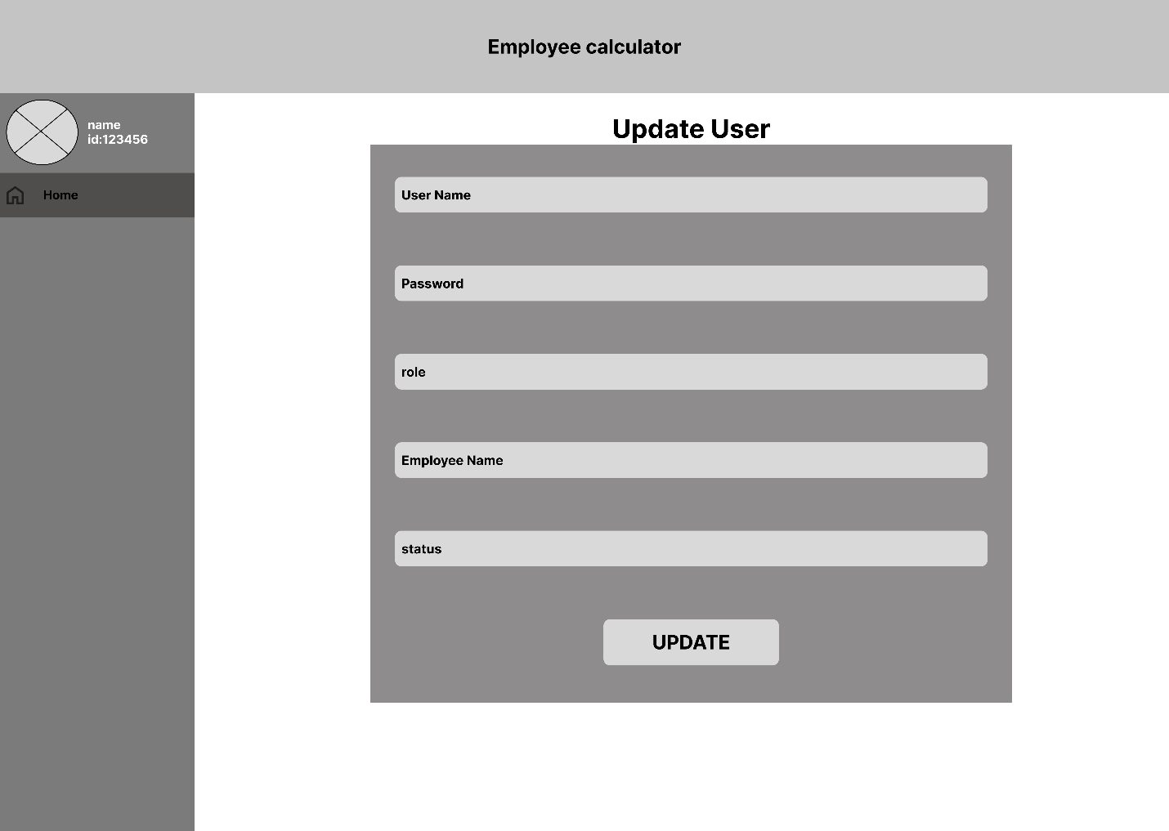

**Admin – Update User**

This page allows administrators to modify an existing user’s details. The form includes editable fields such as **username**, **password**, **role**, **employee name**, and **status**. It is designed to mirror the “Add User” layout for consistency, with an **UPDATE** button clearly displayed at the bottom for submitting changes.

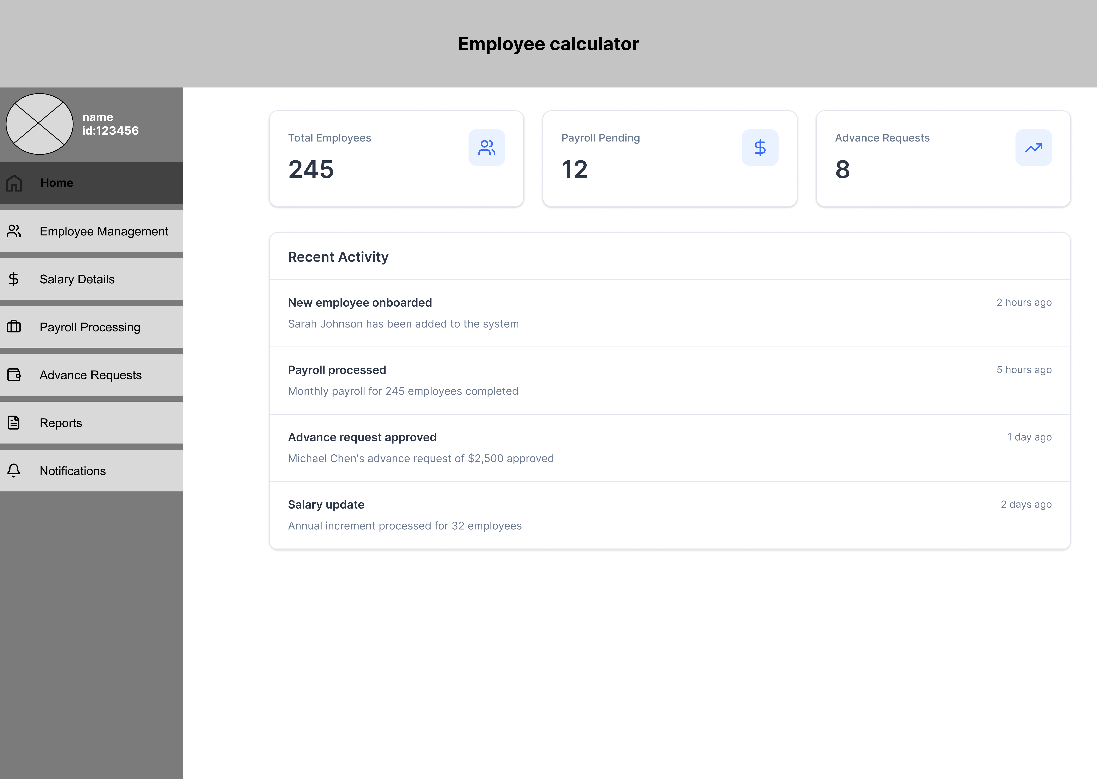

**HR Home Page**

This is the main dashboard for HR users. It highlights key workforce statistics such as total employees, pending payroll items, and advance requests. Recent activity entries like onboarding, payroll processing, and approvals are displayed in a clean list.

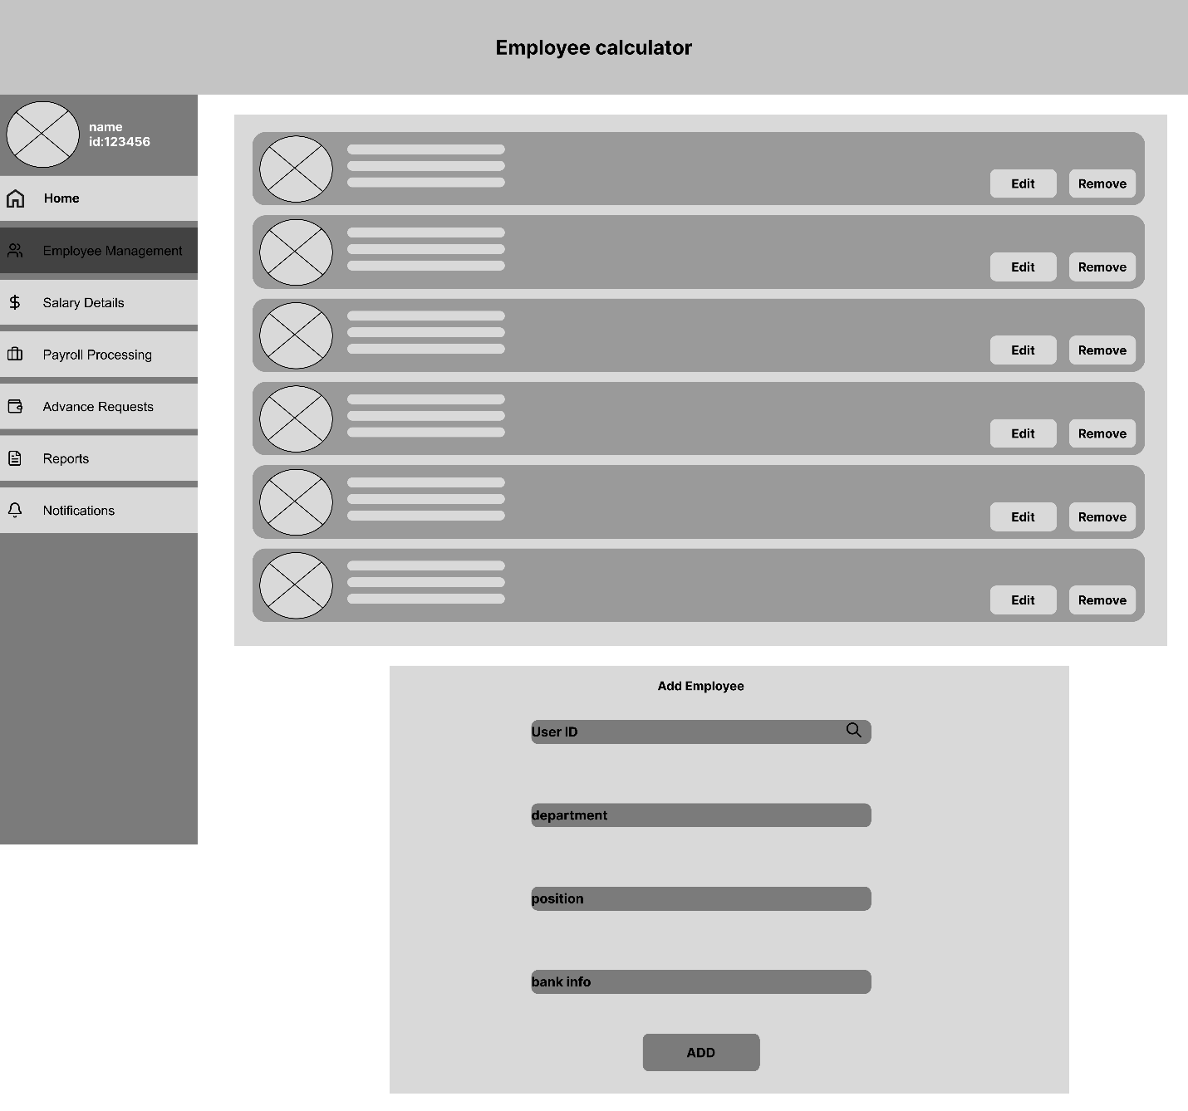

**Employee Management**

This page lists all employees in the system, each displayed with profile placeholders, basic details, and two action buttons: **Edit** and **Remove**. At the bottom, an **Add Employee** form allows HR to register a new employee by selecting a **User ID** and filling in department, position, and bank information. Pagination is included for navigating through large employee lists.

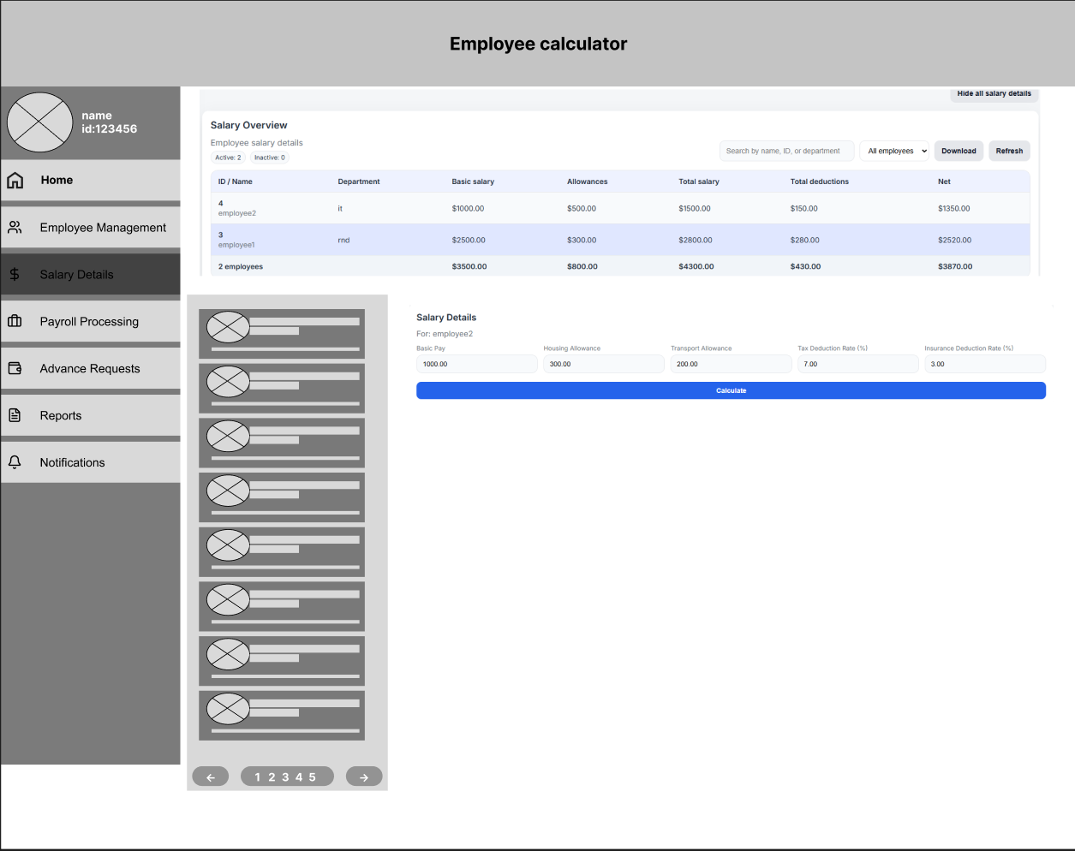

**The Salary Details**

The Salary Details page allows HR staff to view, calculate, and manage employee salary information in a single interface. It includes a salary overview table for all employees, quick employee selection on the left, and an editable salary calculation section on the right for allowances, deductions, and net salary computation.

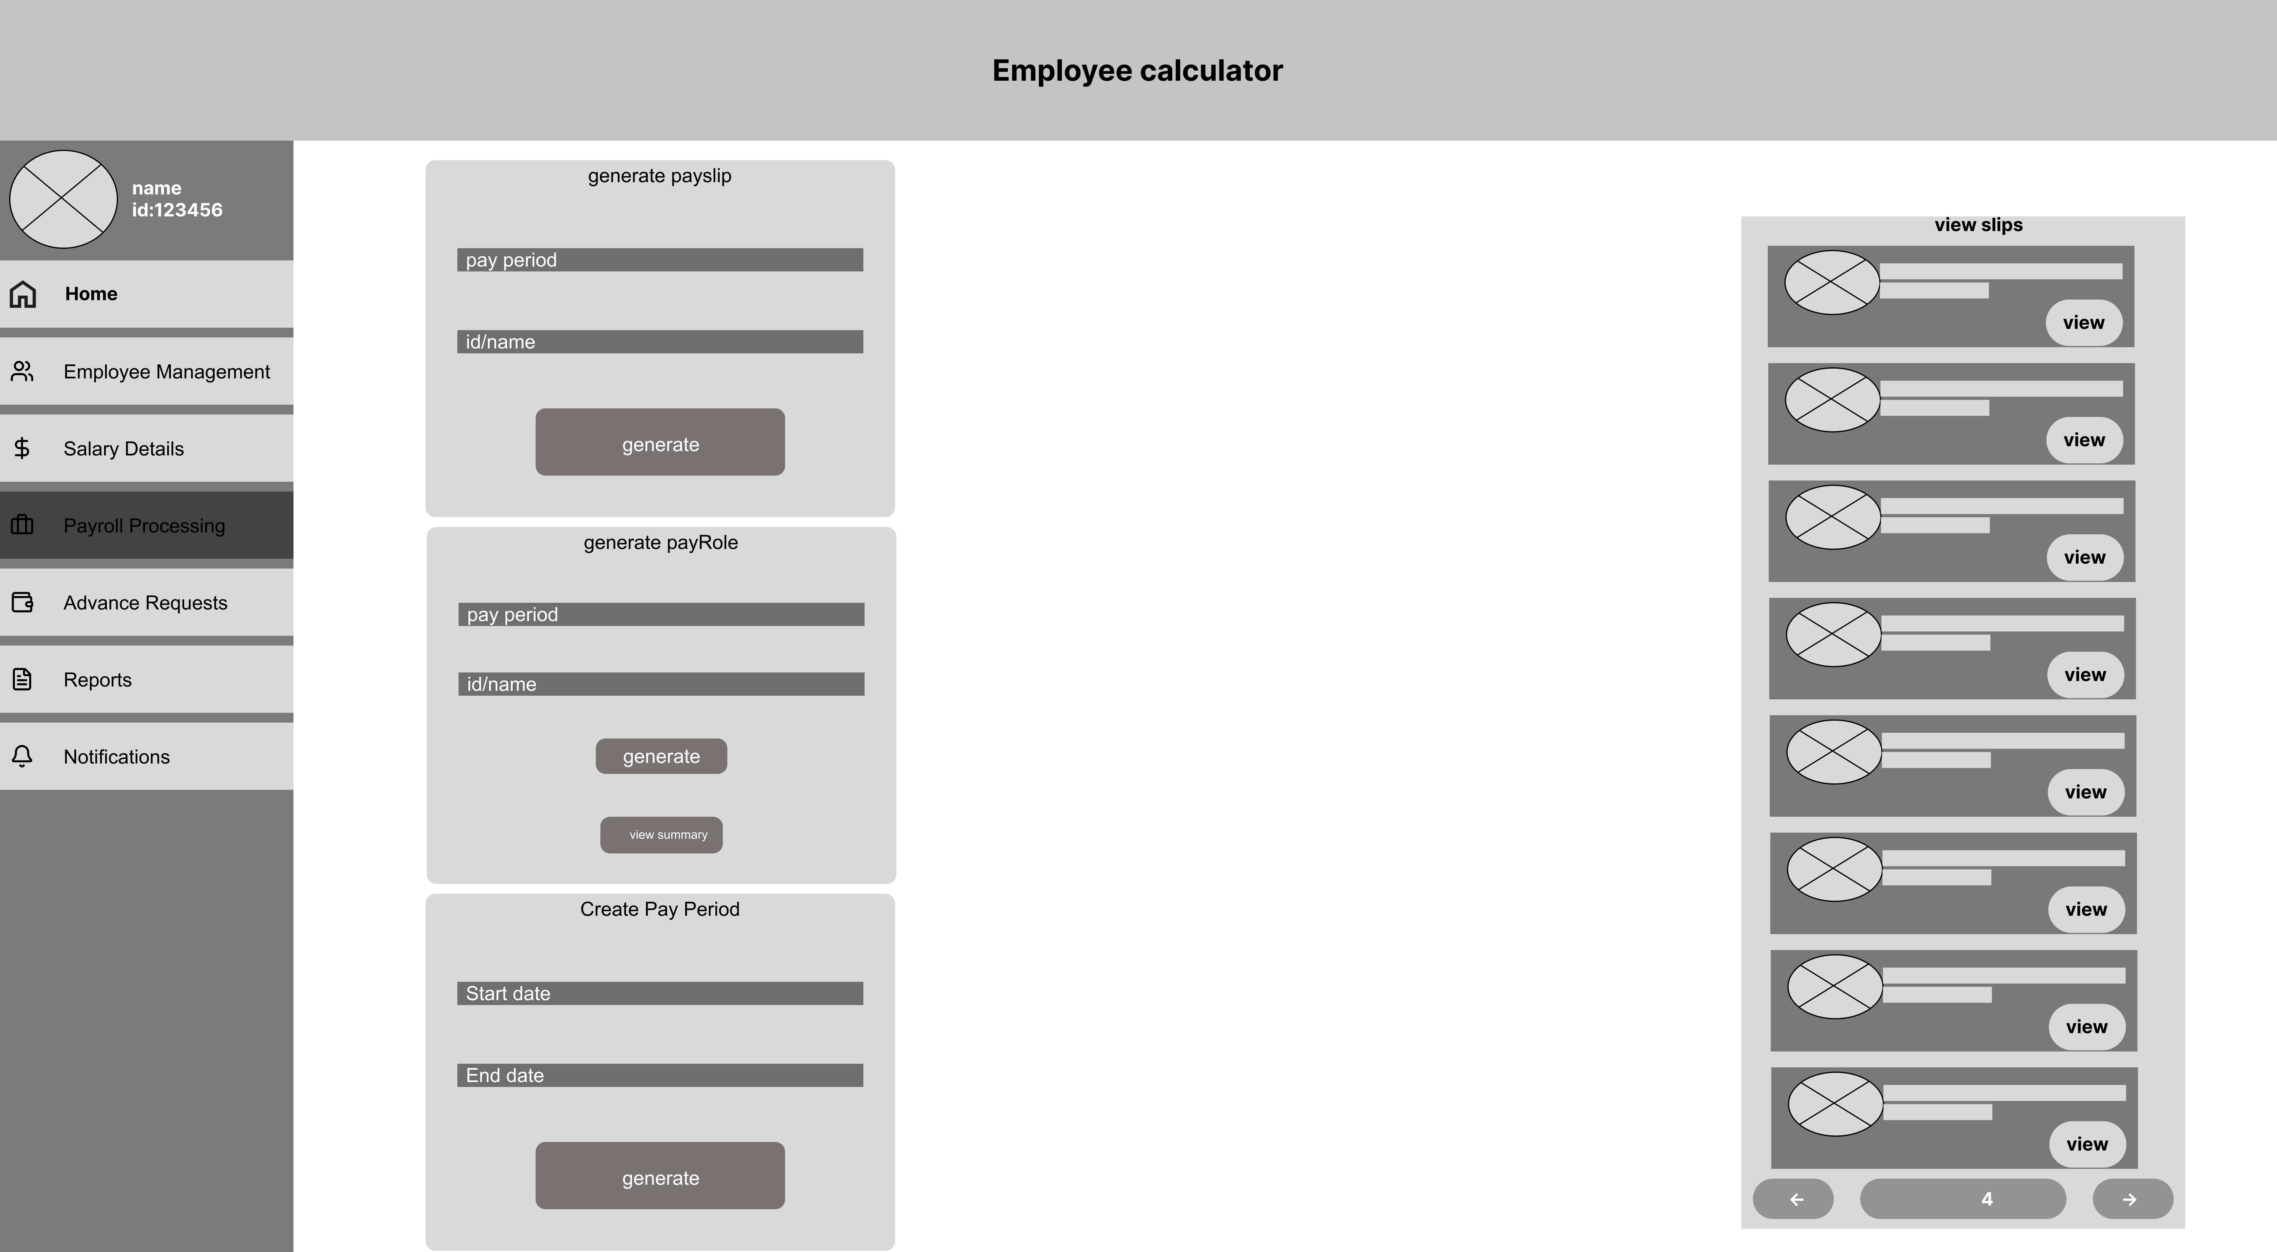

**Payroll Processing 1**

This page lets HR generate both **payslips** and **payroll reports**.

* Two small forms allow HR to select a **pay period** and an **employee** (or ID) to generate individual slips or payroll batches.
* On the right, HR can browse past generated slips using a clean, scrollable list with **View** buttons.
* Pay period time generator

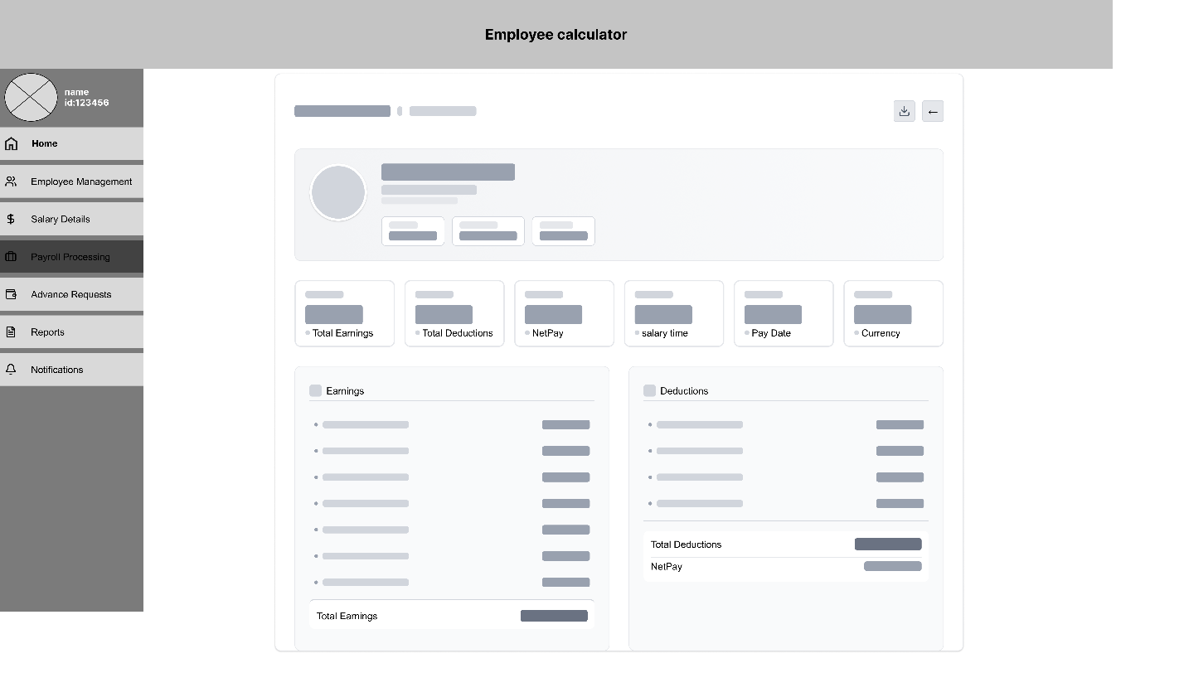

**Payroll Processing 2**

This extended version of the payroll page provides a full table of employees with salary components: **basic pay**, **insurance**, **total salary**, **additions**, and **deductions**.  
A **side panel** shows a payroll summary and allows HR to **approve** or **reject** the payroll batch. This layout supports the full payroll cycle—from calculation to managerial approval.

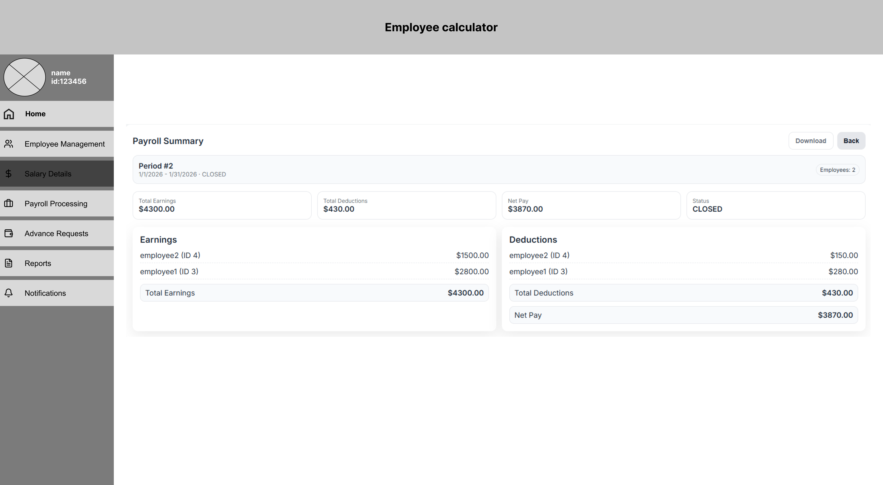

summary payroll

give a summary for all the employees in the company

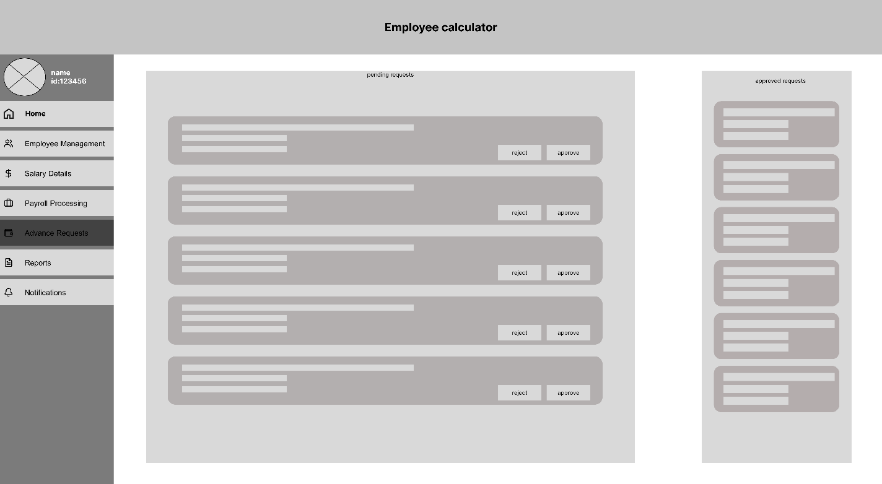

**Advance Requests**

This page helps HR monitor and process employee advance payment requests.

* The left panel shows **pending requests**, each with Reject/Approve buttons.
* The right panel lists **approved requests**, allowing HR to track previously handled cases.  
  This split design helps HR work efficiently while keeping visibility over the approval pipeline.

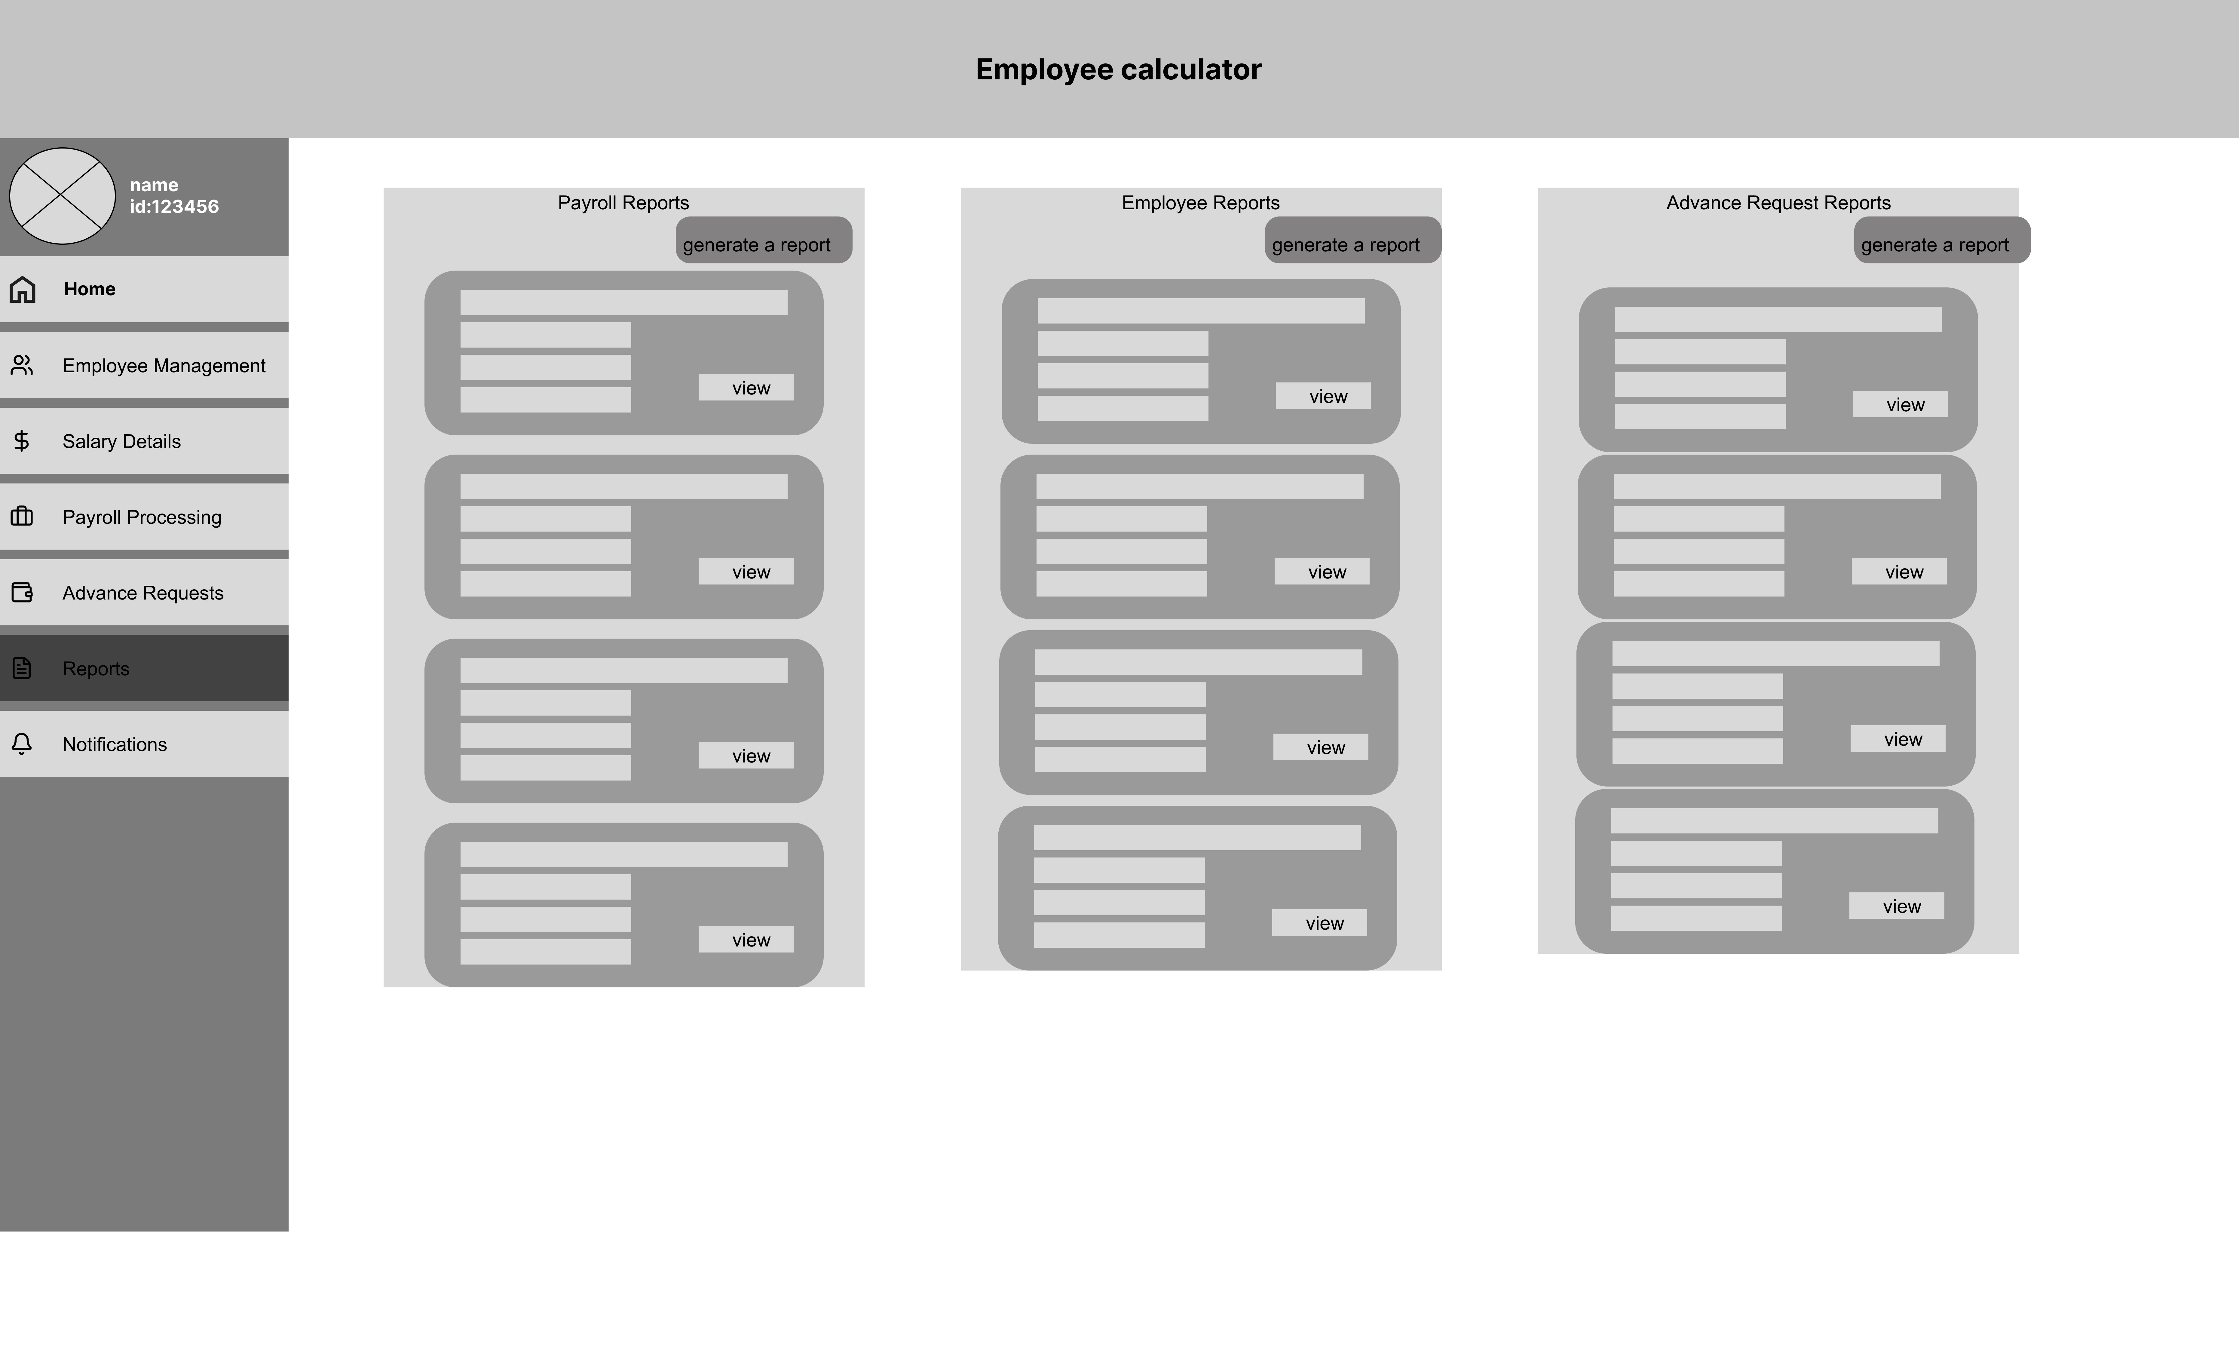

**Reports Overview**

This page groups all HR-related report categories into three groups:

* **Payroll Reports**
* **Employee Reports**
* **Advance Request Reports**  
  Each category displays multiple report items that HR can open using a **View** button. The goal is to make reports easy to find and access quickly.

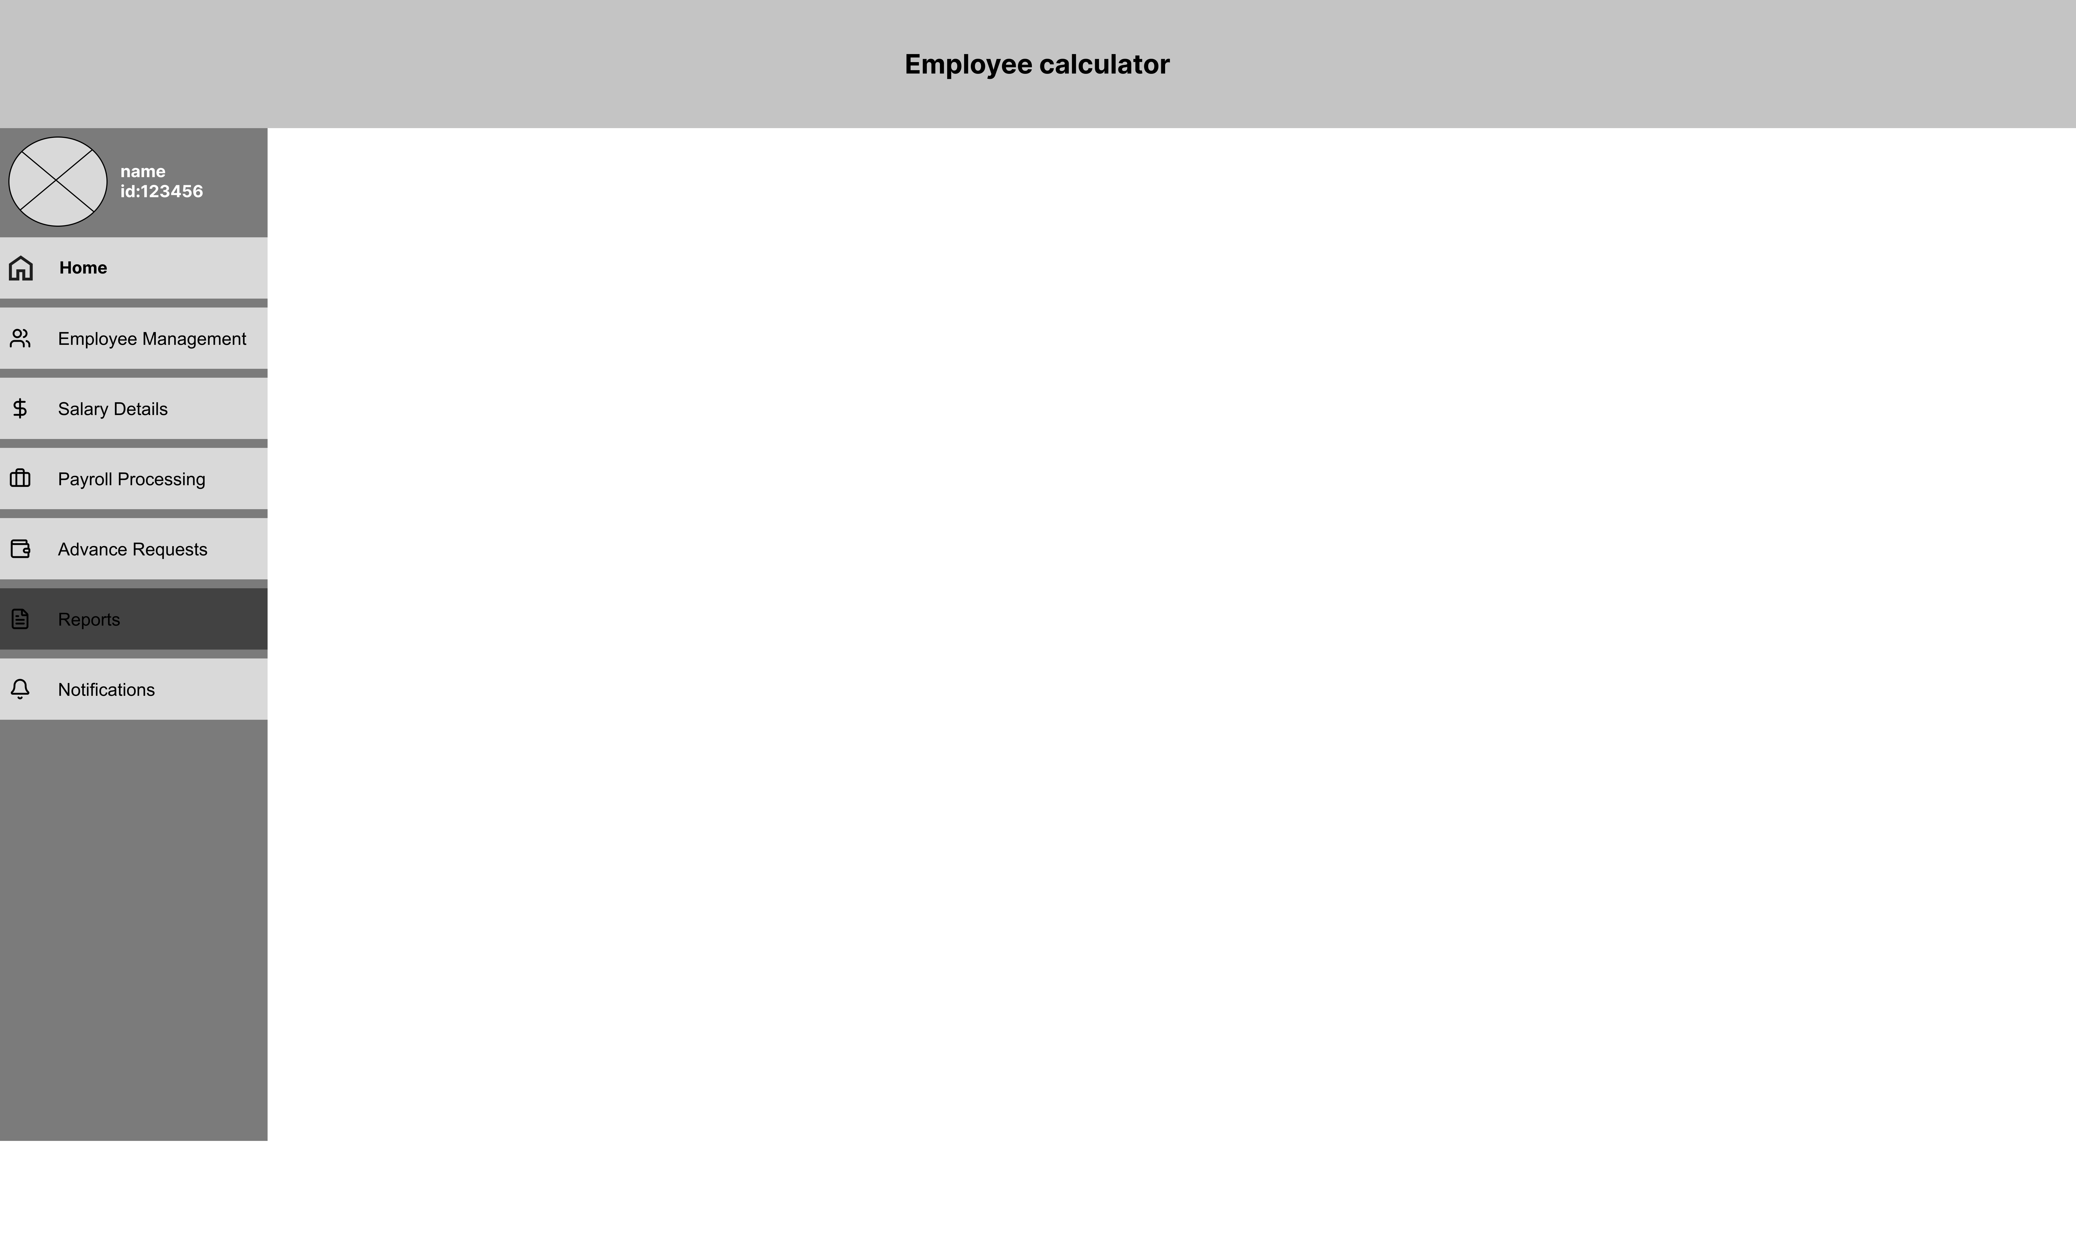

Report generation

This page help the HR creating customized reports



**HR Reports – Detailed Dashboard**

This is the detailed report dashboard page. It includes:

* Quick statistic cards showing summarized data  
  This visual layout helps HR analyze workforce and payroll data with clarity and flexibility.

## **Mockups**

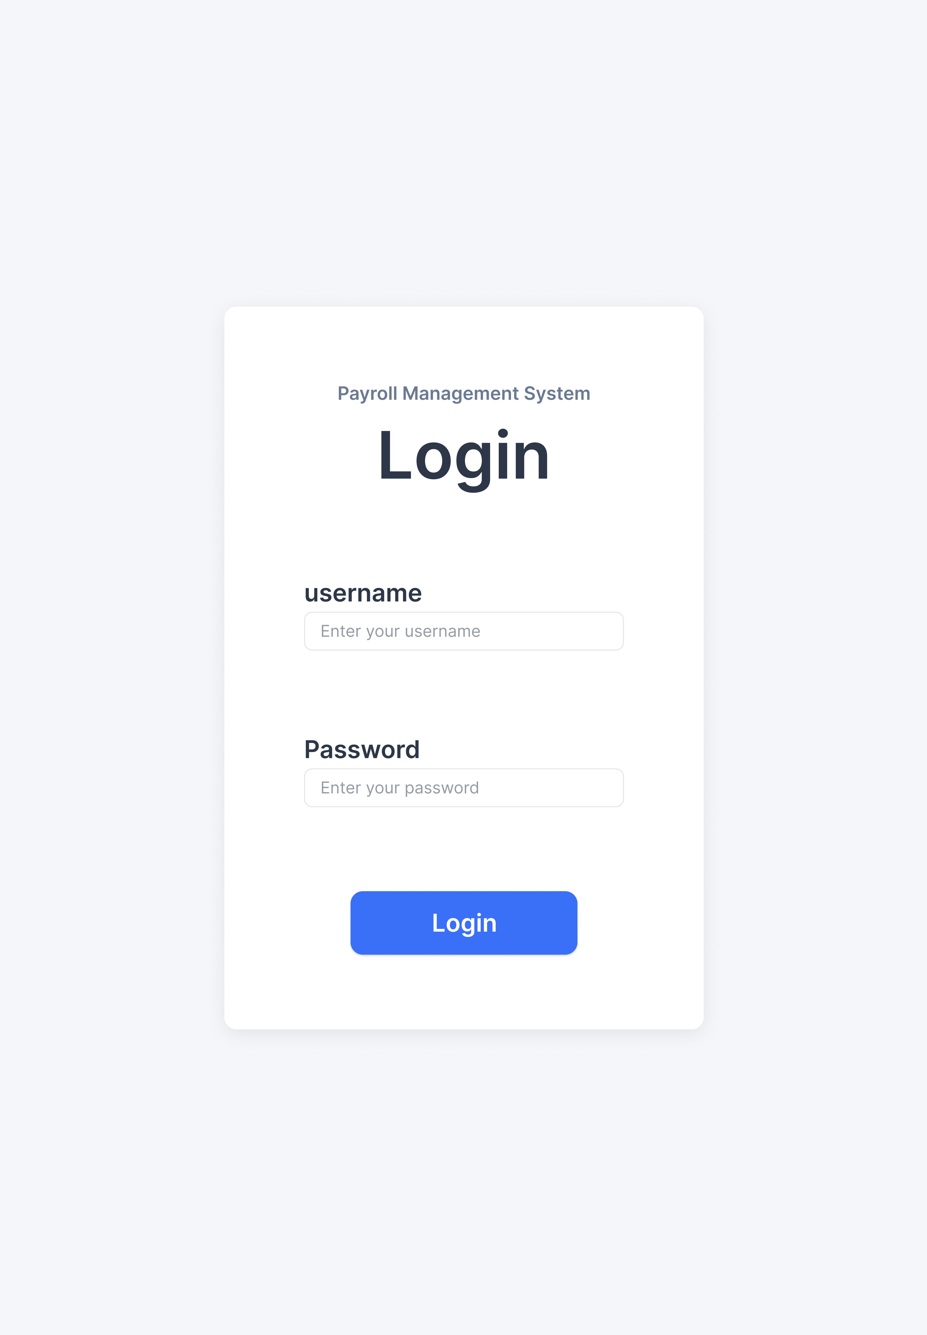

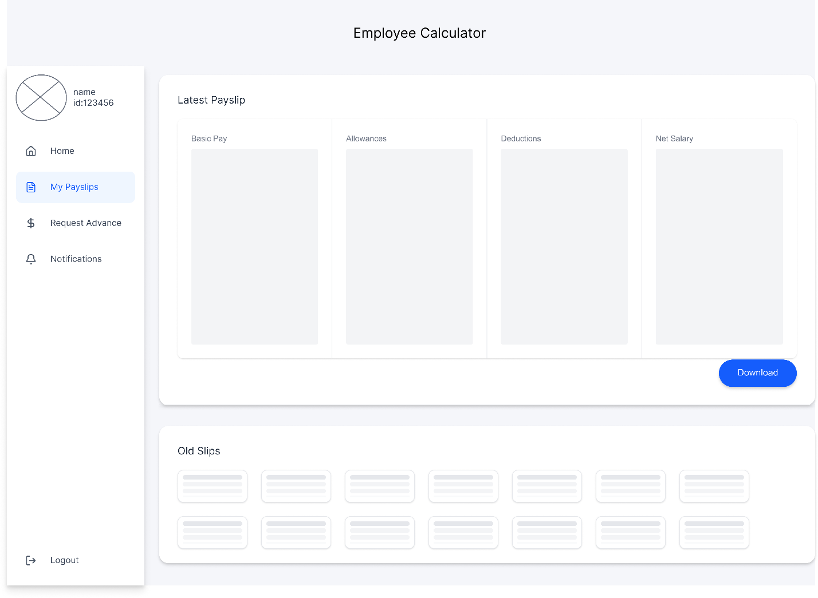

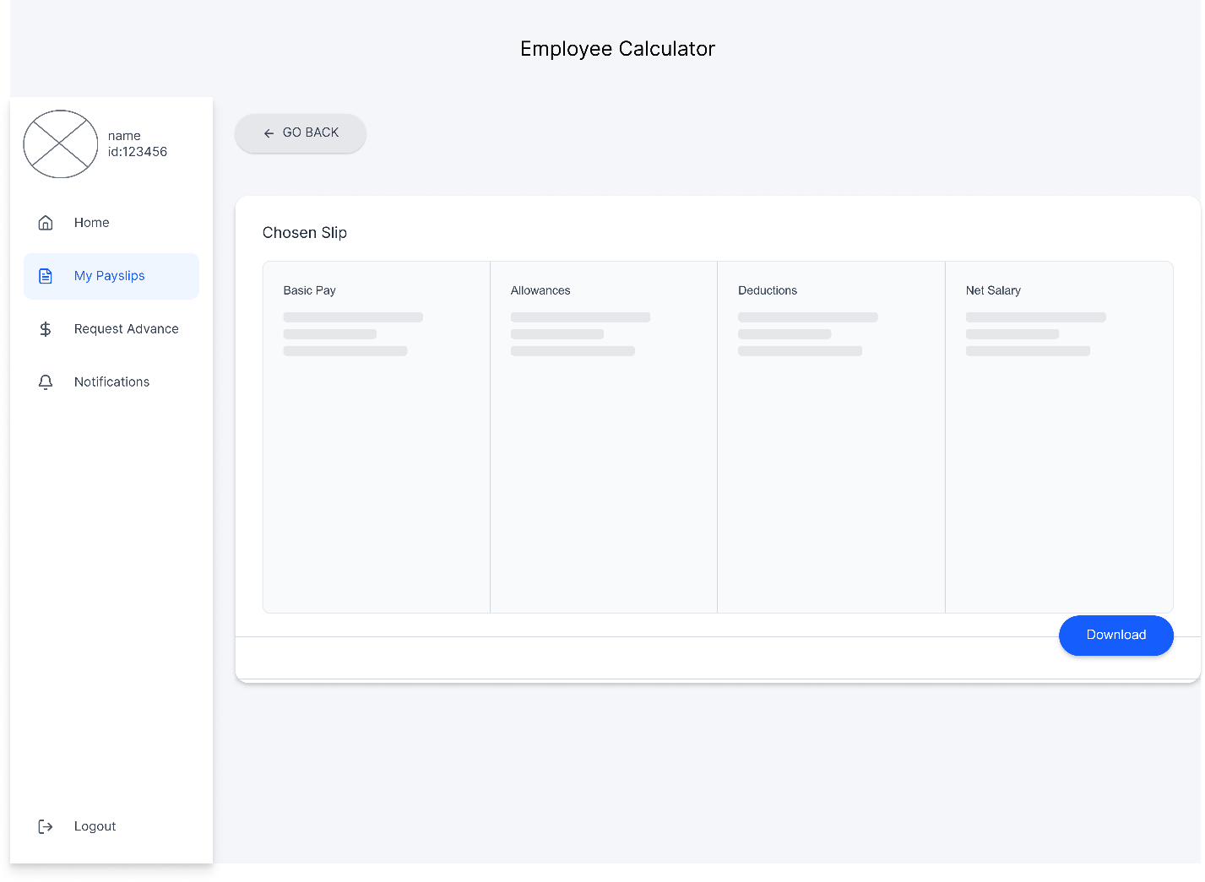

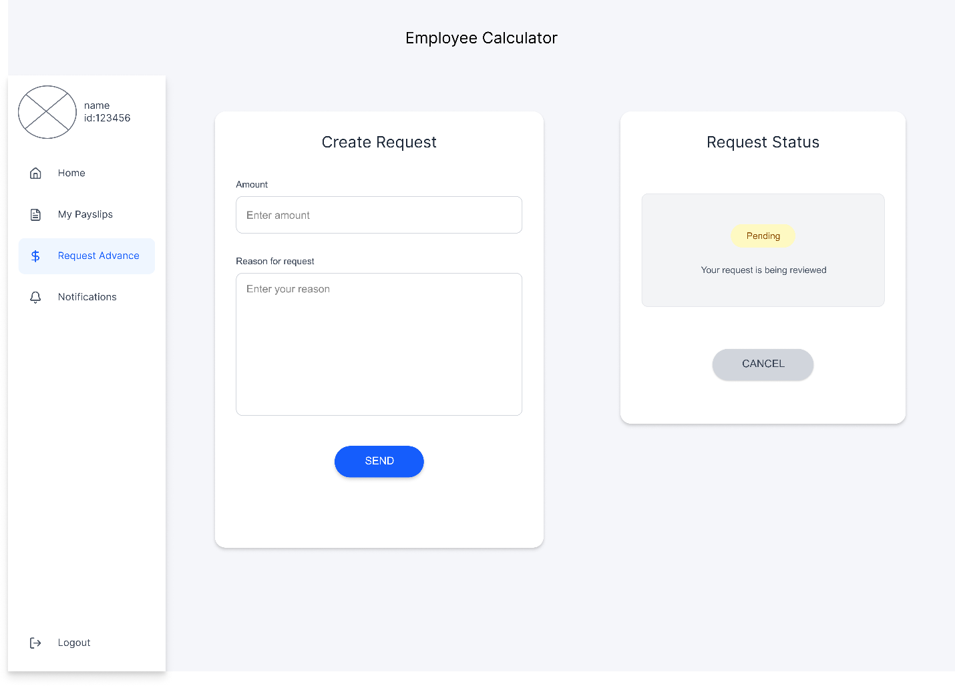

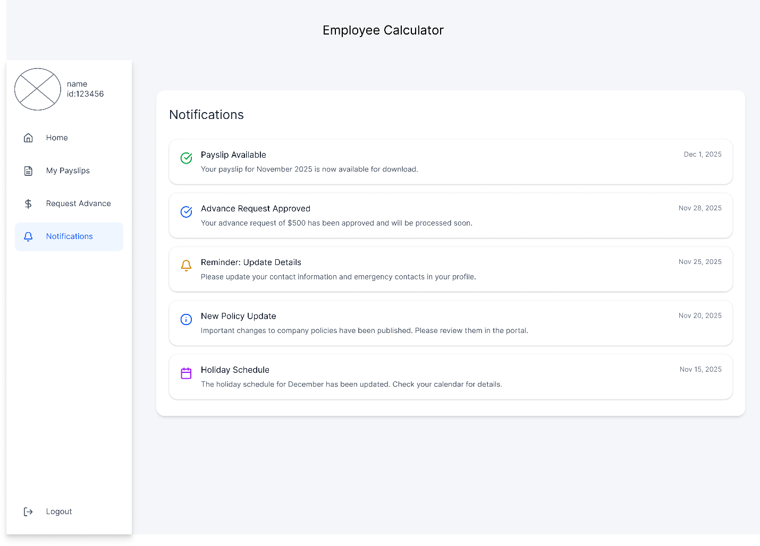

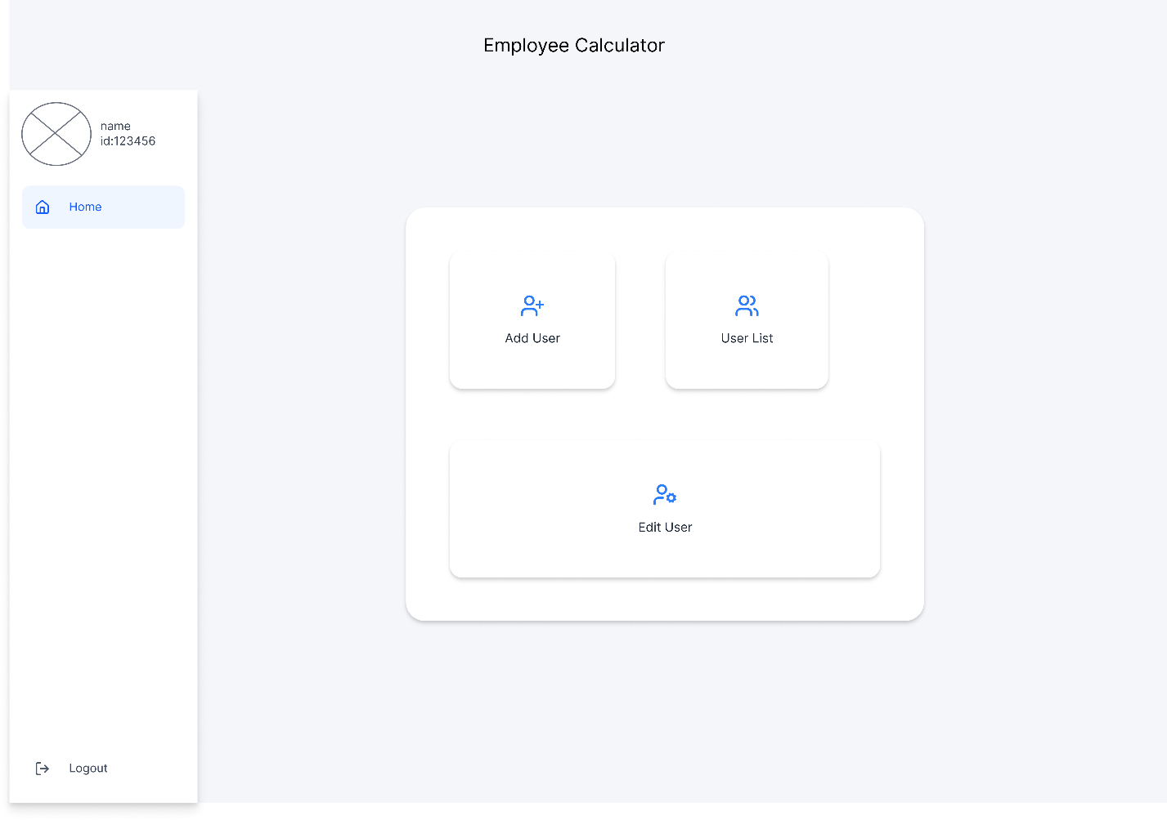

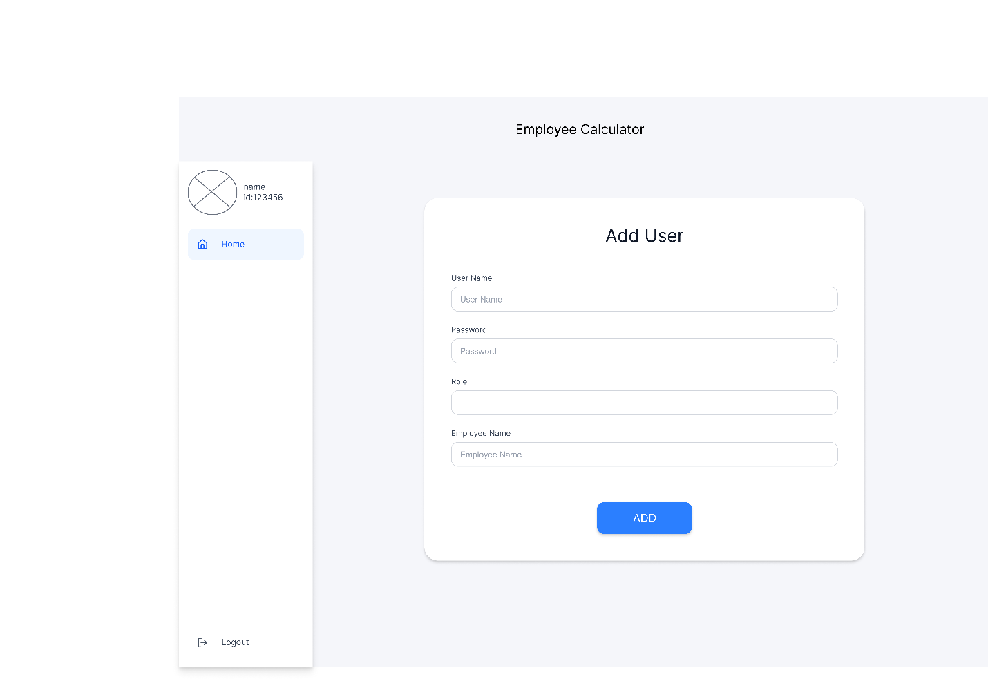

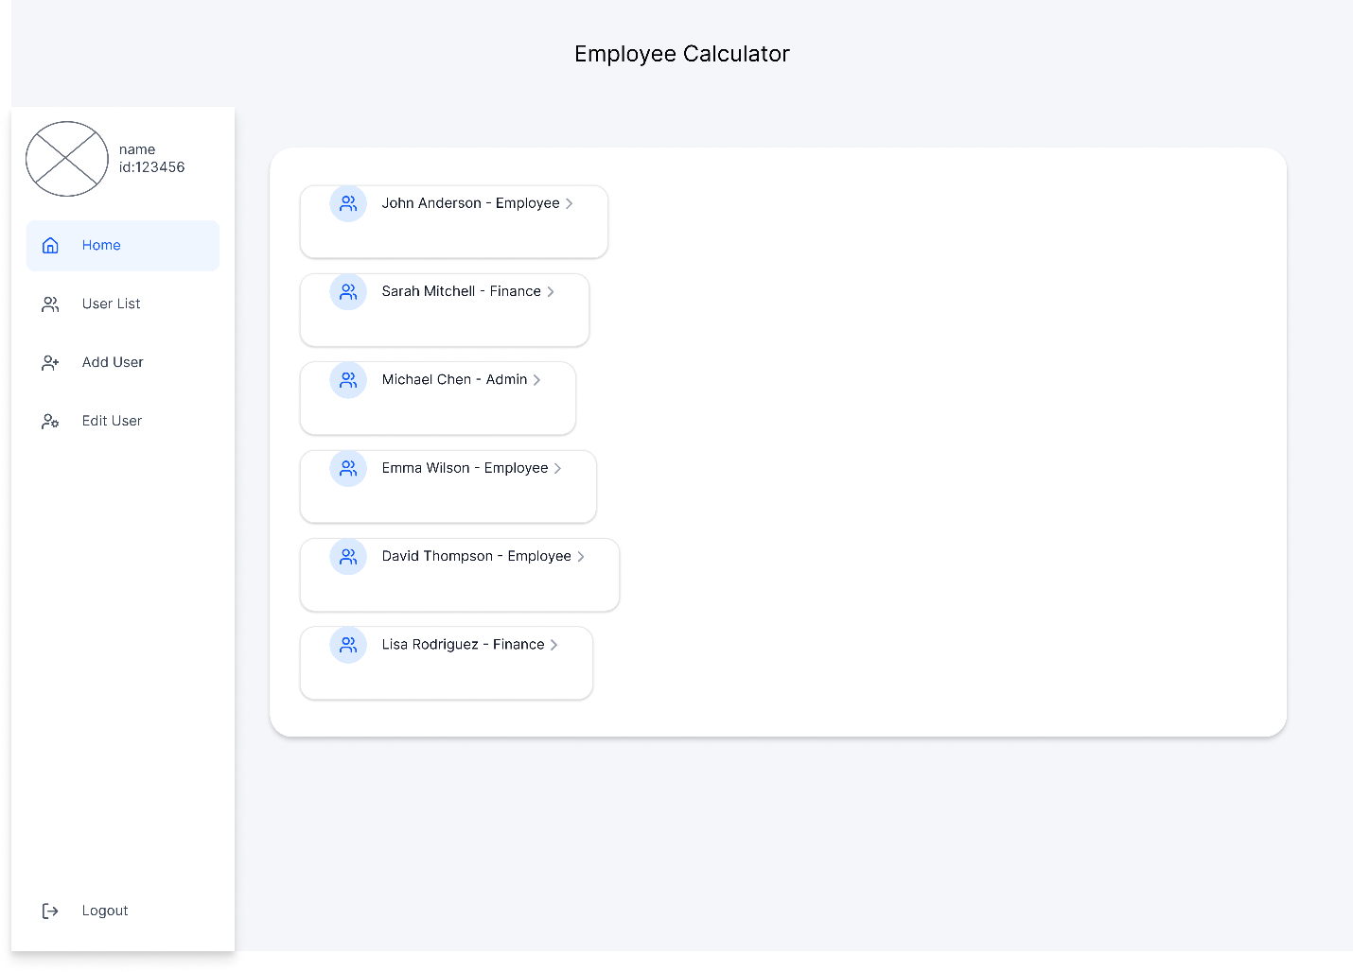

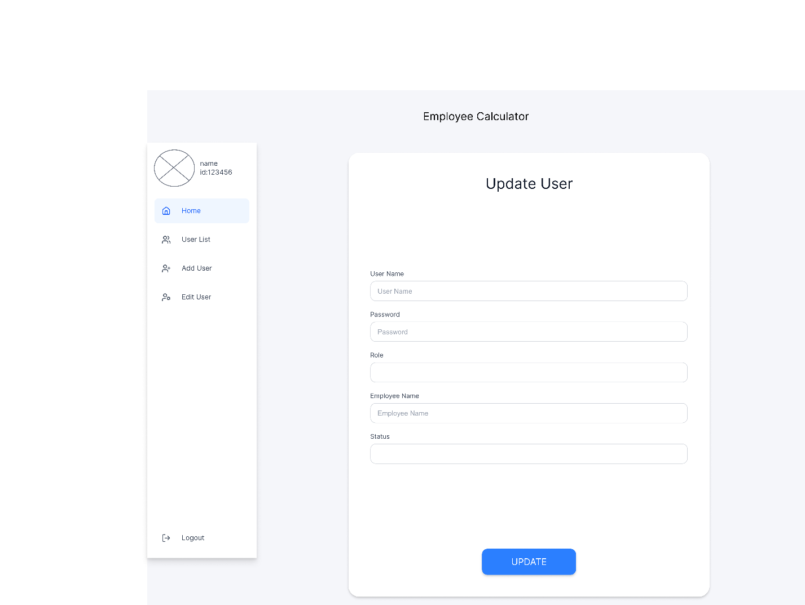

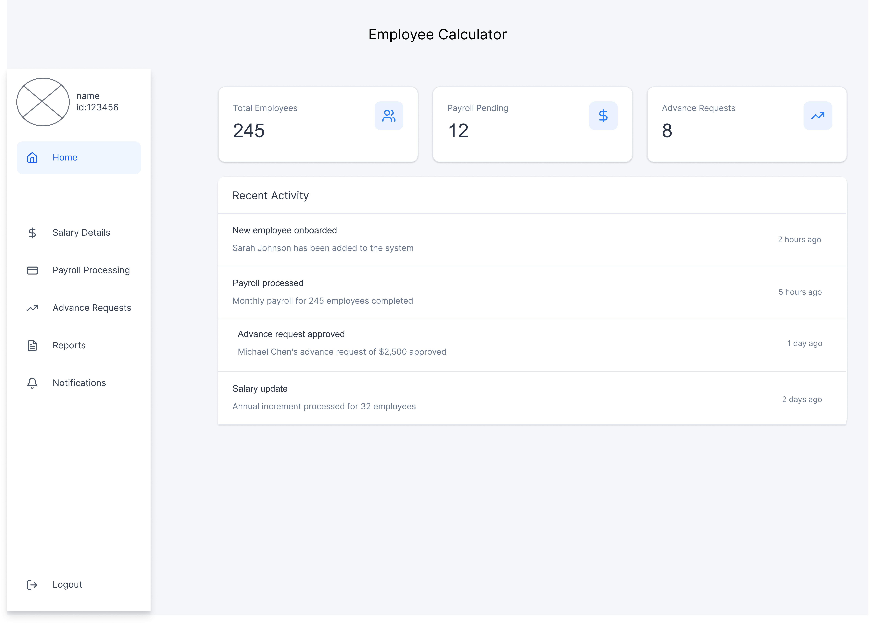

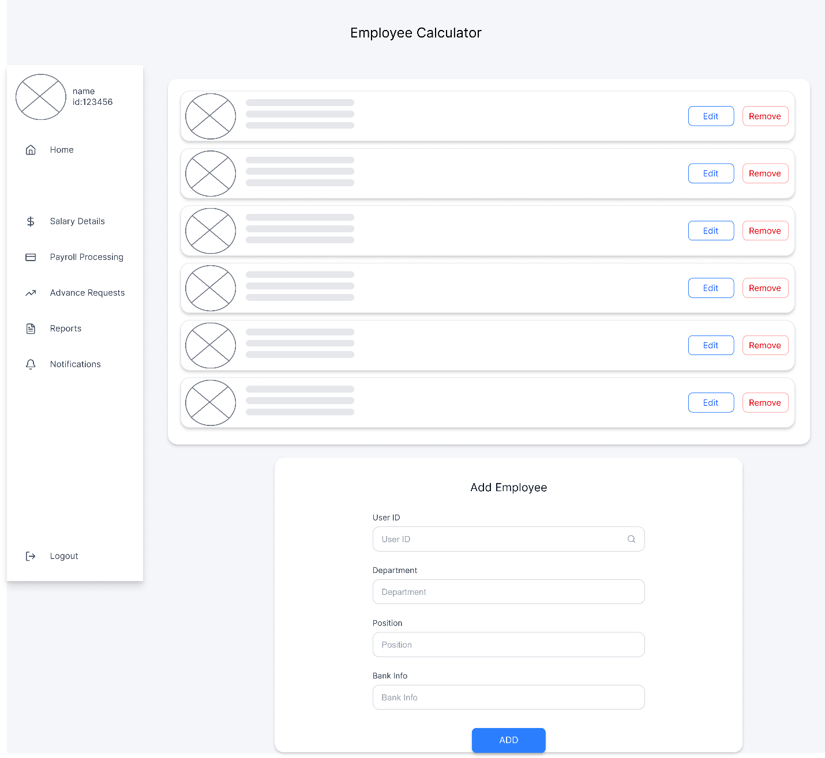

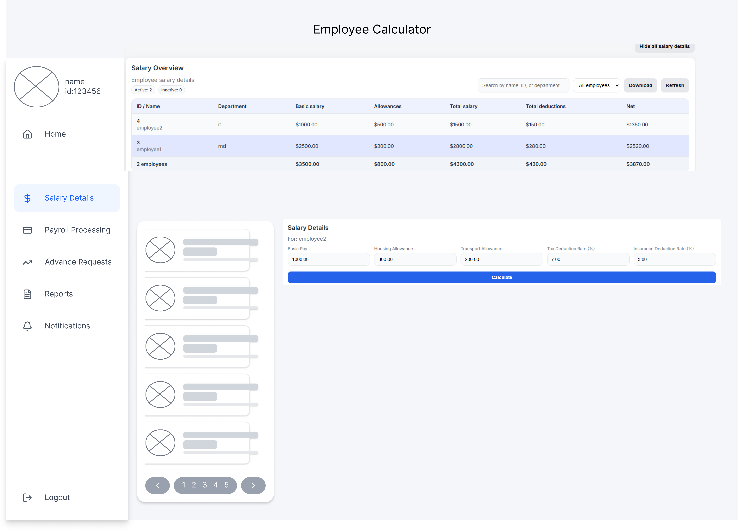



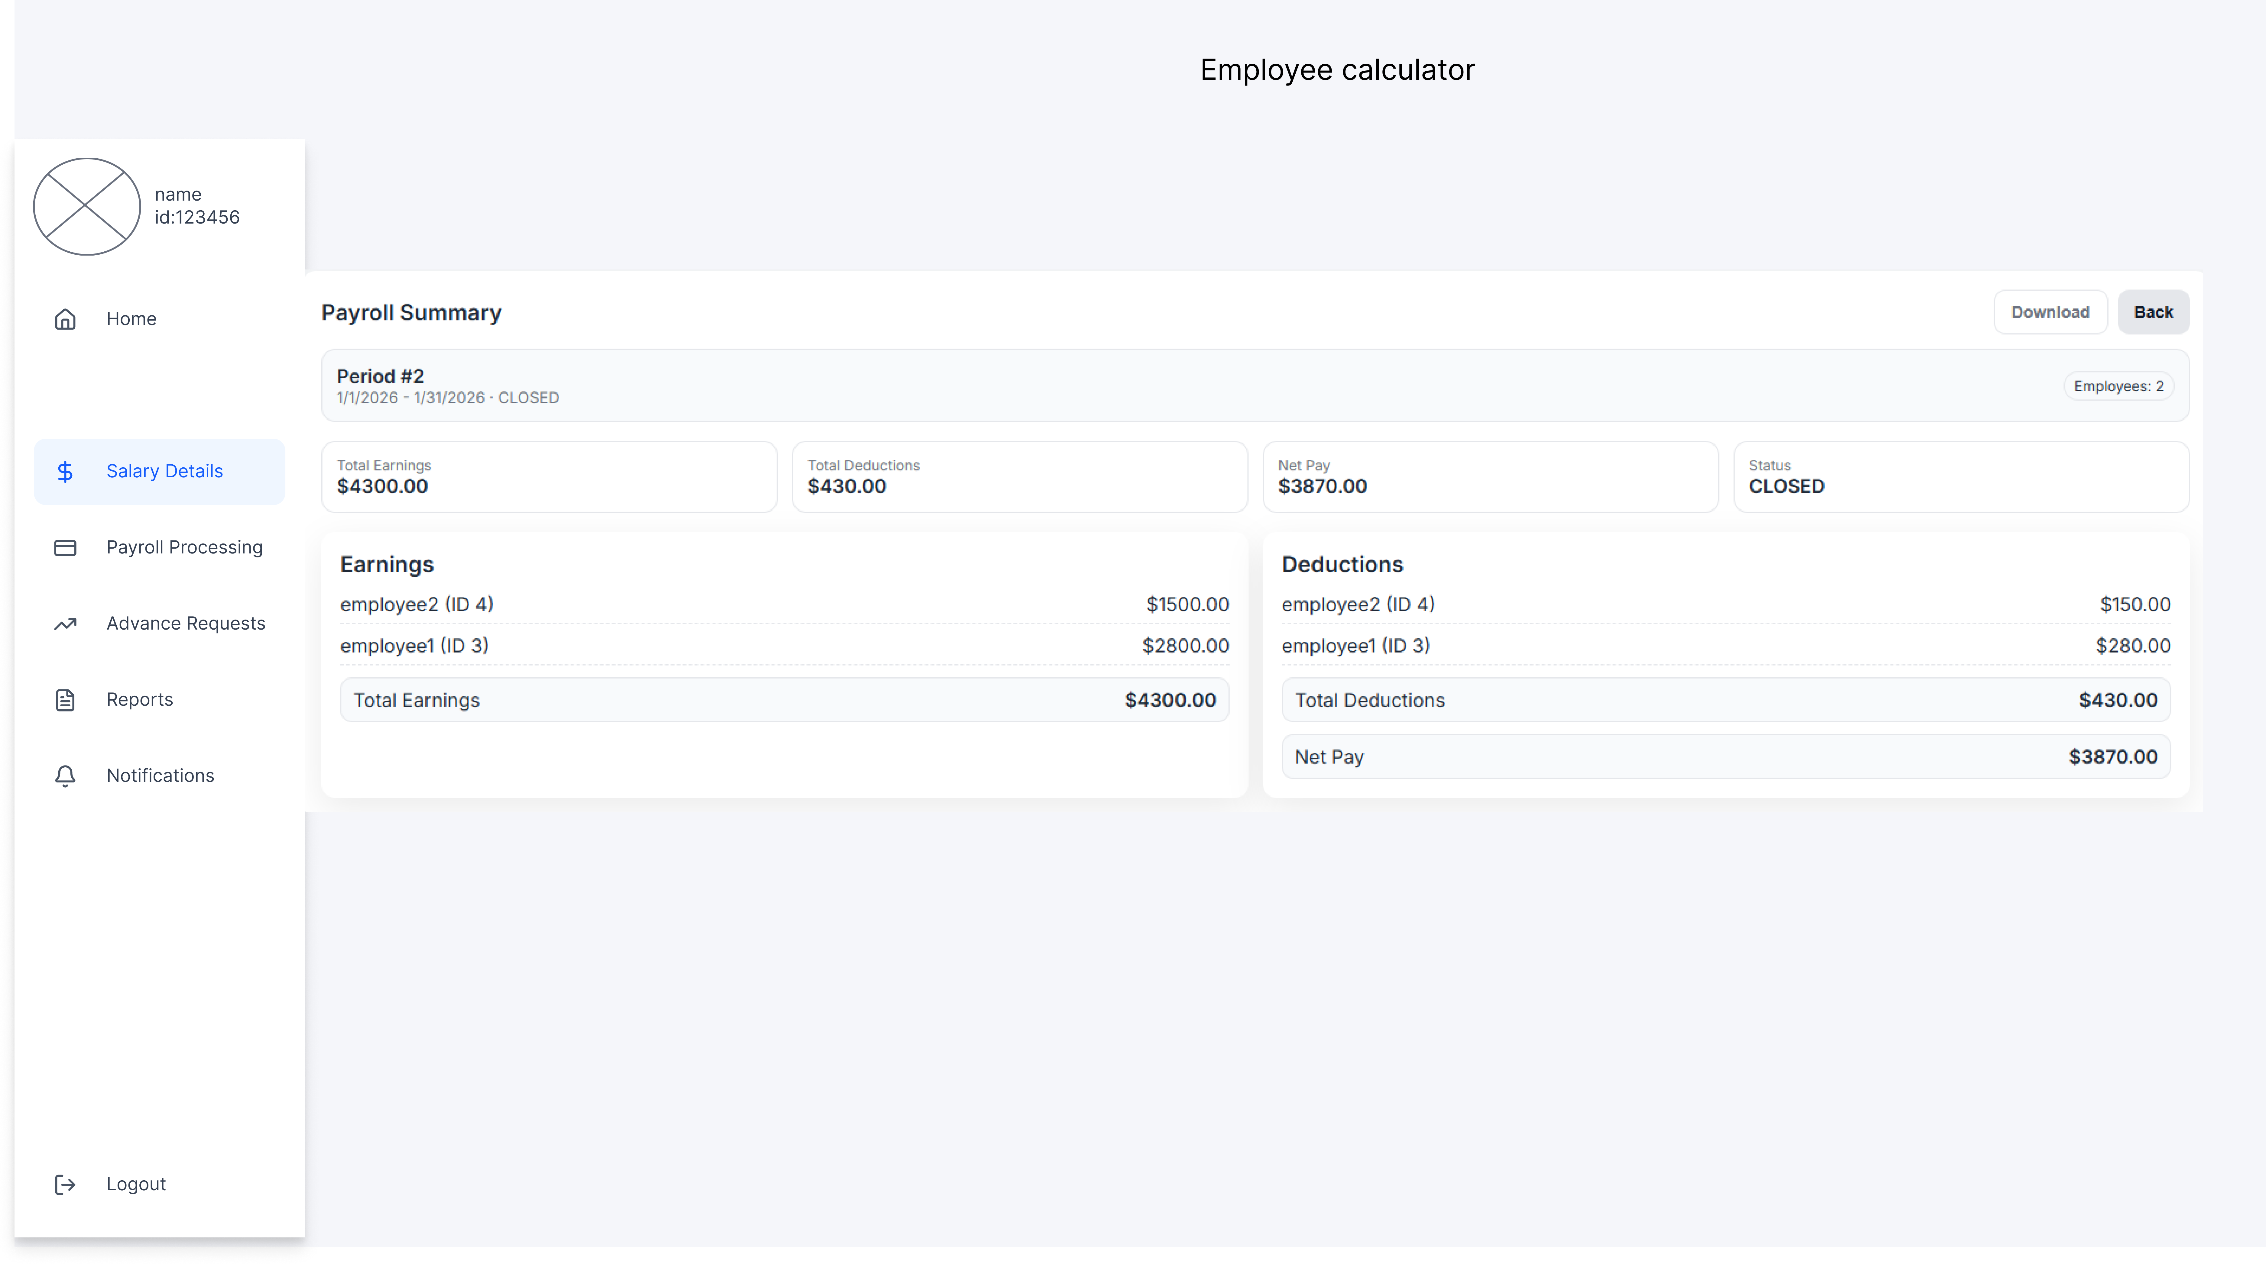

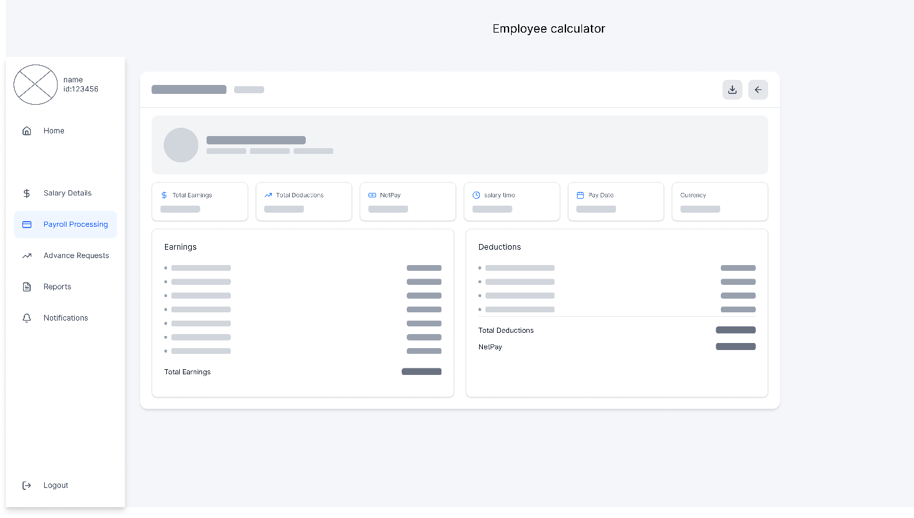

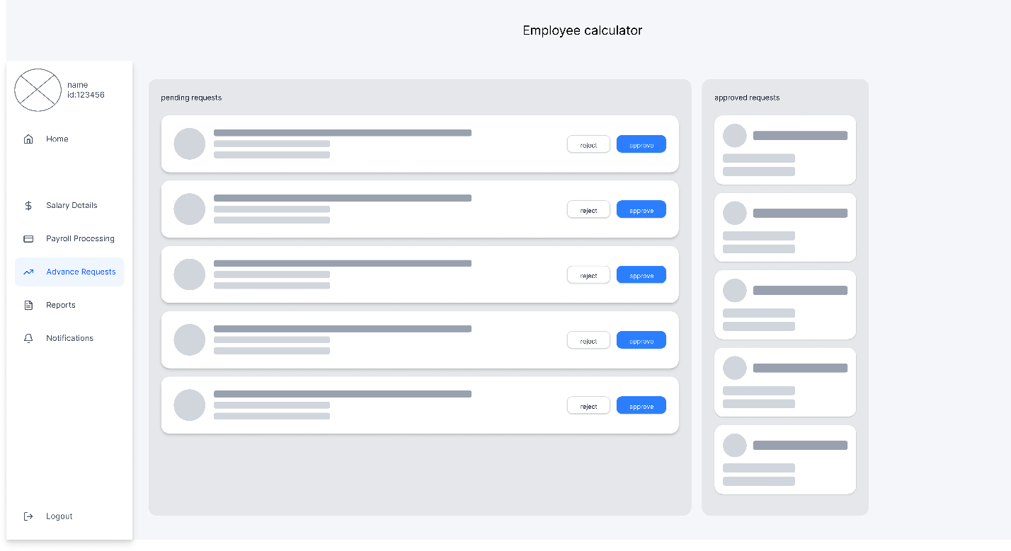

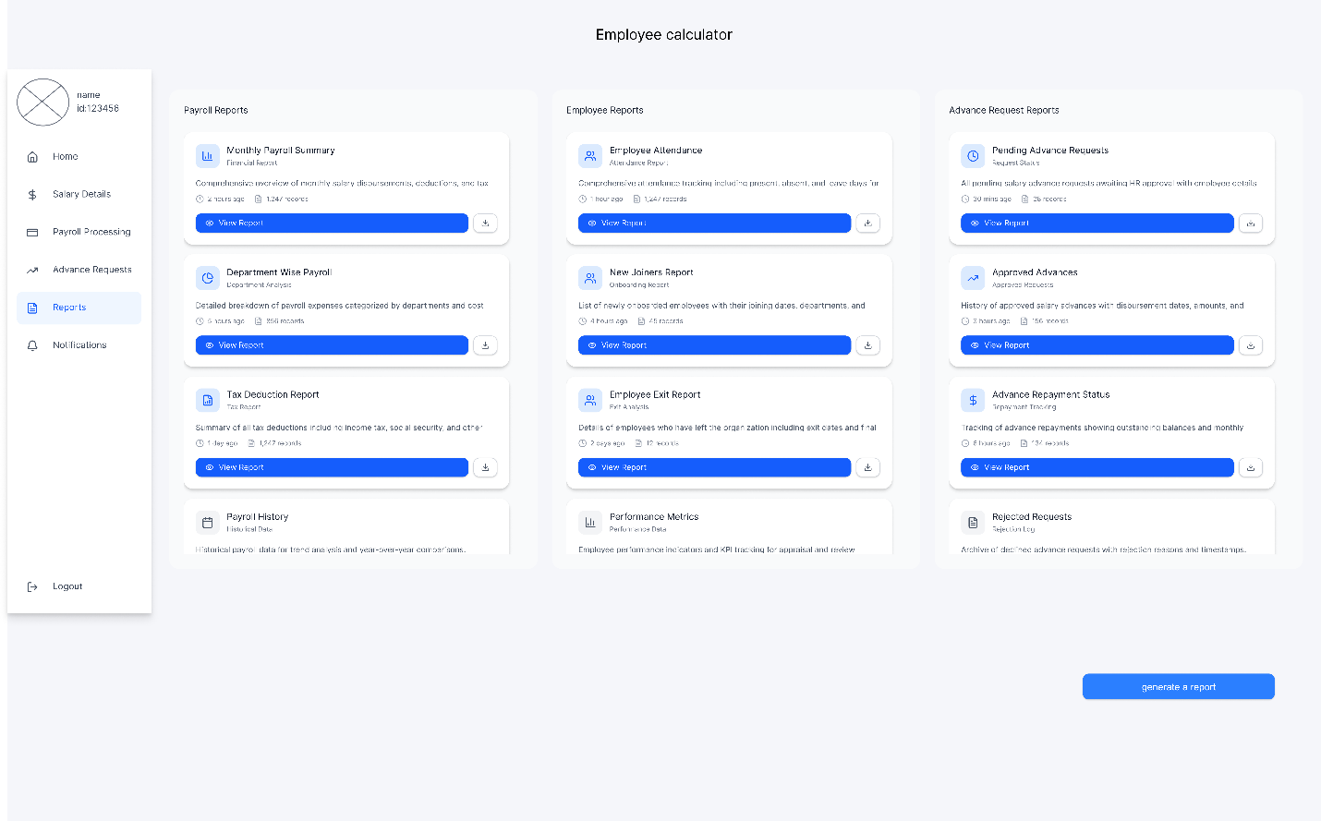

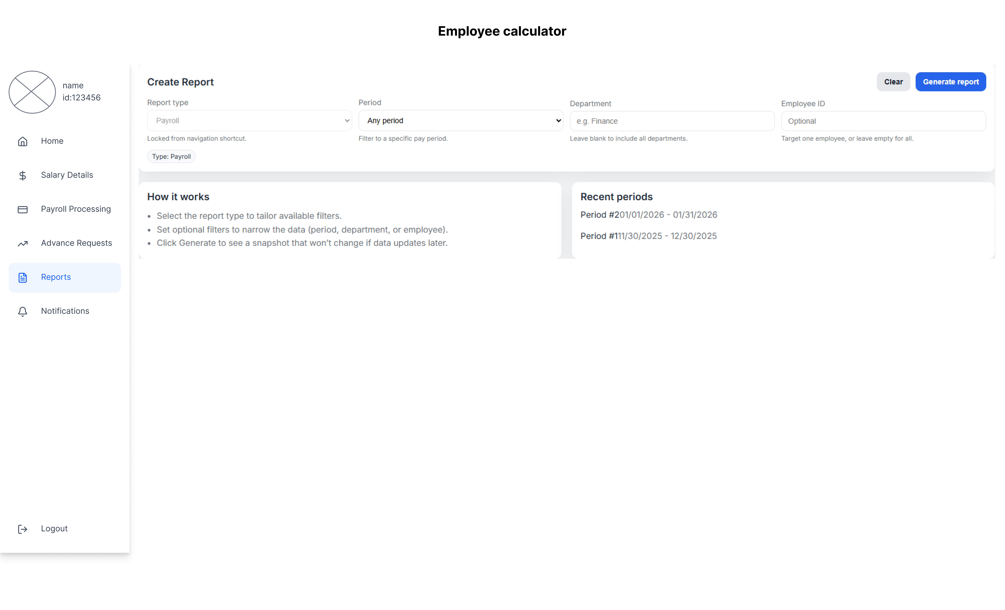



# **Overall Development**

## **Development Overview**

In software engineering, organizations can choose from several development strategies depending on their goals, resources, and time constraints. These strategies typically include:

1. RAD / Low-Code / No-Code platforms
2. Fully coded applications built from scratch
3. Customization of existing software products

For this project, I will use the RAD (Rapid Application Development) methodology using modern code-generation tools like **codex**.

What Are RAD Platforms?

RAD platforms focus on speed, iteration, and productivity. Rather than manually writing code for every line, developers can use visual tools like drag-and-drop UI builders, reusable components, automatic API handling and code-generation frameworks.

* RAD tools are specifically designed to:
* Accelerate development cycles.
* Reduce manual coding effort.
* Increase developer productivity.
* Generate consistent, high-quality code automatically.
* Support iterative prototyping and fast changes.

These platforms can work with cross-platform technologies like React, Flutter, and other web or mobile frameworks to help teams build applications faster than using complete manual coding approaches.

**Why Choose RAD for This Project?**

The Employee Calculator System requires many screens, data-management workflows, and role-based user interfaces (Admin, HR, Employee). A RAD-centric approach is ideal because:

1. Faster Prototyping & Iteration

RAD allows rapidly building wireframes and turning them into functional prototypes. This matches the project requirement for frequent feedback and refinement.

2. Reduced Complexity

The system includes multiple forms, tables, dashboards, and data-driven UI elements. RAD tools generate much of the repetitive code automatically, letting developers focus on logic rather than UI boilerplate.

3. Lower Development Time & Cost

* Reduced coding effort
* Reusable templates
* Faster maintenance cycles

4. Consistency Across Screens

Since the application contains many similar pages (lists, forms, reports, payroll tables), RAD tools ensure consistent layout and behavior.

5. Easy Integration With APIs & Databases

Modern RAD tools integrate easily with backend services, reducing the time needed to configure data operations.

**Comparison With Other Approaches**

User-coded development from scratch

Although it provides maximum control, writing every component by hand would:

* Increase development time significantly
* Require a larger development team
* Introduce more room for errors  
  This approach is less suitable under the project constraints.

Customizing an existing product

This option is typically used for CRM/ERP modifications. However, because the Employee Calculator System includes custom and unique workflows, adapting an existing platform would likely restrict functionality and flexibility.

**Conclusion**

**Choosing RAD platforms provides an optimal balance between speed, customization, maintainability, and cost efficiency.**  
It supports the project goals by enabling rapid development, fast iteration, and consistent UI generation while still allowing enough flexibility to customize complex processes like payroll, requests, and reporting.

## **The preferable Development Tool, Technique, and Software Development Methodology**

**Development Methodology**

The chosen methodology for this project is Rapid Application Development (RAD). RAD emphasizes quick prototyping, iterative refinement, and continuous user involvement, making it ideal for applications that require many user interfaces and frequent updates.

**Justification**

* **Frequent Requirement Changes:** Payroll, HR, and financial operations evolve regularly. RAD allows requirements to be adjusted during development without major disruption.
* **Interface-Heavy System:** The application contains numerous dashboards, forms, lists, and reports. RAD accelerates UI development through fast prototyping.
* **Stakeholder Feedback:** Each department (admin, HR, employee) can validate their module early, reducing the risk of rework.
* **Faster Delivery:** RAD shortens development cycles by using pre-built components, templates, and automated tools.

**Strengths of RAD**

1. **Strengths of RAD for This Project**

* Rapid prototyping allows early visualization of the application.
* Iterative cycles ensure that errors are caught early.
* Parallel development boosts productivity.
* Encourages active collaboration with stakeholders.

**Development Tools**

|  |  |  |
| --- | --- | --- |
| Tool | Purpose | Reason for Selection |
| React.js | Build user interfaces | Component-based structure, reusable elements, fast rendering |
| Vite | Development environment | Extremely fast builds, instant updates, supports RAD cycles |

|  |  |  |
| --- | --- | --- |
| Tool | Purpose | Reason for Selection |
| Node.js | API and server logic | Lightweight, highly scalable, easy to integrate with frontend |
| MySQL | Relational database | Structured payroll, HR, and employee data fits relational models |

|  |  |
| --- | --- |
| Tool | Purpose |
| Figma | Build mockups for RAD prototyping |
| VS Code (with codex) | Efficient development IDE |

**Development Techniques**

**Component-Based Development.**

The system makes use of modular UI components like tables, forms, cards, lists, and dashboards.

Benefits.

* Reusability across modules.
* Consistency in design.
* Faster development.

**Iterative Prototyping.**

The development of all modules (Admin, HR, Employee) take several cycles.

* Mockup.
* Prototype.
* User review.
* Improvement.

This ensures the final product matches user expectations.

**Code Generation and Automation.**

Where possible, tools automate repetitive tasks such as.

* Form creation.
* Routing structure.
* Database models.
* CRUD operations.

This provides a huge boost to speed of development and RAD compliant.

**API-Driven Development.**

Frontend and backend development happens side by side with proper APIs.

Benefits.

* Independent module development.
* Better scalability.
* Improved maintainability.

**Conclusion**

The combination of RAD methodology, modern development tools, and efficient development techniques creates an environment where the Employee Calculator Application can be developed quickly, accurately, and sustainably. This approach ensures high-quality results, full stakeholder involvement, and easy future expansion.

## **Solution Evaluation**

This section evaluates the proposed solution—the Employee Calculator Application—and the chosen development approach. The evaluation compares the development tools, techniques, and methodologies considered during research. Each comparison reflects why the selected choices best support the system’s requirements, complexity, and organizational needs.

## Development Tools Comparison

|  |  |  |  |
| --- | --- | --- | --- |
| Tool Category | Advantages | Limitations | Relevance to Our Solution |
| RAD / Low-Code / Code-Generation Tools | Fast prototyping, minimal coding, rapid UI creation, ideal for frequently changing requirements | Limited customization, dependency on platform features, harder to scale complex logic | Useful for early prototypes, but insufficient for multi-role payroll logic requiring custom APIs |
| Traditional Full-Code Tools (React, Node.js, SQL) | Full flexibility, scalable architecture, maintainable codebase, industry standard | Requires longer development if not managed with agile/RAD | Best fit: allows complete control over payroll formulas, employee relations, and modular UI |
| Customization of Existing Software (ERP add-ons, payroll extensions) | Fast deployment, stable foundation, reduced testing | Very limited customization, costly licensing, does not match unique company processes | Not suitable: system requires custom workflows for HR, Admin, Employee roles |

**Evaluation Summary**

Combining **Codex (Rapid AI coding)** with **full-code technologies (React + Node.js + MySQL)** gives the best balance:

* RAD speed through automation
* Full customization through manual coding
* Scalable architecture
* Control over security and business rules

This hybrid tool choice is the most efficient and the most flexible for building your custom Employee Calculator System.

## Development Techniques Comparison

|  |  |  |  |
| --- | --- | --- | --- |
| Technique | Benefits | Limitations | Suitability |
| AI-Assisted Code Generation (Codex) | Generates components, APIs, SQL queries quickly; reduces repetitive coding; speeds prototyping | Requires review; not always perfect | **Highly suitable:** speeds up development of multiple screens |
| Component-Based Development (React) | Reusable UI components, consistent design, very efficient for large UIs | Requires initial design planning | Ideal for dashboards, cards, tables, forms |
| API-Driven Development (Node.js) | Clean separation of concerns, scalable backend, easy integration with MySQL | Requires structured planning | Ideal for multi-role access (Admin, HR, Employee) |
| Iterative Prototyping (RAD) | Continuous user feedback, catches issues early | Needs frequent communication | Ideal for HR, Admin approvals |
| Manual Coding | Full control for complex salary formulas | Time-consuming without AI tools | Used where Codex cannot generate accurate logic |

**Evaluation Summary.**

The best approach is a hybrid technique.

* Codex takes care of standard code, user interface frames, repetitive parts.
* Developers implement core business logic, salary rules, and other complex validations manually.
* React component architecture ensures maintainability.
* Prototyping ensures constant stakeholder feedback.

This technique combination will directly aid the complexity and rapid development of the project goal.

## Software Development Methodology Comparison

|  |  |  |  |
| --- | --- | --- | --- |
| Methodology | Strengths | Weaknesses | Fit for This System |
| RAD (Rapid Application Development) | Very fast, highly iterative, quick prototyping, ideal for AI tools like Codex, easy UI refinement | Depends on stakeholder feedback availability | **Perfect fit:** for multiple pages wireframes, fast UI changes, multi-role feedback |
| Waterfall | Strict structure | No flexibility | Not suitable |
| Agile | Good iteration cycles | Requires sprint structure, slower than RAD for UI-heavy apps | Can support the project but not optimal |

**Why RAD Fits Best**

* multiple **screens**, requiring frequent visual updates
* HR, and Admin departments need to review prototypes regularly
* Codex accelerates RAD even further by generating ready-to-test components
* Salary logic evolves quickly and needs iterative improvement
* RAD supports building, reviewing, and fixing screens continuously

Therefore, RAD + Codex + React/Node/MySQL = the optimal methodology.

# **Development Plan Discussion**

## **Development Review**

## Peer review feedback

## Interpret the peer review feedback

According to the peer review responses, there were three main areas of improvement that were found and included in the Software Design Document. These enhancements enhance the system design and improve the solution.

* 1. **Combine Finance Staff and HR Staff actor in the Use Case Diagram.**The responses indicated that Finance Staff and HR Staff are close to the duties in the offered system. Having evaluated the system functions given, the two roles primarily relate with:
* payroll processing and approval processes
* reports viewing/exporting
* observing pre-scheduling requests and records of operations

To minimize the redundancy and enhance clarity, the SDD was revised to combine both of the actors into one actor in the use case model.  
Such a change enhances the readability of the diagram, makes the design of access controls less complex, and prevents repeating the same use cases to two actors that share almost similar permissions.

**Opportunity identified:** better definition of roles and easier authorization model (less duplication of role permission).

* 1. **Add Notification / Alert Services**

It was suggested in the feedback that the notification or alert services should be added, which was underlined insufficiently in the past. The reason is that the payroll systems are time-sensitive and depend on status updates.

The SDD was changed so that it has a Notification Service that is activated by the major events.

Notifications can appear as in-app notification list (dashboard notifications page),

**Opportunity identified:** enhanced user experience and quicker response time through decreasing manual follow up between employees and HR.

* 1. **Add Customized Reports Based on Selected Criteria**

The feedback indicated the inclusion of personalized reporting according to the chosen choices, which brings high business values. The SDD was modified to include the Custom Report feature where the HR/Payroll staff can create report with filtering parameters

This feature supports decision-making and improves the system’s usefulness for management reporting.

**Opportunity identified:** better analytics and reporting flexibility rather than predetermined types of reports only.

## Identify and evaluate new opportunities

**Role-Based Access Control (RBAC) Enhancement**

**Opportunity identified:**  
Although user roles existed (Admin, HR Staff, Employee), a more finer role-based access control system can be provided. This would make it possible to control more carefully what actions each role is able to do (e.g. view-only vs. edit permissions).

**Evaluation and decision:**  
This was recognized to be an opportunity worthwhile to be expanded to larger organizations. But it was not completely covered in the existing implementation because of the scope and time constraints. Rather, simple role-based access control was retained whilst RBAC was determined to be an upgrade.

**Justification:**  
The current role separation adequately serves the needs of the current business, and advanced RBAC would create additional complications at this point.

**Improved User Experience Through Frontend Animations and Feedback**

**Opportunity identified:**  
Improving the user experience through UI animations, loading indicator and in-line error messages.

**Evaluation and decision:**  
This was an opportunity that was incorporated under the frontend design approach.

**Justification:**  
These additions make usability better, though not too complex, and are appropriate to current web application conventions.

**Self-Service Profile Management for Employees**

**Opportunity identified:**  
Enabling the employees to update the personal information which is limited like contacts or bank details via the system rather than going through the HR.

**Evaluation and decision:**  
This opportunity was partially included in the system design by allowing employees to view their personal and salary-related information, but full editing capabilities were not implemented.

**Justification:**  
Self-service provides less work load to the HR and enhances accuracy of data. But the free editing might pose a threat to data integrity. Thus, the current system was only to be modified to retain only read access and the controlled updates (with HR approval) were to be defined as a future improvement.

## **Application Development**

## Database

MySQL is the database management system of Payroll Management System. The reason behind the choice of MySQL was that the database is a trusted and open-source relational database with high-performance capabilities, strong data integrity, and great compatibility with web-based applications created on the bases of Node.js and React.

MySQL facilitates storage of structured data, intricate queries and transactional functionalities which are very crucial in payroll systems wherein accuracy, consistency and security are paramount. Moreover, MySQL can be easily integrated with the systems in the background and has scalability that can support the further growth of the system.

**Database Type**

The system is based on Relational Database Management System (RDBMS). The relational database will be appropriate to this application as the payroll information is very well-structured and includes the well-defined relationships among such entities as employees, salaries, pay periods, payrolls, advance requests, and reports.

Key reasons for using a relational database include:

* Strong support for relationships and constraints
* Enforcement of data integrity and consistency
* Efficient handling of financial and transactional data
* Support for ACID properties, which are essential for payroll operations

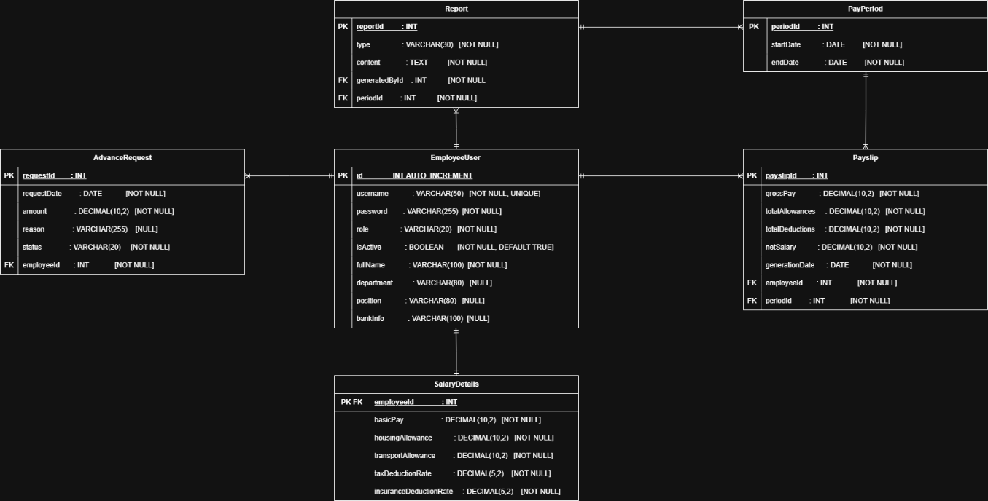

The details inside the image were explained above in the erd design.

## Screenshots of your application

Use your Software Design Document to develop a functional business application. You need to include screenshots for your application in the SDD as evidence of using the preferred tools, techniques, and methodologies.

### Screenshots

**Login page**

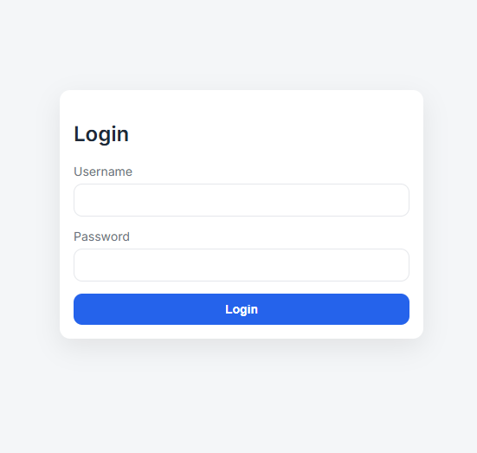

**Admin pages**

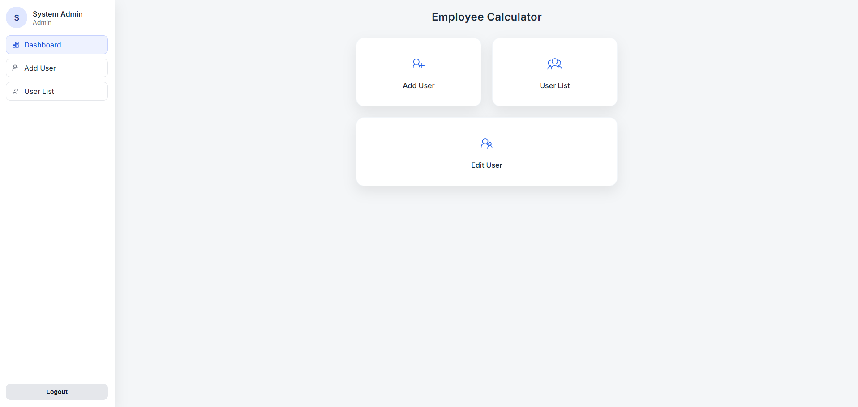

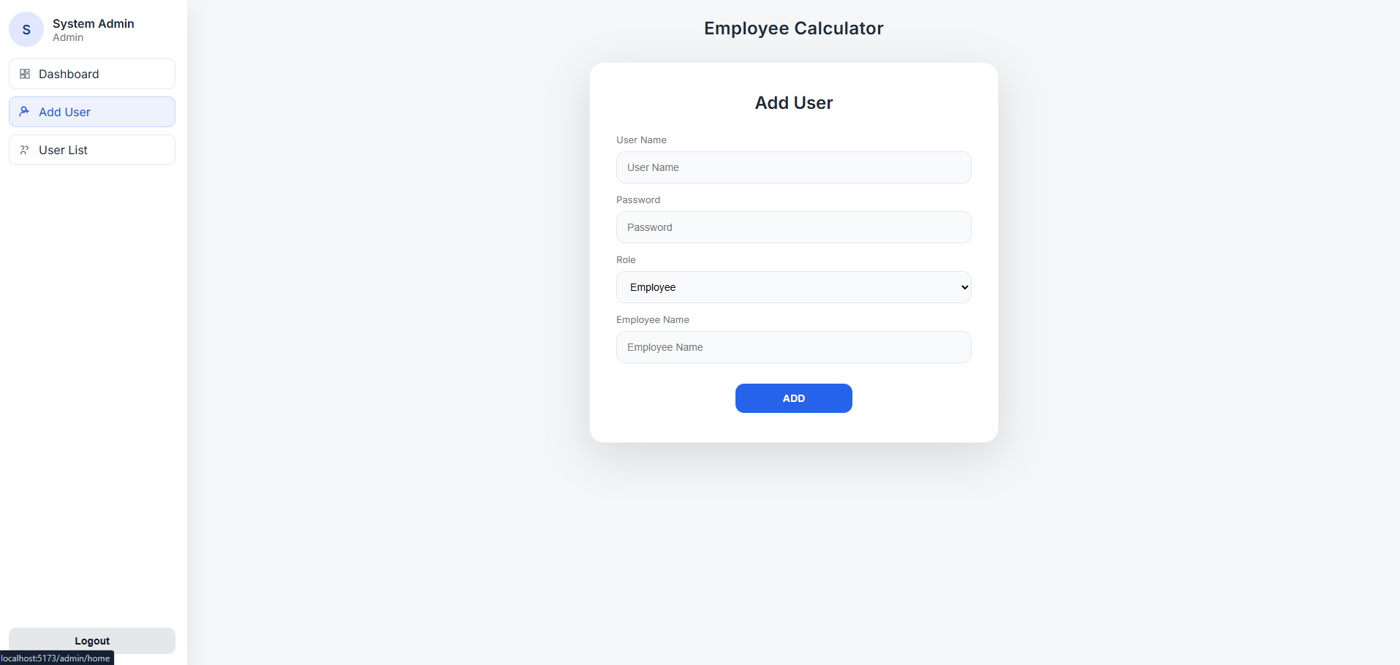

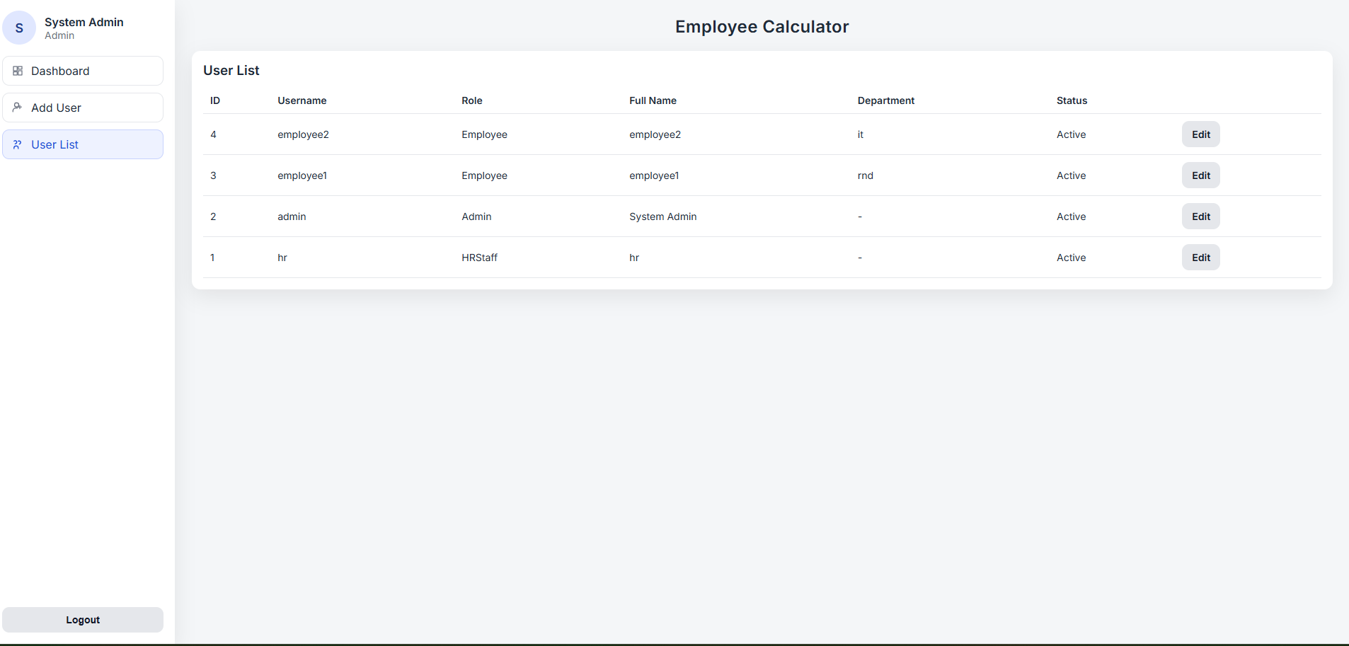

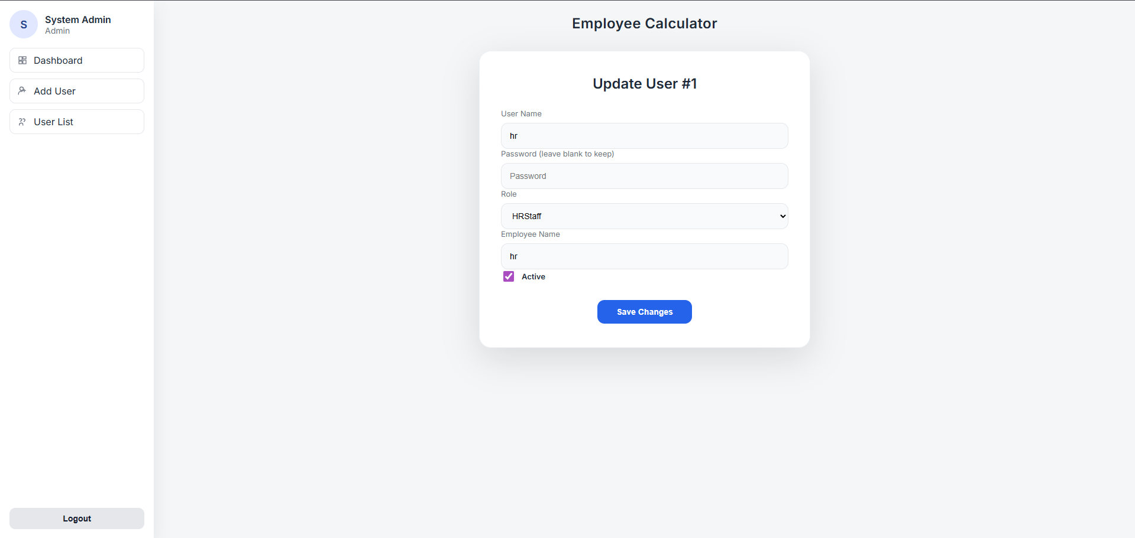

**HR pages**

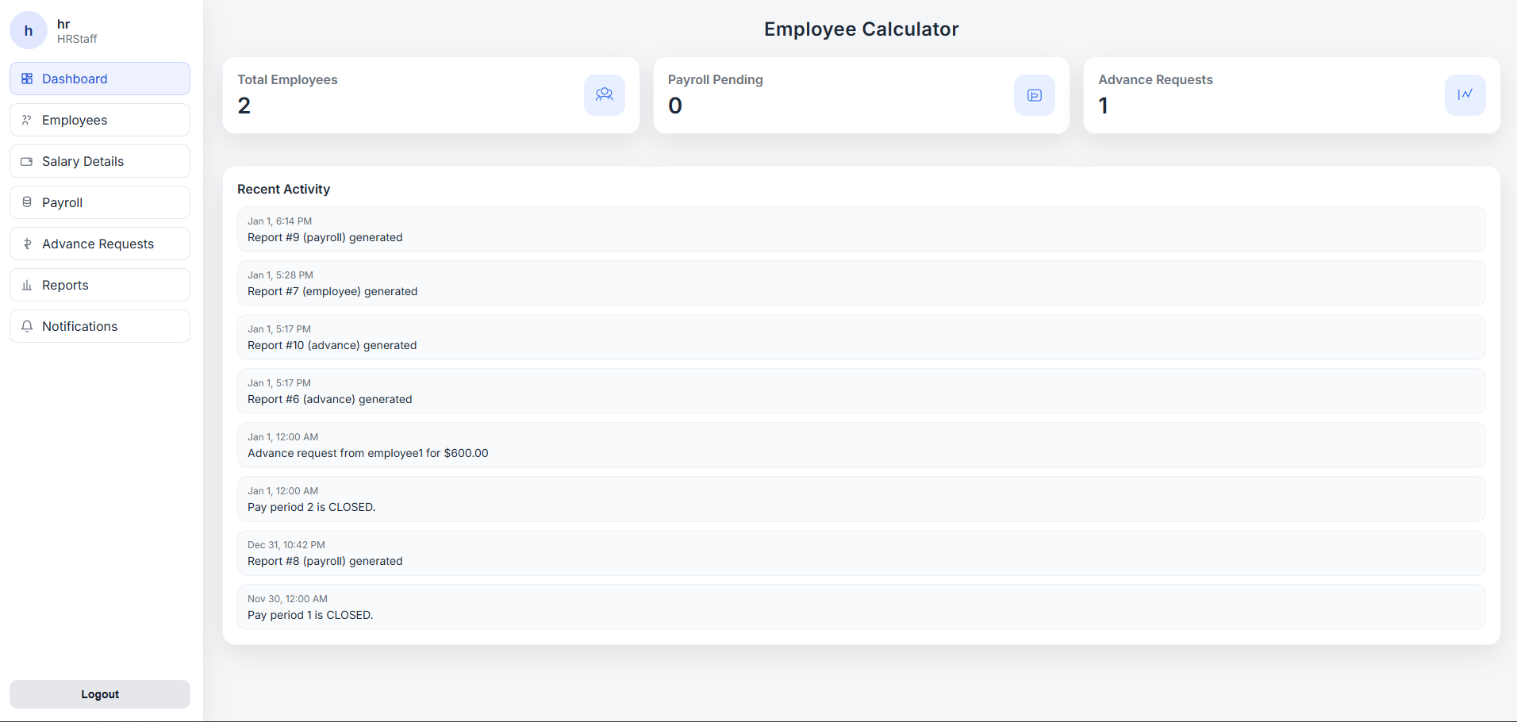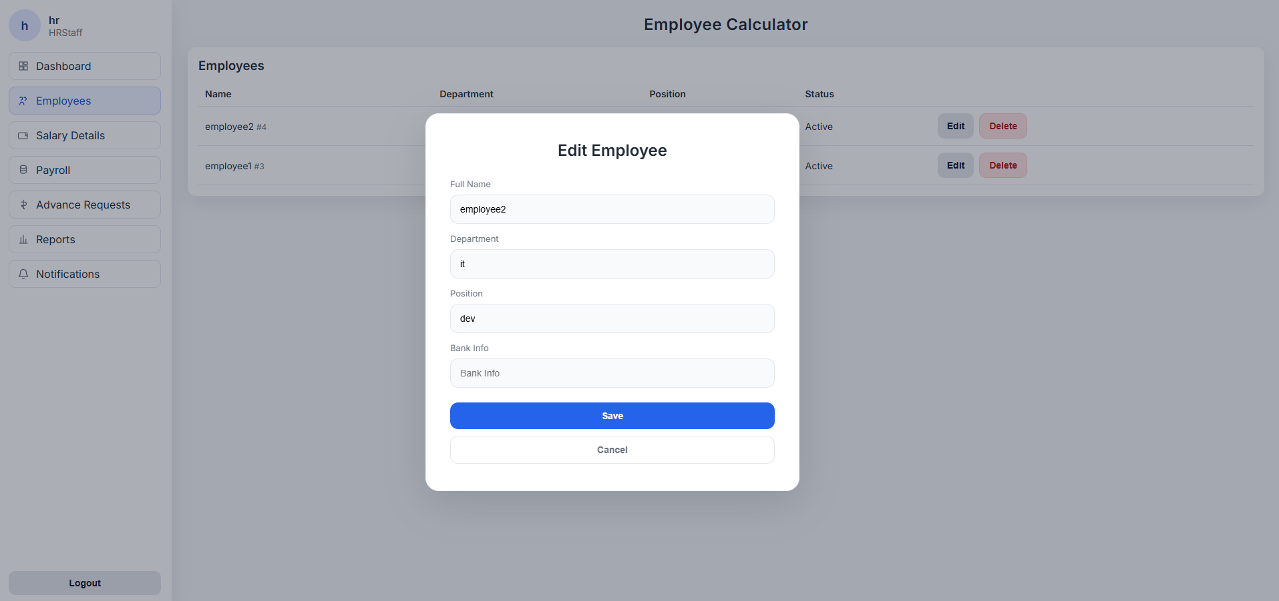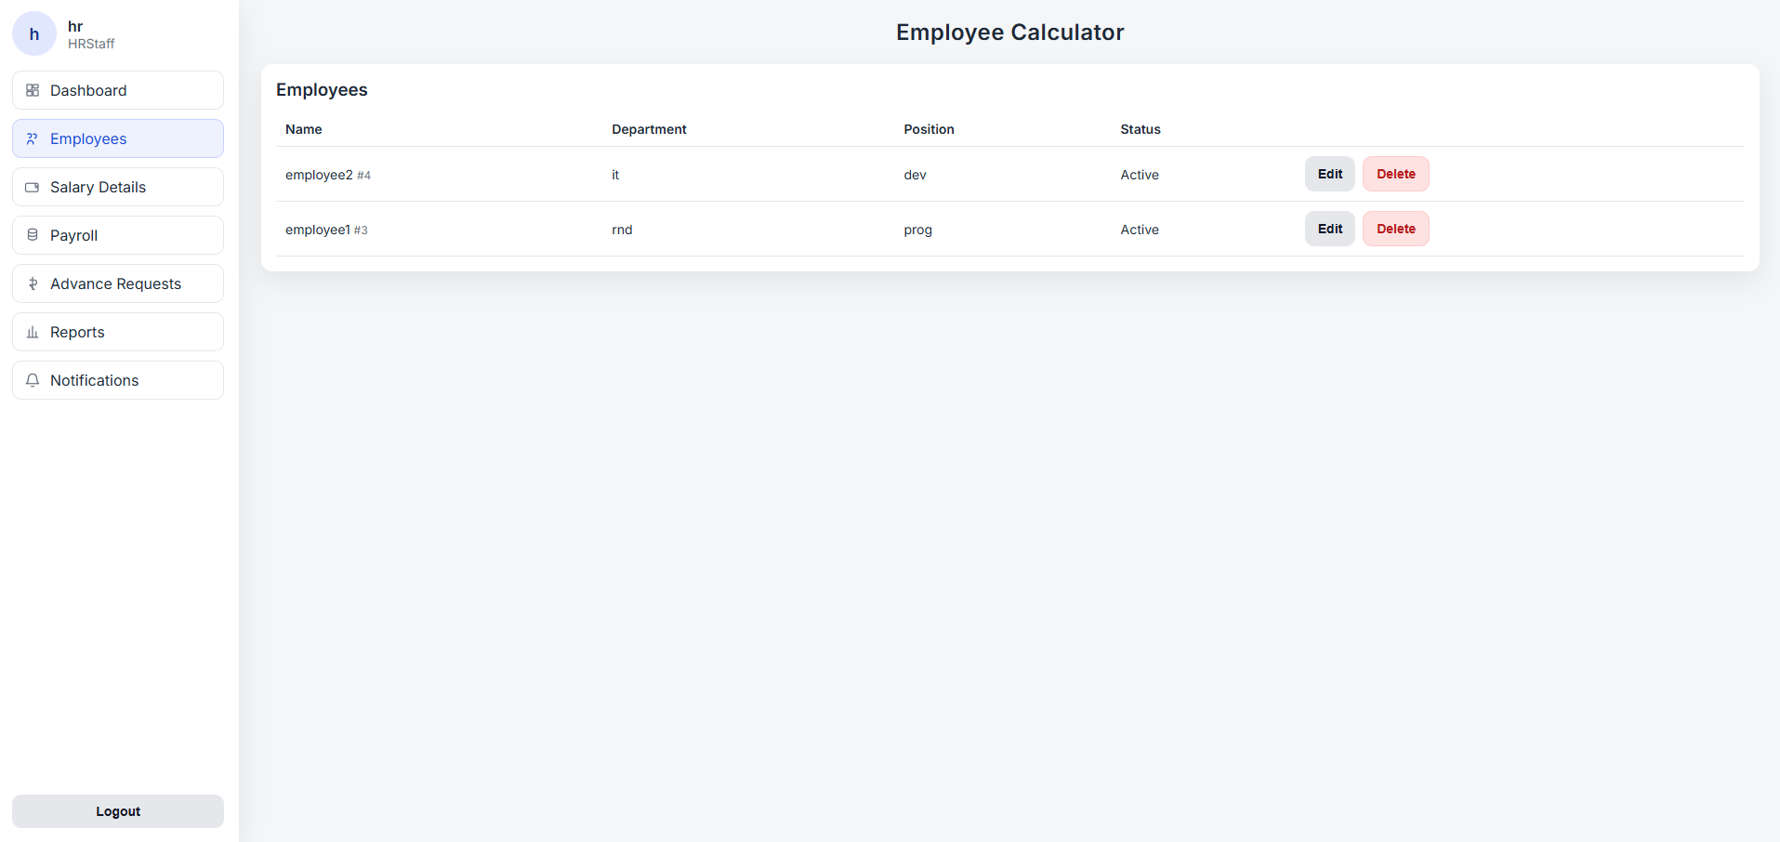

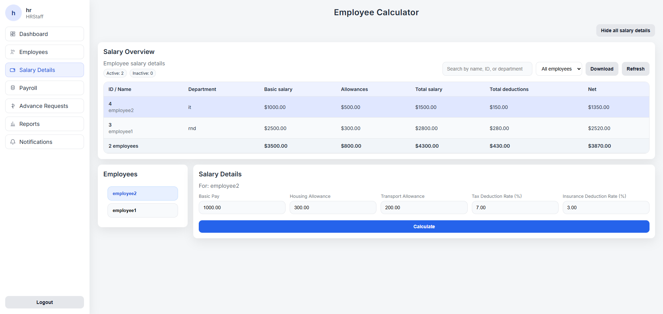

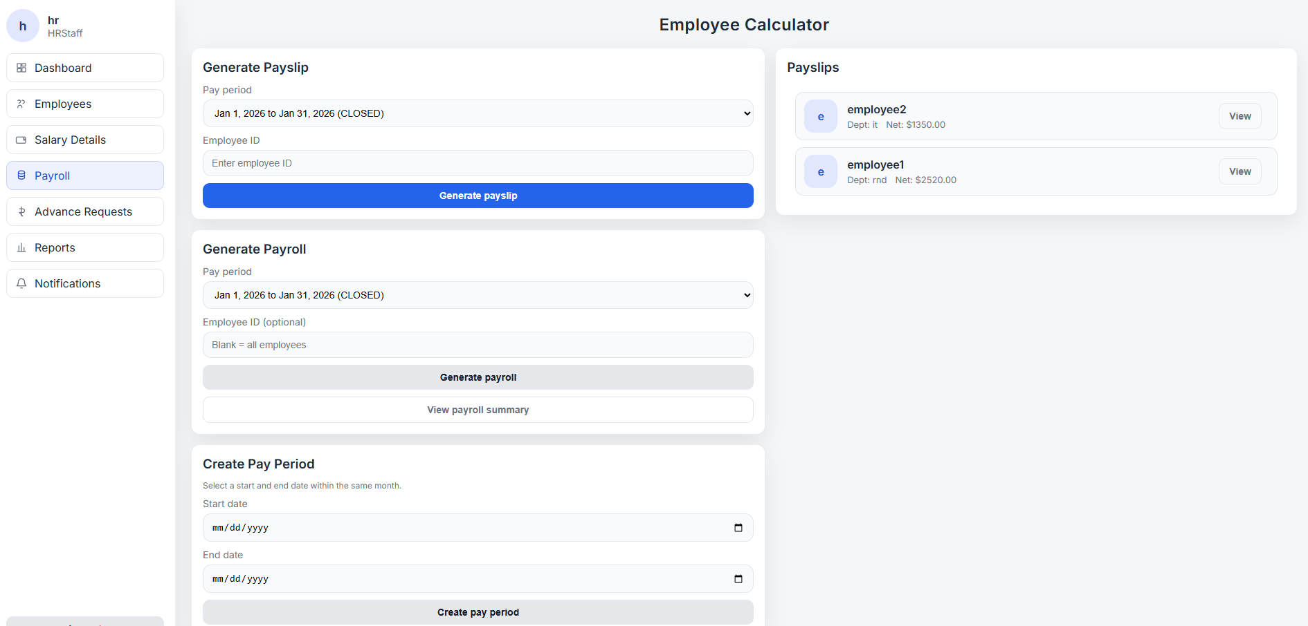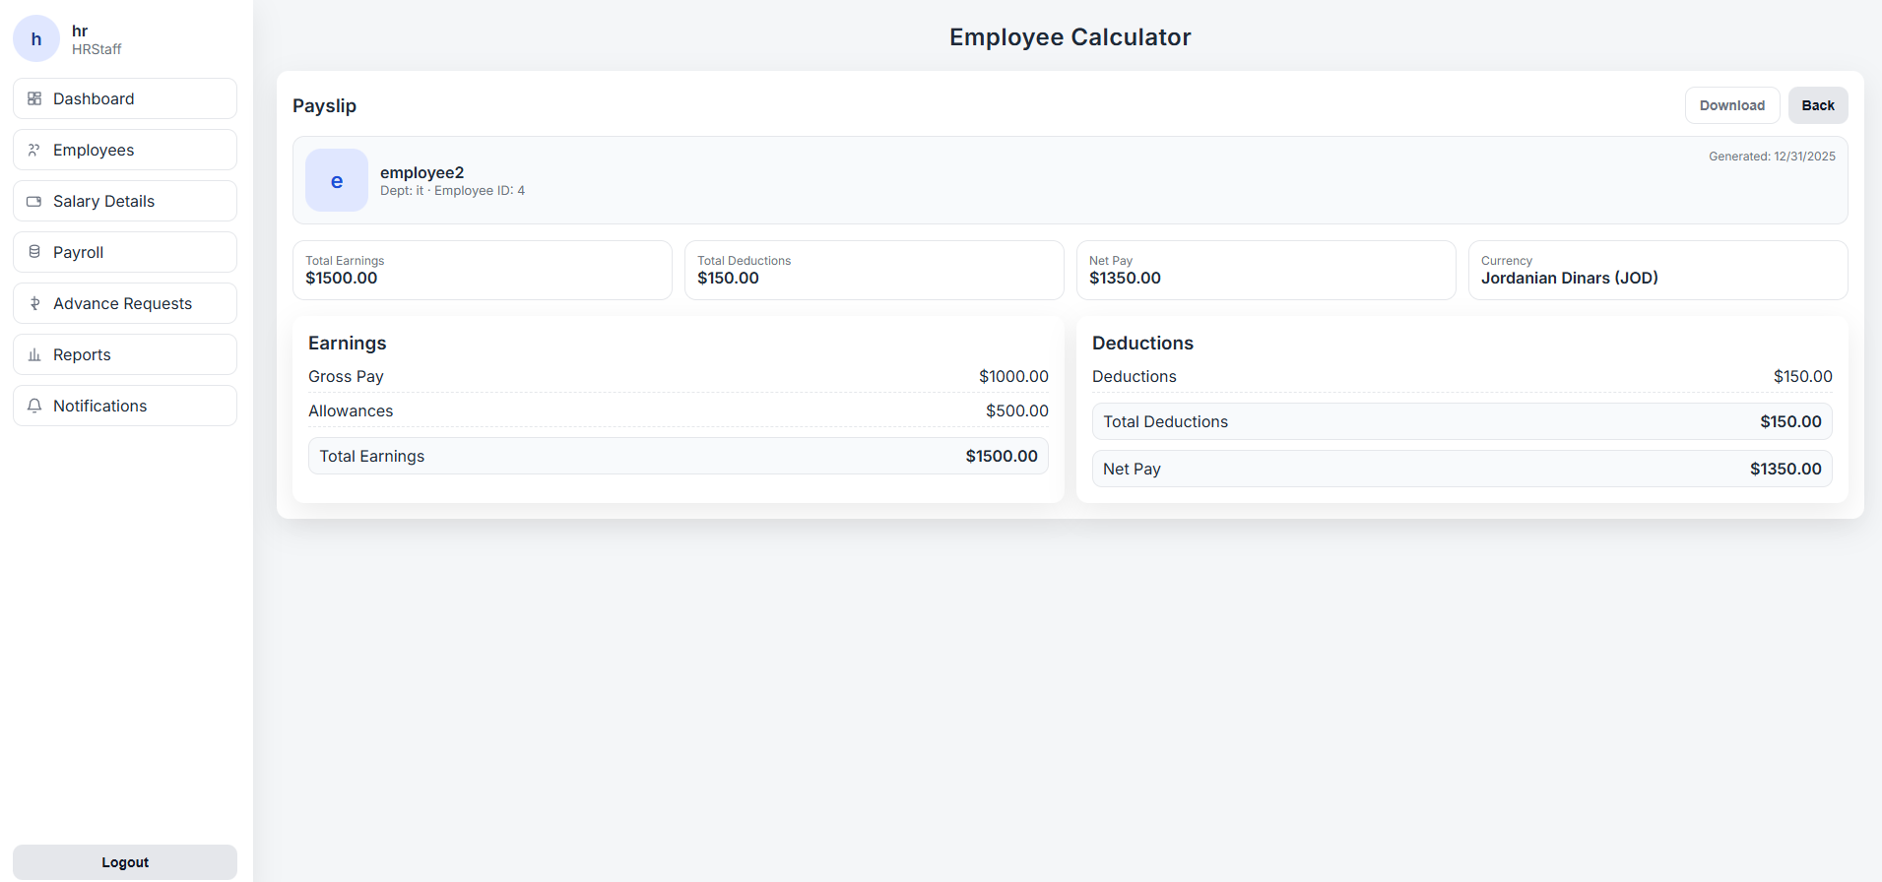

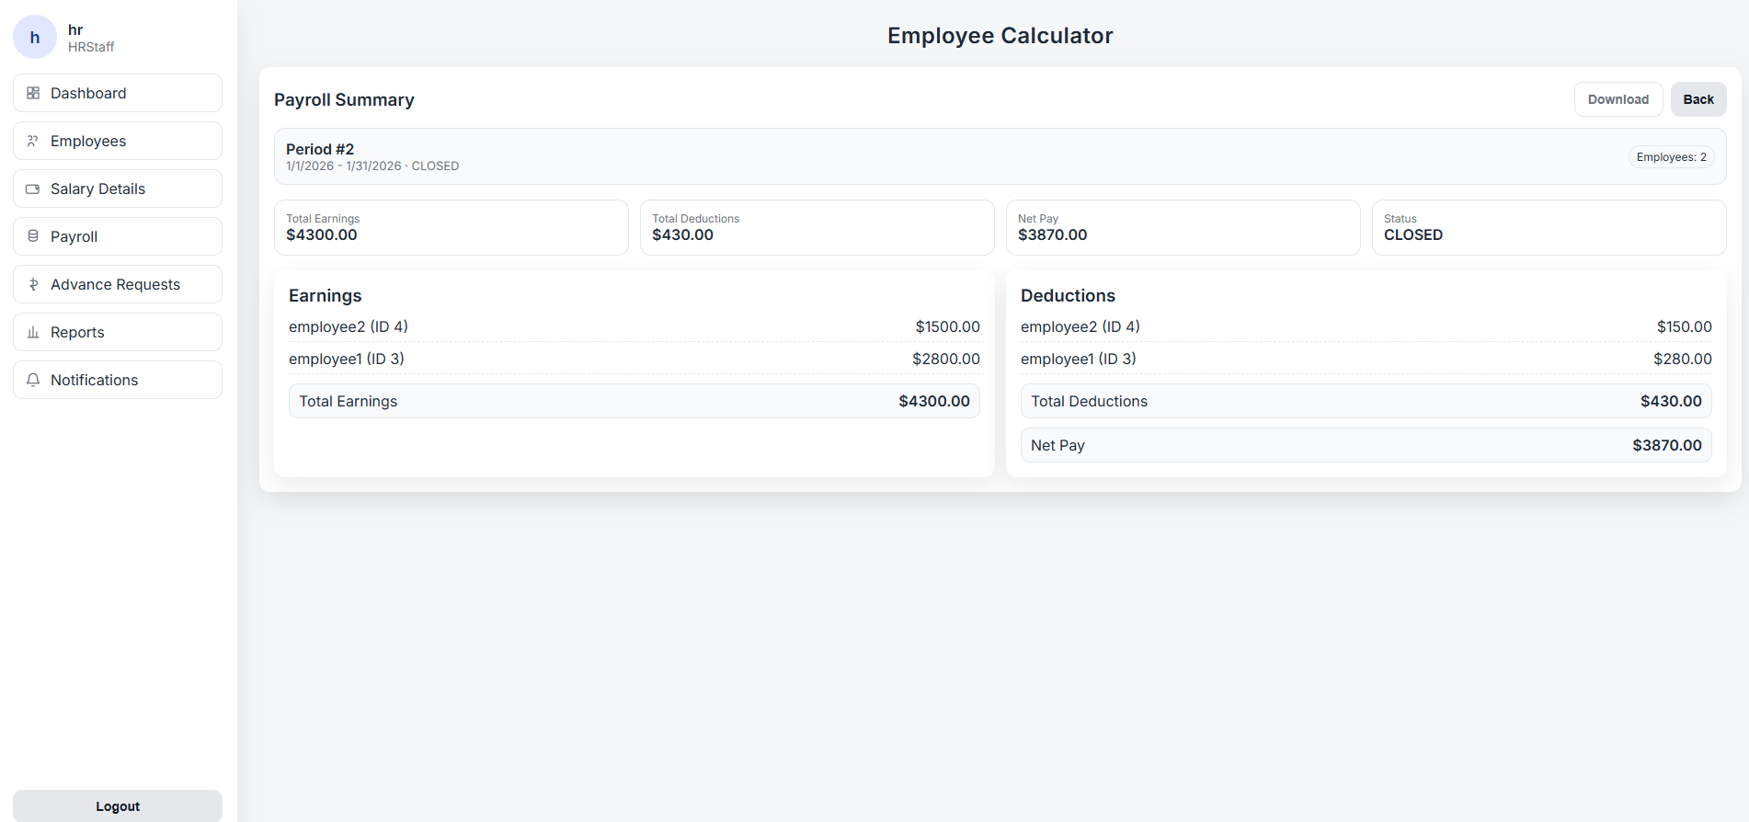

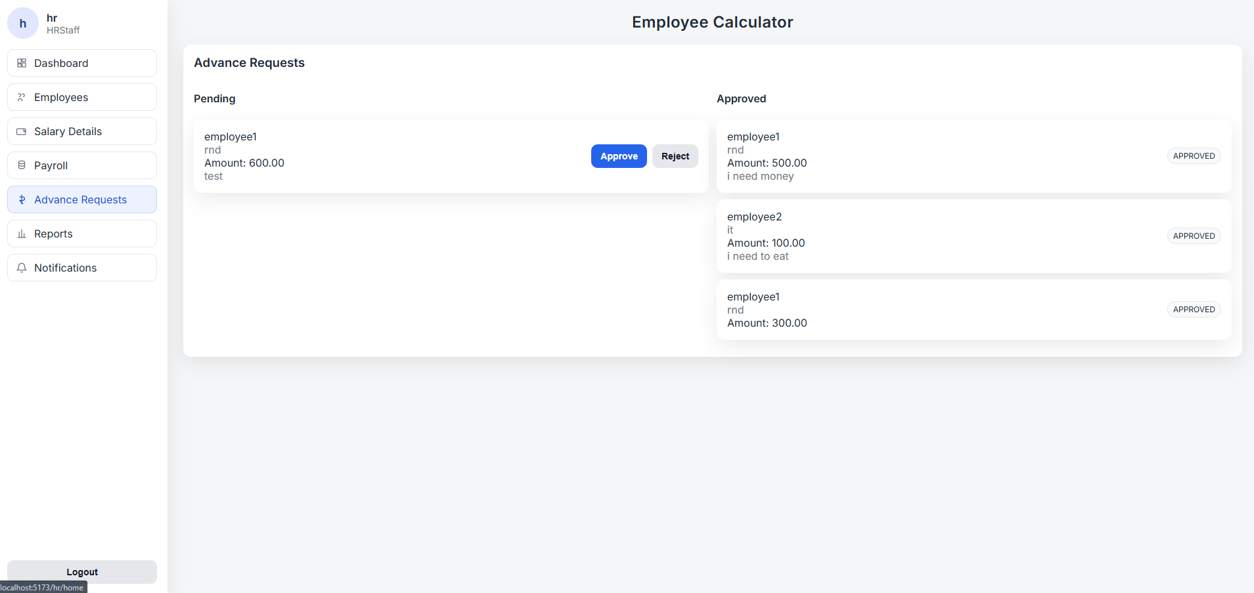

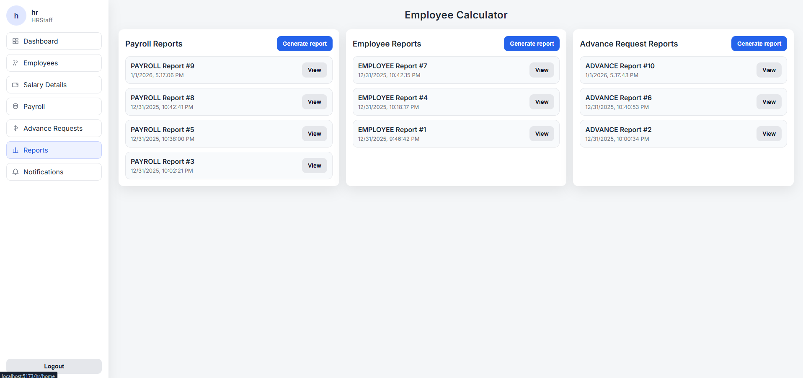

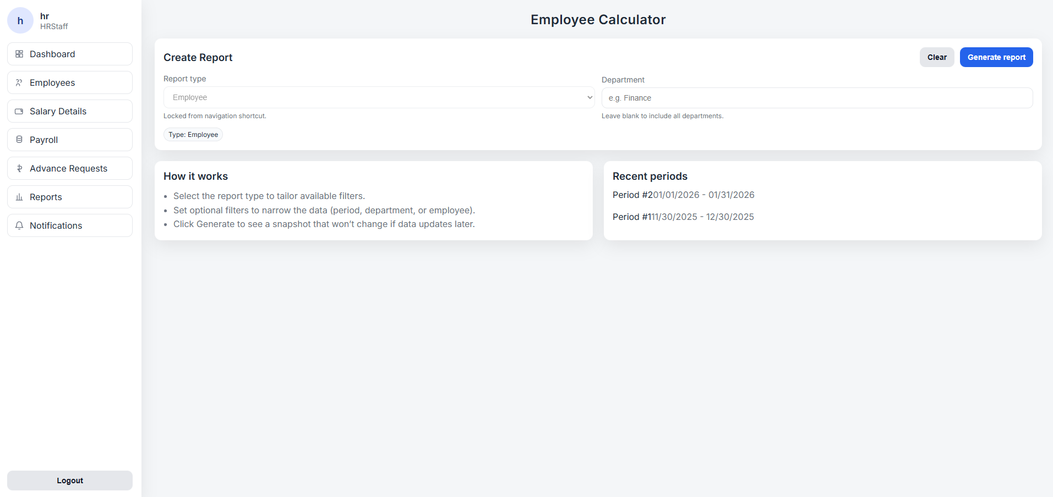

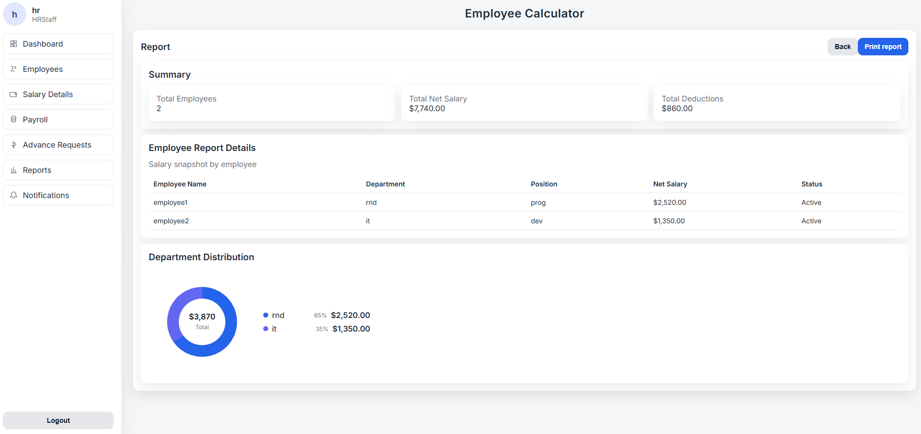

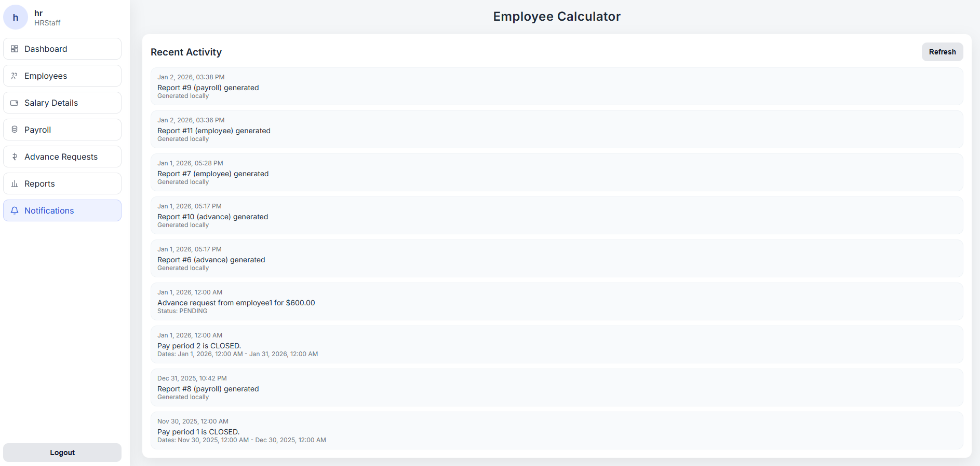

**Employee pages**

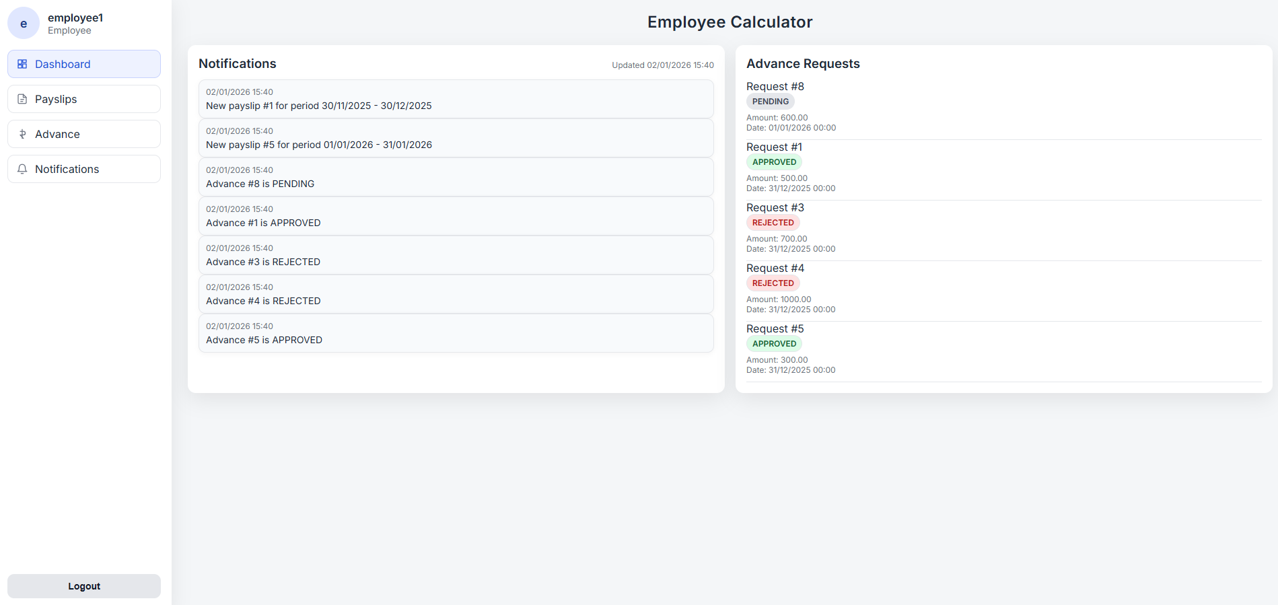

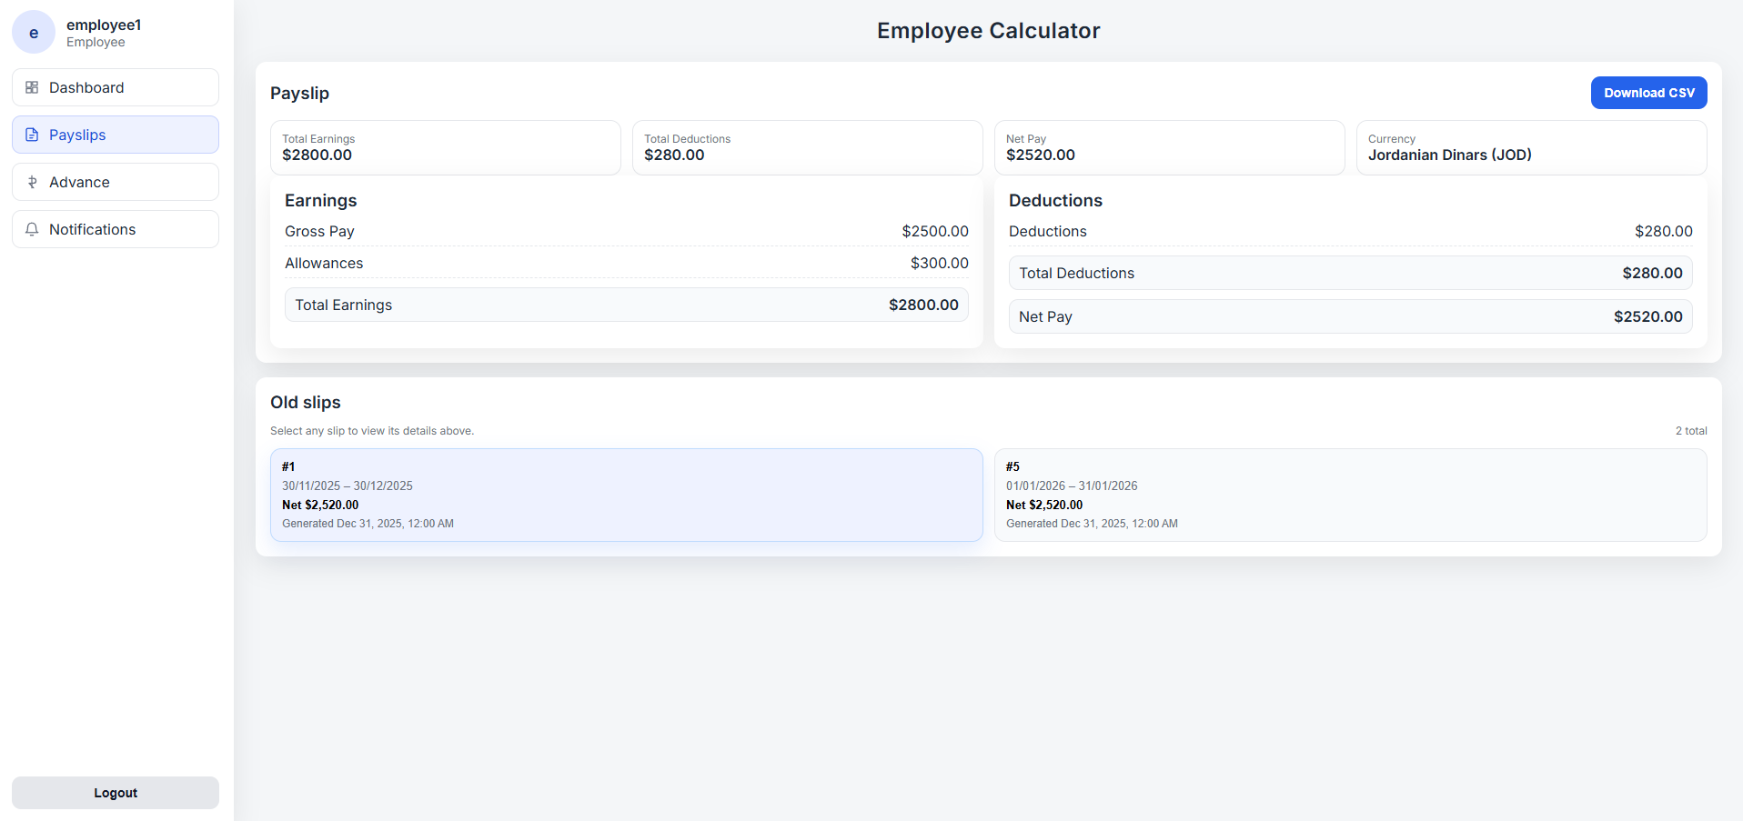

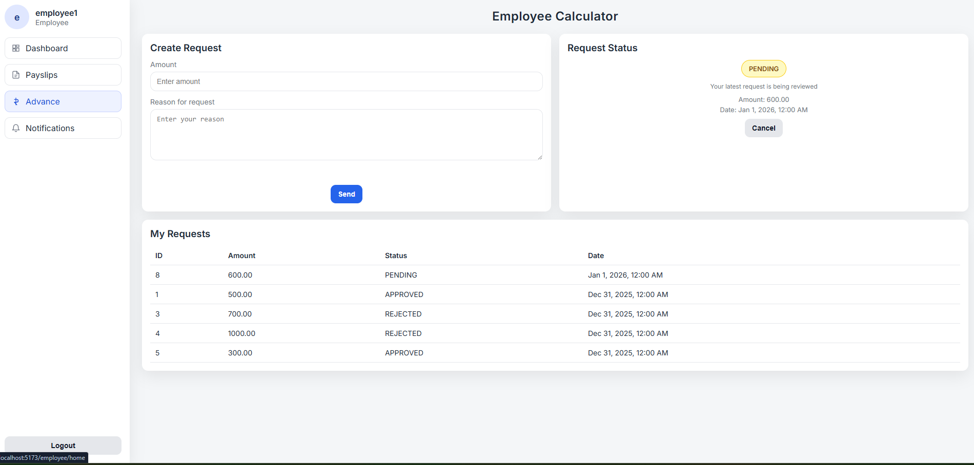

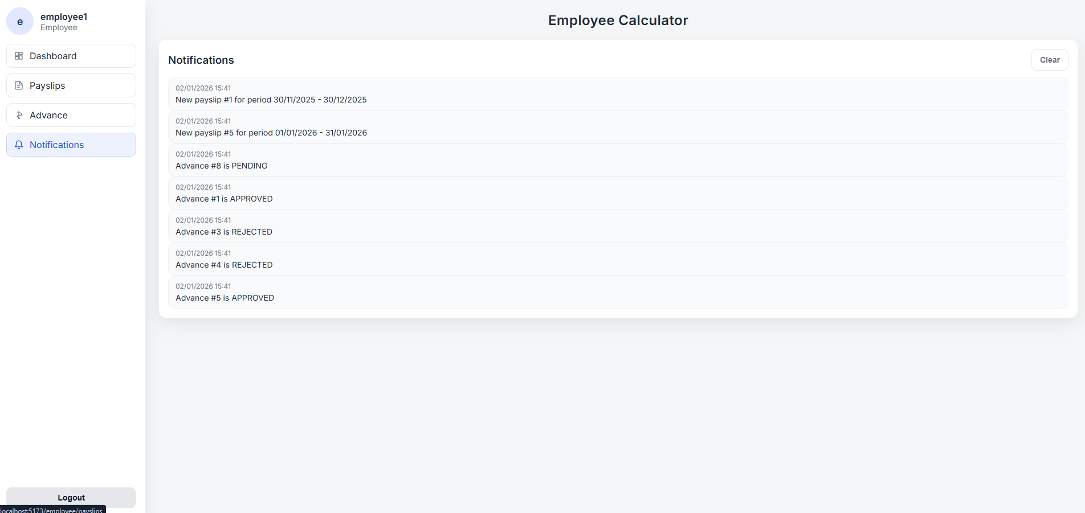

# **Testing**

## **Testing plan**

Research and use information relating to software testing to create a suitable test plan for your business application, in particular, you have to include at least 5 test cases for the system to be implemented.

**Note 1**: you need to test all the functionalities, UI, performance, integration, usability and database testcases in your application.

**Note 2:** for each test case you need to identify:

1. **Test ID** **and/or name:** a unique identifier that should follow a standard naming convention.
2. **Module name:** the module or feature under test.
3. **Test data**: this describes the dataset(s) to use for the test.
4. **Assumptions or preconditions**: describe the various steps that must be accomplished prior to testing, or what we can assume situationally about the test, such as “after a successful login.”
5. **Test priority:** define whether the test is low, medium or high priority.
6. **Test scenarios:** a high-level action from which the test case derives.
7. **Fill the below table:**

Table 3 Test cases plan table

|  |  |  |  |  |  |
| --- | --- | --- | --- | --- | --- |
| Test id | Steps of Happy path | Steps of Alternative path | Steps of Exceptional path | Expected result | Actual result |
|  |  |  |  |  |  |
|  |  |  |  |  |  |
|  |  |  |  |  |  |
|  |  |  |  |  |  |
|  |  |  |  |  |  |
|  |  |  |  |  |  |

Functional Test Cases

|  |  |  |  |  |  |
| --- | --- | --- | --- | --- | --- |
| Test ID | Steps of Happy Path | Steps of Alternative Path | Steps of Exceptional Path | Expected Result | Actual Result |
| TC-FUNC-01 | Login with valid username and password | Login with different valid roles (Admin/HR/Employee) | Invalid password or inactive account | User authenticated and redirected to correct dashboard | Pass |
| TC-FUNC-02 | Admin creates a new employee with valid data | Create employee with optional fields empty | Duplicate username or missing required fields | Employee created successfully or validation error shown | Pass |
| TC-FUNC-03 | HR updates salary details for an employee | Update only allowance fields | Enter negative or invalid salary values | Salary details updated correctly or rejected | Pass |
| TC-FUNC-04 | Process and submit payroll for open period | Process payroll for selected employees only | Attempt payroll on closed period | Payslips generated and payroll submitted | Pass |
| TC-FUNC-05 | Employee submits advance request | Employee edits request before submission | Request exceeds allowed amount | Request saved or rejected with message | Pass |

UI Test Cases

|  |  |  |  |  |  |
| --- | --- | --- | --- | --- | --- |
| Test ID | Steps of Happy Path | Steps of Alternative Path | Steps of Exceptional Path | Expected Result | Actual Result |
| TC-UI-01 | Navigate using sidebar menu | Navigate using icons | Broken route or wrong page | Correct page loads with active highlight | Pass |
| TC-UI-02 | View employee table with pagination | Change visible columns | Page number out of range | Table displays correctly | Pass |
| TC-UI-03 | Submit form with valid input | Optional fields left empty | Required fields missing | Inline validation messages displayed | Pass |
| TC-UI-04 | Resize browser window | Use tablet-sized screen | Layout overlap occurs | Responsive layout maintained | Pass |
| TC-UI-05 | View notifications list | Scroll long notification text | Text overflow | Notifications readable and styled | Pass |

Performance Test Cases

|  |  |  |  |  |  |
| --- | --- | --- | --- | --- | --- |
| Test ID | Steps of Happy Path | Steps of Alternative Path | Steps of Exceptional Path | Expected Result | Actual Result |
| TC-PERF-01 | Load employee list (1000+ users) | Use search to reduce list | Page freezes or slow load | Page loads within acceptable time | Pass |

Integration Test Cases

|  |  |  |  |  |  |
| --- | --- | --- | --- | --- | --- |
| Test ID | Steps of Happy Path | Steps of Alternative Path | Steps of Exceptional Path | Expected Result | Actual Result |
| TC-INT-01 | Login via UI → API → DB | Login with different roles | Database unavailable | End-to-end login works | Pass |
| TC-INT-02 | Submit advance request | Submit without reason | Invalid employee ID | Request saved or error returned | Pass |
| TC-INT-03 | Submit payroll → payslips saved | Preview payroll only | Duplicate payslip attempt | Payslips saved once | Pass |
| TC-INT-04 | Update salary → payroll recalculated | Update allowance only | Update fails silently | Payroll uses updated data | Pass |
| TC-INT-05 | Generate & export report | Filtered report export | Export failure | File downloaded correctly | Pass |

Usability Test Cases

|  |  |  |  |  |  |
| --- | --- | --- | --- | --- | --- |
| Test ID | Steps of Happy Path | Steps of Alternative Path | Steps of Exceptional Path | Expected Result | Actual Result |
| TC-USAB-01 | First-time user logs in | Uses password visibility toggle | Confusing error message | Easy and clear login flow | Pass |
| TC-USAB-02 | Employee views latest payslip | Search by date | Cannot identify latest slip | Payslip easy to locate | Pass |
| TC-USAB-03 | HR processes payroll step-by-step | Uses filters | Confusing submit action | Clear workflow and guidance | Pass |
| TC-USAB-04 | Track advance request status | Notification received | Status unclear | Status labels understandable | Pass |
| TC-USAB-05 | Generate report | Combine multiple filters | Empty result unclear | reporting clear | Pass |

Database Test Cases

|  |  |  |  |  |  |
| --- | --- | --- | --- | --- | --- |
| Test ID | Steps of Happy Path | Steps of Alternative Path | Steps of Exceptional Path | Expected Result | Actual Result |
| TC-DB-01 | Insert unique username | Update non-unique fields | Duplicate username insert | DB enforces uniqueness | Pass |
| TC-DB-02 | Delete employee record | Update employee data | Orphan salary record | Cascade delete works | Pass |
| TC-DB-03 | Insert valid advance request | Update request status | Invalid set amount | FK integrity maintained | Pass |
| TC-DB-05 | Create new pay period | Close period | Duplicate dates | Unique pay period enforced | Pass |

## **Performance review**

Review the performance of your business application against the Problem Definition Statement and initial requirements by measuring the overall success of the application against your original prediction.

This section reviews the performance of the Payroll Management System against the original Problem Definition Statement and initial system requirements. The goal of the application was to replace manual payroll processing with an automated, accurate, and user-friendly system that supports multiple user roles and improves efficiency.

Evaluation Against the Problem Definition

The original problem identified inefficiencies, errors, and delays caused by manual salary calculation and spreadsheet-based payroll management. The developed system successfully addresses these issues by automating salary calculations, payslip generation, and payroll processing. Test results show that core payroll operations are completed accurately and within acceptable response times, significantly reducing the likelihood of human error.

Functional Performance Evaluation

All critical functional requirements, including user authentication, employee management, salary configuration, payroll processing, advance request handling, and report generation, were tested and achieved successful outcomes. The system correctly enforces role-based access control and ensures that each user interacts only with features relevant to their role. Functional test cases passed, confirming that the system meets its core business objectives.

User Interface and Usability Performance

The application’s user interface was evaluated for clarity, responsiveness, and ease of use. Navigation through dashboards, tables, and forms was found to be intuitive, allowing users to complete tasks with minimal guidance. Usability test results indicate that both employees and HR staff can perform common operations, such as viewing payslips or processing payroll, efficiently and without confusion. This confirms that the system meets its usability requirements.

Performance and Integration Evaluation

Performance testing demonstrated that the system can handle large datasets, such as loading employee lists and generating payroll for multiple employees, within acceptable time limits. Integration testing confirmed seamless communication between the frontend (React), backend (Node.js), and database (MySQL). End-to-end workflows, such as login, payroll submission, and report generation, functioned reliably without data loss or synchronization issues.

Database Performance and Integrity

Database testing verified that all constraints, relationships, and transactions operate correctly. Primary and foreign key constraints ensured data integrity, while cascading rules maintained consistency when records were updated or deleted. The database structure effectively supports payroll calculations, reporting, and historical record keeping without redundancy or integrity violations.

Overall Success Evaluation

Based on the testing outcomes and performance measurements, the Payroll Management System meets or exceeds the initial performance expectations defined during the problem analysis stage. The system successfully improves accuracy, reduces processing time, enhances data organization, and supports informed decision-making through customized reporting.

**Comparison with the Problem Definition Statement.**

Some of the challenges that were identified as part of the original problem are manual payroll processing, high probability of human error, challenges in handling employee salary information, and inefficient reporting mechanisms. The system was designed with the prediction that automation would significantly reduce errors, save time, and improve data organization.

The Payroll Management System implemented manages to solve these threats through automated determination of salary, keeping records of the employees within a central database, and the development of payslips and reports electronically. Subsequently, manual and time-consuming payroll related processes have been automated and this makes them more efficient and uniform, which proves the solution is successful in correcting the initial issue.

**Testing in Comparison to Original Functional Requirements.**

The initial requirements established the core functionalities which included secure user authentication, role based access control, employee management, salary setup, payroll processing, advance salary request and reporting. The last system provides all these features as intended.

It was able to fulfill the prediction that the various user roles (Admin, HR Staff, and Employee) would be able to interact with the system independently and efficiently. Every role is given its unique interface and functionalities depending on its duties, and hence the interface and functions are clear, secure, and with the appropriate access control.

**Effectiveness and Precision in Operations.**

Enhancement of accuracy in the calculations of salary and processing payroll was among the primary expectations of the system. Using pre-established salary information and automatic computing, the system reduces inconsistency and human error. Standard rules are also used to produce payslips meaning that they give the same results when applied on all employees and pay periods.

The system in the efficiency criteria saves on the amount of time it takes to complete payroll cycles as well as payroll information. The predictions of the initial performances are confirmed as operations like searches of employee records, creation of payslips and reports can be done within a short time when compared to manual methods.

**Experience and Real-Life Usability.**

It was expected that the system would be user-friendly and open to users who have varying levels of technical expertise. The last application does not fail to live up to this expectation by offering a well-organized interface that is easy to navigate and has structured dashboards. Employees can get their payslips with ease and instruct advance requests, whereas HR employees are not obliged to create superfluous complexity in managing payrolls.

This shows that the system is not only technically sound but also practically and user-centered based on the way it works.

## **Critical review for all application development phases**

Analyse the factors that influence the performance of a business application and use them to undertake a critical review of the design, development and testing stages of your application. Conclude your review by reflectively discussing your previously identified risks.

**Factors Influencing Business Application Performance**

Several factors influence the overall performance and success of a business application such as the Payroll Management System:

* Quality of system design
* Choice of development methodology and tools
* Accuracy of business logic and data handling
* Usability and user experience
* System security and data protection
* Testing coverage and validation
* Risk management and mitigation strategies

These factors were considered across all development phases.

**Critical Review of the Design Phase**

The design phase played a critical role in shaping the application’s performance and reliability. A major strength of this phase was the use of **clear system modeling techniques**, including use case diagrams, activity diagrams, component diagrams, class diagrams, and an ERD.

**Strengths:**

* The **use case diagrams** clearly defined responsibilities for Admin, HR Staff, and Employees, reducing ambiguity and improving role-based access control.
* The **ERD design** ensured strong data integrity by defining proper relationships between employees, salary details, payslips, pay periods, and advance requests.
* UI artifacts such as **sitemaps, wireframes, and mockups** improved usability and ensured that users could easily navigate complex payroll processes.

**Limitations:**

* Some design decisions, such as simplified role-based access control instead of advanced RBAC, were constrained by project scope and time.
* Certain future enhancements (e.g., employee self-service editing) were intentionally excluded to avoid data integrity risks.

**Impact on performance:**  
The strong architectural foundation reduced redundancy, improved maintainability, and ensured that payroll calculations and reporting functions could scale reliably. However, design trade-offs were necessary to balance complexity and development time.

**Critical Review of the Development Phase**

The development phase adopted the **Rapid Application Development (RAD)** methodology supported by **React, Node.js, and MySQL**, along with AI-assisted code generation tools.

**Strengths:**

* RAD enabled **fast prototyping and iterative improvement**, allowing early feedback from HR and Admin perspectives.
* Component-based development in React improved **code reusability and consistency**, which positively affected performance and maintainability.
* API-driven development ensured a clear separation between frontend, backend, and database layers.

**Limitations:**

* AI-assisted code generation required careful review to ensure correctness, especially for **salary calculation logic**, which could not rely solely on automated outputs.
* Rapid iteration increased the need for disciplined version control and validation to avoid introducing inconsistencies.

**Impact on performance:**  
The chosen tools and methodology significantly reduced development time while maintaining acceptable performance. The system efficiently handles payroll calculations, large employee datasets, and report generation, confirming that the development approach supported business performance goals.

**Critical Review of the Testing Phase**

Testing was essential in validating the system’s reliability, accuracy, and usability. Multiple testing categories were used, including functional, UI, performance, integration, usability, and database testing.

**Strengths:**

* Functional tests confirmed correct payroll calculations, payslip generation, and advance request processing.
* Integration testing verified seamless interaction between React frontend, Node.js backend, and MySQL database.
* Database tests ensured referential integrity, preventing orphan records and data inconsistency.
* Usability tests demonstrated that users with limited technical expertise could complete tasks efficiently.

**Limitations:**

* Performance testing was limited to simulated loads rather than real-world concurrent payroll cycles.

**Impact on performance:**  
The testing phase significantly reduced the likelihood of runtime errors, data corruption, and usability issues. Although advanced testing could further enhance robustness, the implemented tests adequately support the system’s current operational needs.

**Reflective Discussion of Previously Identified Risks**

Several risks were identified earlier in the SDD and were actively addressed throughout the development process:

1. **Data Breach or Unauthorized Access (High Risk)**  
   This risk was mitigated through secure authentication, role-based access control, encrypted passwords, and restricted access to sensitive payroll data. Although there was no full implementation of advanced RBAC, the existing solution is a good way of minimizing unauthorized access.
2. **System Crash During Payroll Processing (High Risk)**  
   This danger was mitigated by using organized testing, database integrity controls, and stable backend architecture. the control of the flow of payroll processing also minimized system failure risks.
3. **User Errors or Insufficient Training (Medium Risk)**  
   User errors were reduced due to usability-based design, user-friendly dashboards, clear validation messages. This minimized the reliance on intensive training and enhanced user trust.
4. **Resistance to Change (Medium Risk)**  
   Even the availability of the already known workflows, well-designed UI representations, and automation features contributed to the simplification of the process of changing the manual payroll system into the digital application.
5. **Hardware Compatibility Issues (Low Risk)**  
   The web-based deployment was designed to work with several devices and operating systems, which reduced this risk to a large amount.

**Reflection:**  
Most identified risks were either fully mitigated or reduced to acceptable levels through design decisions, testing strategies, and development controls. Some risks, such as advanced security testing and scalability under extreme load, remain as opportunities for future improvement rather than failures of the current system.

## **Application evaluation and future development**

Justify **improvements** to the business application system made because of feedback and also feedback, which was not acted upon, including opportunities for improvement and further development.

**Improvements Implemented Based on Feedback**

Peer review feedback played an important role in refining the system design and functionality. Several improvements were implemented to increase usability, efficiency, and business value.

* Addition of Notification and Alert Services

**Feedback received:**

It was suggested that the system should provide clear notifications for important payroll events, such as advance request approvals, payroll completion, and payslip generation.

**Improvement implemented:**

Notification Service was included in the system design and architecture. Notifications are presented on the user dashboard and alert users of important events in the system.

**Justification:**

Payroll systems are time sensitive and users require timely update. This resulted in the implementation of notifications lessening the number of manual follow-ups between HR and the employees and adding to the responsiveness and user satisfaction of the system in general.

* Customizable Report Generation

**Feedback received:**

Feedback highlighted the need for more flexible reporting.

**Improvement implemented:**

The system was enhanced to support custom report generation, allowing HR staff to filter the report based on the type with diffrant criteria for each type and the ability to make a report spesfice for someone or something.

**Justification:**

Custom reports improve decision-making and provide management with deeper insights into payroll trends, expenses, and workforce analytics. This enhancement significantly increased the system’s usefulness beyond basic payroll processing.

* Simplification of Actor Roles in System Design

**Feedback received:**

It was indicated that the roles of Finance Staff and HR Staff had many overlaps in the system responsibilities.

**Improvement implemented:**

These roles were merged into a single HR Staff actor in the use case model and system design.

**Justification:**

This simplification decreased duplication in the access control, enhanced readability of the diagrams and allowed easier management of the authorization model yet allowed all the payroll functions that were needed.

**Feedback Not Acted Upon and Justification or opportunities talked about in this section (Identify and evaluate new opportunities)**

Not all feedback and suggested improvements were implemented due to project constraints, risk considerations, and scope limitations. However, these decisions were made deliberately and are justified below.

* **Advanced Role-Based Access Control (RBAC)**

**Feedback received:**  
this was talk about as new opportunity. This enhancement was **not fully implemented**.

**Justification:**  
While advanced RBAC would increase security and flexibility, it would also add significant complexity to the system design and development. Given the project’s time constraints and organizational size, the existing role-based model (Admin, HR, Employee) was sufficient to meet current business needs. Advanced RBAC was therefore deferred as a future enhancement.

* **Full Employee Self-Service Profile Editing**

**Feedback received:**  
Employees should be allowed to update personal details such as bank information directly. This feature was partiallyexcluded.

**Justification:**  
Allowing unrestricted editing of sensitive financial data could lead to data integrity and security issues. To maintain accuracy and control, employees were limited to viewing their information, with updates managed by HR. Controlled self-service with approval workflows was identified as a future improvement.

**Opportunities for Future Development**

Based on system evaluation and unimplemented feedback, several opportunities for future development have been identified:

1. **Enhanced RBAC System**  
   Introduce fine-grained permissions for larger organizations with complex approval hierarchies.
2. **Employee Self-Service with Approval Workflow**  
   Allow employees to submit profile updates that require HR approval before being applied.
3. **Integration with External Systems**  
   Integrate with accounting, tax, or HRMS platforms to automate financial reporting and compliance.

# **Implementation and support**

Describe your implementation plan you may include user notification, user training, installation of hardware, installation of software onto production computers, and integration of the system into daily work processes. Also, describe your support and maintenance plan.

1. **Pre-Implementation Preparation**

Prior to deployment the following activities will be fulfilled:

* Last system validation, regression testing
* Checking of the accuracy of payroll computations on real sample data
* Confirmation of user roles, permissions, and access policies
* Preparation of user documentation and quick-start guides

This stage would mean that the system is ready to go to production and is in line with organizational policies.

1. **User Notification and Communication**

Clear communication is critical to successful implementation.

* Every user ( Admin, HR Staff and Employees) will be informed beforehand regarding:
  + System go-live date
  + New payroll workflows and system benefits
  + Temporary downtime during deployment
* Notifications will be delivered through:
  + Email announcements
  + Internal memos

Early communication minimizes change resistance and prepares users to adoption.

1. User Training Plan

Specific training sessions will be performed according to the roles of users:

* Admin Training
  + User management
  + Role assignment
* HR Staff Training
  + Employee management
  + Salary configuration
  + Payroll processing
  + Advance request approval
  + Report generation
* Employee Training
  + Login and navigation
  + Viewing payslips
  + Submitting advance requests

The methods to be used in training will include:

* Live demonstrations
* Step-by-step user manuals
* Short video tutorials
* Hands-on practice sessions

This ensures users can operate the system confidently and independently.

1. **Hardware Installation**

The application is web-based and as such does not require much hardware installation.

* The system can run on:
  + Standard office computers
  + Modern web browsers (Chrome, Edge, Firefox)
* Server requirements:
  + A dedicated or cloud-based server to host the backend and database
  + Adequate storage for payroll history and reports

Existing organizational infrastructure will be reused where possible to reduce cost.

1. **Software Installation and Deployment**

The deployment process includes:

* Installation of backend services (Node.js API)
* Deployment of the frontend application (React)
* Setup and configuration of the MySQL database
* Environment configuration (production variables, security settings)
* Database migration and initial data import
* Creation of production user accounts

Deployment will be scheduled outside payroll processing periods to minimize risk.

1. **Integration into Daily Work Processes**

The system will be integrated gradually into daily HR operations:

* Parallel run with the existing manual system during the initial phase
* Validation of payroll outputs between old and new systems
* Full transition after successful validation

This phased integration ensures business continuity and builds user trust.

**Support and Maintenance Plan**

* 1. **Technical Support**A designated IT support team will:
* Handle user-reported issues
* Resolve system errors and bugs
* Assist with login and access problems
  1. **Preventive Maintenance**Regular maintenance activities include:
* Database backups (daily or weekly)
* Monitoring server performance and storage usage
* Reviewing system logs for errors or unusual activity
* Applying security patches and updates
  1. **Corrective Maintenance**Corrective maintenance will address:
* Identified software bugs
* Performance bottlenecks
* Calculation or reporting issues discovered during use
  1. **Adaptive and Perfective Maintenance**As business needs evolve, the system will be updated to:
* Add new features
* Improve usability and performance
* Adapt to changes in payroll policies or regulations
  1. **Documentation and Knowledge Support**
* System documentation will be kept up to date
* User manuals will be revised after major updates
* FAQs and troubleshooting guides will be provided